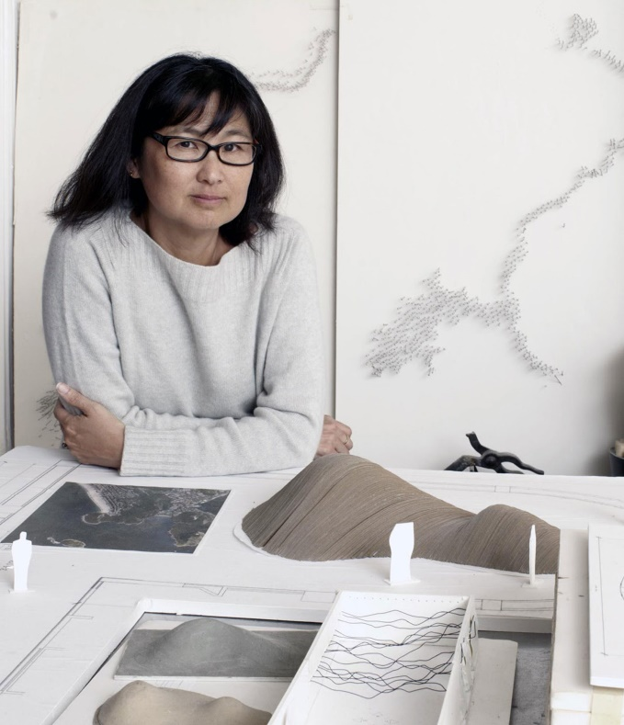
Maya Lin
American, born 1959
Artist, designer and environmentalist, Maya Lin interprets the natural world through science, history, politics, and culture, creating a remarkable and highly acclaimed body of work in art and architecture. Her works merge the physical and psychological environment, presenting a new way of seeing the world around us.
Lin's Memorials address the critical social and historical issues of our time. From the Vietnam Veterans Memorial which she designed as an undergraduate student at Yale, to The Civil Rights Memorial in Alabama, and the Women's Table at Yale make our history part of the landscape. To her latest, ‘What is Missing?’ which is focused on the environment.
Lin's art explores how we experience and relate to Nature, setting up a systematic ordering of the land that is tied to history, memory, time, and language. Her interest in landscape has led to works influenced by topographies and natural phenomena.
Though widely known for her Vietnam Veterans Memorial, Maya Lin entitles what she claims as her last memorial: “What is Missing?”, “a nonprofit that blends art and science to raise awareness about the ongoing loss of biodiversity and natural habitats.” In her work, Lin encourages individuals to reflect on the nature around them (e.g. their backyard or local park) in order to draw broader connections and awareness to the larger issues surrounding nature, climate and environment.

Born in Athens, Ohio, Lin’s father was a ceramist and former dean of the Ohio University College of Fine Arts, while her mother was a poet and professor of literature at Ohio University. Lin graduated from Yale University with a Bachelor of Arts and a Master of Architecture degree in 1986.
Artistic Practice
Throughout her career, the artist, designer, and architect Maya Lin has created work that reflects ‘an environmentalist ethos’. “Frequently working in a large scale with technological tools such as sonar maps and satellite images, Lin re-imagines and reconstructs the often hard-to-discern contours of the earth in gallery installations.
For her well-known sculpture “Water Line” (2006), Lin used wire suspended from the ceiling to render actual topography of the ocean floor, imparting to viewers an eye-level perspective.
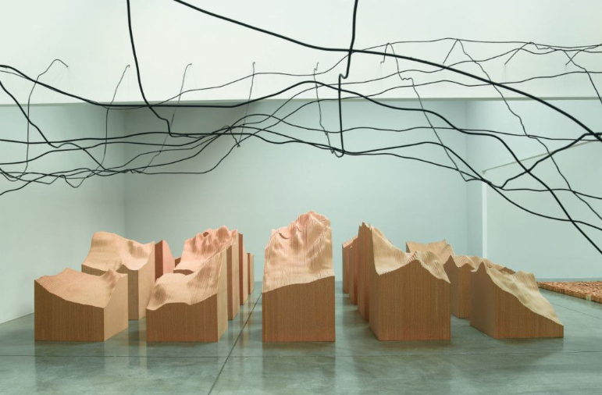
Despite being referred to as a Post-Minimalist artist, Lin’s work offers an aesthetic experience in terms of its organic physicality and imaginative presentation. Lin’s uses a wide-range of materials in her projects—including everything from wood and metal wire to blown glass and recycled silver. The scientific precision and intentionality behind each of Lin’s work offers a seemingly legible visual experience.
Installation of Water Line and Blue Lake Pass (Pace Gallery, 2009)
Selected Solo and Group Exhibitions
2019 Maya Lin: Flow, Grand Rapids Art Museum, Iowa
2018 Indicators: Artists on Climate Change, Storm King Art Center, New Windsor
2016 Glass: Maya Lin, Kiki Smith & Fred Wilson, Pace Gallery, New York
2017 Maya Lin: Ebb and Flow, Pace Gallery, New York
2016 Glass, Pace Gallery, New York
2014 Platform: Maya Lin, Parrish Art Museum, Water Mill
Selected Awards and Honors
2016 Presidential Medal of Freedom
2014 Dorothy and Lillian Gish Prize
2009 National Medal of Art
2005 elected to National Women’s Hall of Fame
2005 elected to The American Academy of Arts Letters
2003 Finn Juhl Prize
2000 Golden Plate Award Academy of Achievement
1999 Rome Prize
Key Terms
- environmentalist: a person who is concerned with or advocates the protection of the environment; a person who considers that environment, as opposed to heredity, has the primary influence on the development of a person or group.
- psychological: of, affecting, or arising in the mind; related to the mental and emotional state of a person; having a mental rather than physical effect.
- memorial: something, especially a structure, established to remind people of a person or event; a commemorative monument.
- topography: the arrangement of the natural or an artificial physical feature of an area; a detailed description or representation on a map of the natural and artificial features of an area.
- natural phenomena: a remarkable natural event including weather, fog, thunder, tornadoes, earthquake, eruptions, etc.
- nonprofit: (also known as not-for-profit) a public organization, often a charity, granted tax-exemption for their particular social cause; a public organization that does not gain income for advocating their particular social cause
- biodiversity: the variety of life in the world or in a particular habitat or ecosystem
- natural habitat: an ecological or environmental area where a specific species lives
- ethos: the characteristic spirit of a culture, era, or community as manifested in its beliefs and aspirations
- post-minimalism: used in various artistic fields for work which is influenced by, or attempts to develop and go beyond, the aesthetic of minimalism… Minimalist procedures such as additive and subtractive process are common in postminimalism, though usually in disguised form.
In visual art, post-minimalist art uses minimalism either as an aesthetic or conceptual reference point. Postminimalism is more an artistic tendency than a particular movement. Post-minimalist artworks are usually everyday objects, use simple materials, and sometimes take on a "pure", formalist aesthetic. However, since postminimalism includes such a diverse and disparate group of artists, it is impossible to enumerate all the continuities and similarities between them.
- in-situ: to be in the original place or position

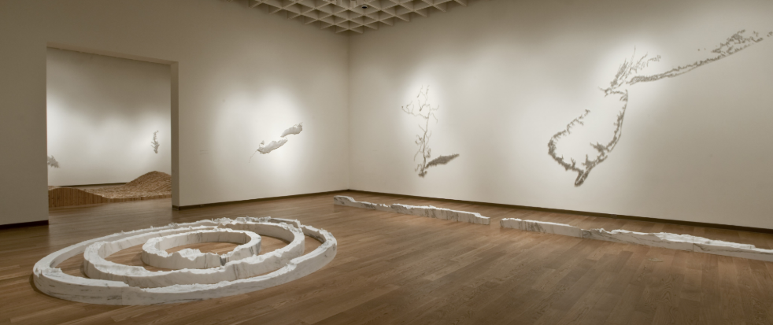
Articles and Interviews
The New York Times | "Q&A with Maya Lin on Saving the Planet Through Art"
This short interview with Maya Lin overviews her position as an artist and environmentalist and how those two things intersect in order to bring awareness about planetary issues to the public. The artists states, “I think that’s why I’m site-specific in my work. It’s just a love of getting people to think what might be right under their feet or right out in their back yard. And I do think you want to connect people to nature and the environment on a more personal level.”
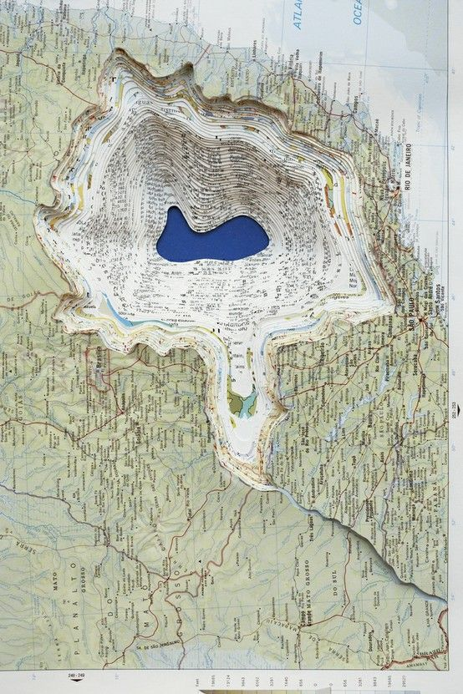
National Endowment for the Arts | Maya Lin Interview
In this interview, Maya Lin addresses her position as designer, artist, and architect. She also describes her approach to the environment and how that informs her art, stating, “For instance, a lot of my artworks, focus on the environment. If I look at a river, I look at the entire length of the river. We tend to pollute what we don’t see and what we don’t own. Based on ecological terms, what’s downstream from you? None of my concern. What’s upstream? People focus on what they can see. So, I started a whole series on rivers that tries to get you to think of river as a living unified organism. In order to protect it, you have to see it in its entirety.”

The New York Times | "What Happens When Site-Specific Art Outlasts Its Surroundings?"
“Art always takes on new meanings when it enters the public sphere. Sometimes it’s viewer, not the artist, who decides a work is site-specific.” This article deals directly with the complication of site-specific art projects that become problematic in the spaces they were designed to be a part of over time. One artist describes this shift as turning a “significant in-situ situation into decoration.” Maya Lin’s work “Topo” is one such work—it was destroyed in 2008 after having been installed two decades earlier. While Ann Hamilton is not mentioned in this article, ideas of ephemerality, materiality, and site-specificity come into question.
Art 21 | The "Black Gash of Shame" Revisiting the Vietnam Veterans Memorial Controversy
The Art Story | Maya Lin: American Architect and Sculptor
Princeton University | Princeton Commissions Maya Lin for Outdoor Installation
PBS Becoming American: The Chinese Experience | Interview with Maya Lin
Maya Lin discusses her book, her creative process, the importance of writing, and her family background.
BILL MOYERS: “My favorite line from your book comes very close to the end where you write, ‘I do not think you can find a reason for everything you make.’ Talk to me about that.”
MAYA LIN: “Everything you make is being made by every single experience you've ever had in your whole life, and on top of that, things you were born with. I think your personality comes out. There's no way of really saying: "If A, then B, or A plus B equals C in creativity." The true strength of the creative arts is that you allow yourself to think about something. Then how it finds its way in your mind to the surface through your hands to-- whether it's paint or sculpture-- is intuited. I think there's reason to it. But could you extrapolate? Could you actually formulate a mathematical theorem? Absolutely not.”
International Sculpture Center | One Who Sees Space: A Conversation with Maya Lin
The New York Times | Maya Lin Captures the Hudson's Beauty and Power
The New York Times | "Where to See (Really See) the Art of Maya Lin"
PBS WOSU Public Media | Selected Bio on Maya Lin
The New York Times | "Maya Lin's 'Here and There' at Pace Gallery"
National Women’s Hall of Fame | Maya Lin
The New York Times | "Of Nature and Rivers of Pins"
Videos
Video interviews with Maya Lin and documentation of her projects.
- What is Missing? | Maya Lin's Interactive Memorial "What is Missing?"
“What is Missing” is an interactive, on going memorial to the planet. It maps species on the brink of extinction, natural disasters, conservation efforts around the globe, and more. Visitors to the site can contribute their own memories of natural sites of personal significance. This video is part of the “What is Missing?” projects and contextualizes the problem of deforestation by showing how quickly famous parks such as Central Park in Manhattan would disappear if they were deforested at the same rate as the Amazon rainforest: https://www.youtube.com/watch?v=DpuvLDrBPdA.
- Art 21 | Maya Lin: Disappearing Bodies of Water – Extended Play
- Art 21 | Maya Lin: New York – Extended Play
- Smithsonian American rt Museum | Interview with Maya Lin on the project “Wonder”
- The New York Times | Maya Lin’s “Wave Field”
- TIME | Maya Lin: First Woman to Design a Memorial on the National Mall
- Makers | Maya Lin, Artist, Architect & Memorial Designer
- Khan Academy | The Vietnam Veterans Memorial

Publications
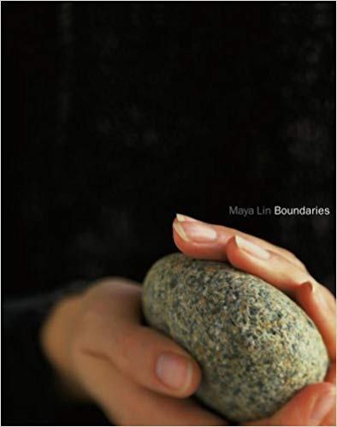
Boundaries (2010) by Maya Lin
Boundaries is her first book: an eloquent visual/verbal sketchbook produced with the same inspiration and attention to detail as any of her other artworks. Like her environmental sculptures, it is a site, but one which exists at a remove so that it may comment on the personal and artistic elements that make up those works. In it, sketches, photographs, workbook entries, and original designs are held together by a deeply personal text. Boundaries is a powerful literary and visual statement by "a leading public artist" (Holland Carter). It is itself a unique work of art.

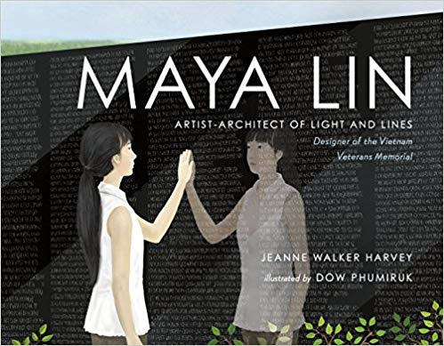
Maya Lin: Artist-Architect of Light and Lines (2017) by Jeanne Walker Harvey
You may be familiar with the iconic Vietnam Veterans Memorial. But do you know about the artist-architect who created this landmark?
As a child, Maya Lin loved to study the spaces around her. She explored the forest in her backyard, observing woodland creatures, and used her house as a model to build tiny towns out of paper and scraps. The daughter of a clay artist and a poet, Maya grew up with art and learned to think with her hands as well as her mind. From her first experiments with light and lines to the height of her success nationwide, this is the story of an inspiring American artist: the visionary artist-architect who designed the Vietnam Veterans Memorial.

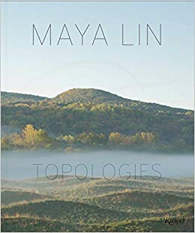
Maya Lin: Topologies (2015) by Maya Lin
The first comprehensive monograph on the acclaimed American artist and architect, known for her environmental works and memorials that distill a tranquil yet texturally rich minimalism.
This visually rich volume presents 50 projects from the last three decades that demonstrate the scope of Lin’s creative process, featuring her own sketches and drawings and linked by her ideal of making a place for individuals within the landscape. With her environmental works Storm King Wavefield, Eleven-Minute Line (Sweden), and Pin River–Yangtze (Beijing), Lin maintains a balance between art and architecture, drawing inspiration from culturally diverse sources.

Related Recent Exhibitions
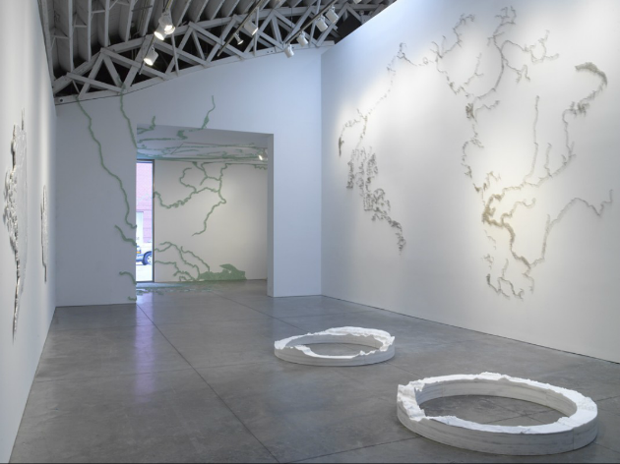
Maya Lin: Ebb and Flow (2017)
Pace Gallery is pleased to present Maya Lin: Ebb and Flow featuring 11 new installations and sculptures that continue the artist's ongoing investigation of water in its different states. The exhibition includes wall and floor pieces made from recycled silver, glass marbles, steel pins, and marble. Lin's fourth exhibition with Pace since she joined the gallery in 2008, Ebb and Flow was on view at 537 West 24th Street from September 8 through October 7, 2017.
"I've always been fixated on water," says Lin. "Maybe it's because it exists in multiple states, and you can never understand it in nature as a fixed moment in time. The new show coming up at Pace is about the transitory state of water, and of the earth itself. I'm very interested in the shifting flux of things. And especially now with human development and climate change, the world is being altered at an incredible pace from rising seas, disappearing polar ice, to our major rivers and estuaries and how they have been changed by us. I wanted to capture some of those events: 'Can we stop time? Can we freeze a moment in something that is always in flux? Can I reveal aspects of the natural world that you may not even realize are shifting?'"
The works in Ebb and Flow map the water at Victoria Falls, in the Nile River, the Arctic, and the Antarctic and translate its presence into humanly scaled comprehensible forms. The exhibition includes two new Silver River works depicting the Nile and Columbia Rivers. Using recycled silver, Lin evokes water through the silver's smooth and reflective qualities, and symbolically portrays a finite resource with a recycled material. In other works, such as Where the Water Flows North (2017) Lin uses steel pins set into the gallery wall to create a three-dimensional drawing that illustrates the dispersion and movement of waterways. Drawn together, the new works reflect Lin's ongoing interest in capturing the different states and constant flux of our world's most essential element.

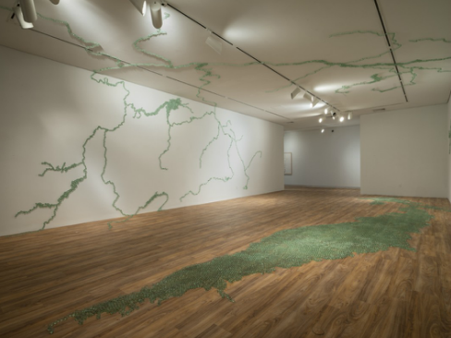
Maya Lin A River is a Drawing (2013)
In this groundbreaking exhibition developed in close collaboration between the Hudson River Museum and this visionary artist, focusing on the theme of the Hudson River. With the Museum's architectural features and location along the banks of the river as a potent backdrop, Lin will create a series of new works and ambitious site-specific installations that invite visitors to interact.
The exhibition presents twelve works, with continuous focus on bodies of water, particularly the Hudson River. It begins in the lobby space with Pin River Hudson Watershed, 2018, one of the largest in the series of her pin-river sculptures to date, composed of more than 20,000 pins. In the Museum's Courtyard, Reed River, 2018, an immersive installation is created from more than 200 bamboo reeds in the form of a 3D drawing of the Hudson River basin. Another outdoor installation, Concrete River, 2018, is on HRM's veranda and overhang looking out to the river vista. The piece connects existing cracks, holes, bumps on the grounds, by filling them in with painted silver lines, visually connecting the Museum's campus to the river.

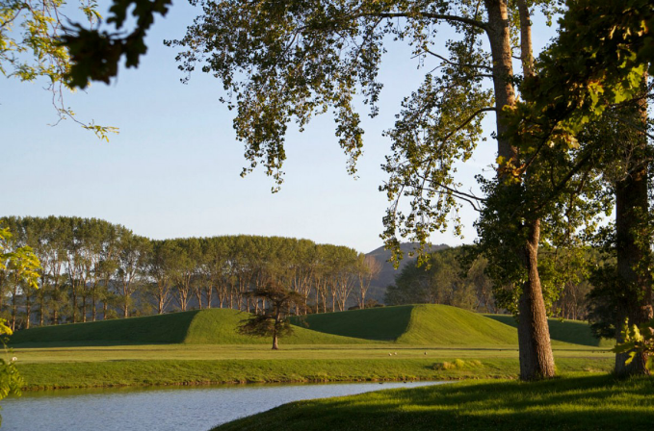
A Fold in the Field (2013)
Encompassing approximately 30,000 square meters, "A Fold in the Field" is Maya Lin's largest and most ambitious earthwork to date. It is Lin's first earthwork depicting folds in the earth of which there are five in total, the highest of which gently rises to 11.5 meters. Set on a flat plain, the folds emerge and billow from the terrain, the slopes determined with The Farms wildlife in mind, permitting the sheep to graze the slopes and keep the grass the appropriate length. This is consistent with her large-scale environmental artworks, and the artist's interest in how one experiences and relates to the landscape. Lin's five folds make dramatic new wave forms in the flattest and lowest section of the Farm: the coastal flats. Creating five undulations in this location, Lin's work both echoes the waves of westerly weather that shape the coastline, and the slow, inevitable gravitational slide of the land down slopes and valleys towards the sea. By sculpting the earth and altering its surface appearance in this way, Lin's work enables us to relate to the forces both within and upon the land.

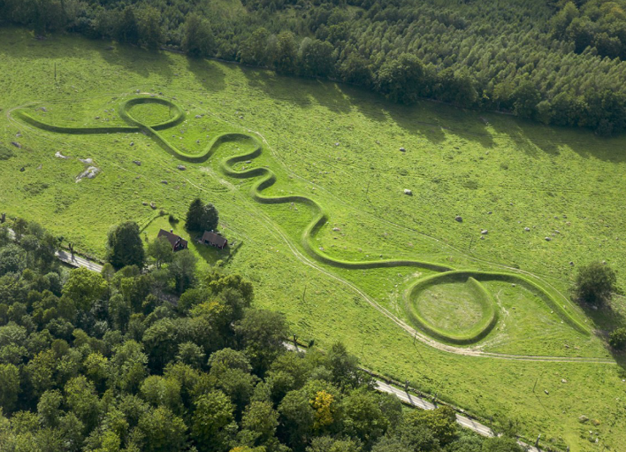
Eleven Minute Line (2004)
"Somewhere between a line and a walk"
In this work, Maya Lin was exploring the relationship between two- and three- dimensional space and the connection between prehistoric forms of the Americas and Europe.
In Southeastern Ohio, where the artist grew up, there exist many burial and effigy mounds from the time of the Hopewell and Adena tribes - between 1000BC and 700 AD. One of the most striking is a mound in the shape of a snake - the Serpent Mound. When European settlers first encountered these works and their accompanying artifacts, they were convinced that the forbears of the present day Native Americans could not have been sophisticated enough to produce them. They conjectured that a more "advanced" European culture had visited the Americas much earlier and left these works.
Perhaps it is the history of the origins of these forms that drew the artist to create a work linking Europe and the Americas. The early burial mounds of both places have a formal similarity that interested the artist.
The artist was also interested in exploring the qualities of a line drawing, and how a two-dimensional mark is experienced three-dimensionally. The first "sketch" existed outside of the Wanås castle as a gravel drawing. A topographic model of the site was then created in order to translate that first sketch into a drawing to fit the pasture's sloping landscape. It was "drawn" with an understanding that both reading it from the road and walking upon it would have to be equally balanced experiences.

Broader Thematic Overview & Discussion
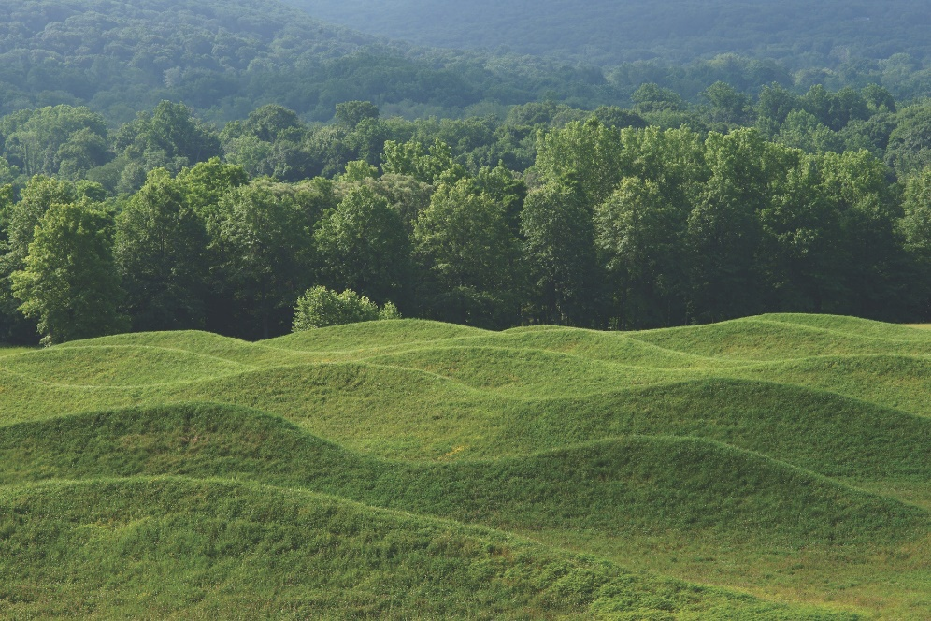
Earthwork
sometimes referred to as land art or earth art, is art made directly in the landscape, sculpting the land itself into earthworks or making structures in the landscape using natural materials such as rocks or twigs.
The movement was an outgrowth of conceptualism and minimalism: the beginnings of the environmental movement and the rampant commoditization of American art in the late 1960s influence ideas and works that were, to varying degrees, divorced from the art market. The rejection of traditional gallery and museum spaces defined the earth art practice. By creating their works outside of these institutions, Earth artists rebuffed the commodity status these venues conferred on art, again challenging traditional definitions of art as something to be bought and sold for profit.

The Art Story | Earth Art Concepts, Styles, and Trends
The Art Story | Summary of Earth Art
Artsy | 10 Female Land Artists You Should Know
My Modern Met | Images of Unforgettable Land Art

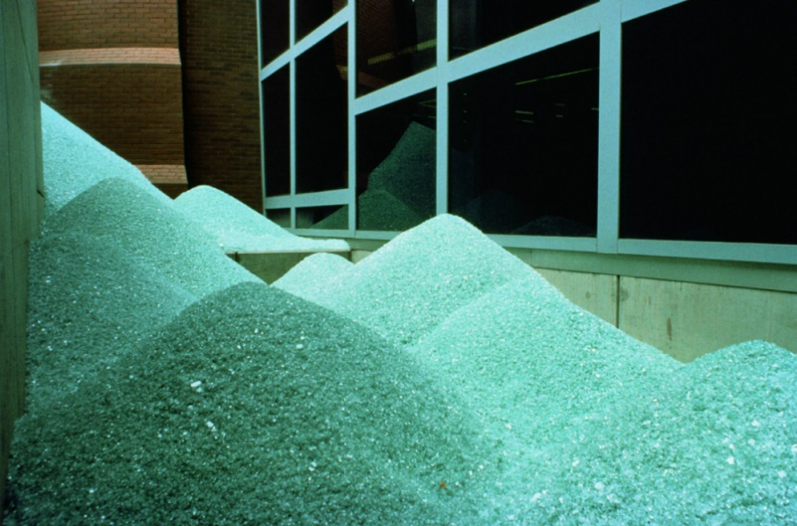
Environmental Art
is art that addresses social and political issues relating to the natural and urban environment. Encompassing a range of artistic practices both historical approaches to nature in art and more recent ecological and politically motivated types of works. Environmental art has evolved away from formal concerns, utilized earth as sculptural material, and processes it in relationship to social concerns. Many environmental artists seek to investigate our human relationship with the environment through embedding their artistic practice within it.
The Art Story | Summary of Environmental Art
Wide Walls | 7 Environmental Artists Fighting for Change

Discussion Themes & Prompts
The Artist, Art, and the Environment
“We often forget that we are nature. Nature is not something separate from us. So, when we say that we have lost our connection to nature, we’ve lost our connection to ourselves.”
– Andy Goldsworthy
- The Artist & Climate Change
Artsy | Nine Artists Respond to Climate Change
The New York Times | 12 Artists On: Climate Change
A dozen artists respond to climate change by making issue-specific works with accompanying messages about the global emergency.
Huffington Post | 8 Artists Taking on the Big Global Challenge
Eco Arts Foundation | A Collection of Artists and Works Influenced by Climate Change
Questions:
- Do artists have responsibility to draw attention to climate change and environmental issues in their work?
- Do you think making earthworks--some of which are remotely located or easily destroyed—can make a large socio-economic impact?

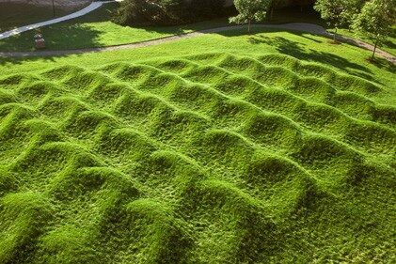

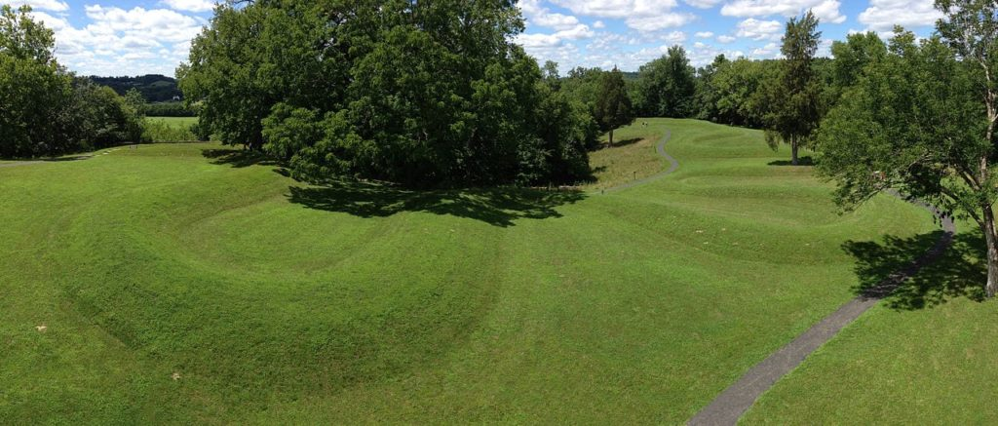
- The Influence of Pre-Modern Earthworks

Columbus Navigator | The Ancient Ohio Earthworks Are Thousands of Years Old
Cahokia Mounds | Central Missouri’s Historic Earthwork Site
Ocmulgee Mounds | The Ancestral Homeland of the Muscogee People (Creek Nation)
Effigy Mounds | Introduction to the Late Woodland Period Mounds
Questions:
- Considering Earthworks have been around for thousands of years, is it appropriate to consider contemporary artists as the first environmentalist artists?

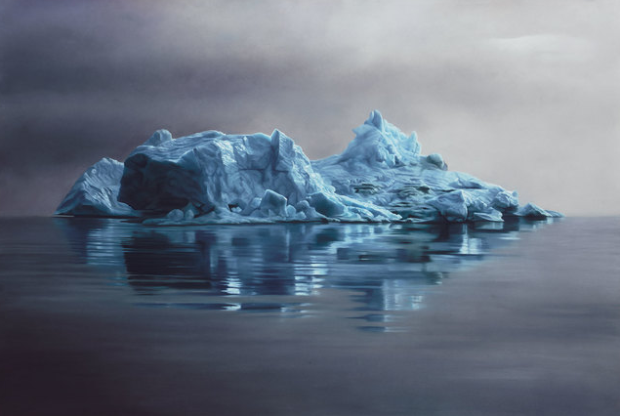
Comparable Artists & Artworks
Zaria Forman
American, born 1982
Greenland #62 (2013)

Zaria Forman’s pristine, photorealist paintings of the ocean and remote, icy landscapes are painted by hand—quite literally using her fingertips to render marks in paint and chalk, rather than brushes.

Traveling to far-flung corners of the globe affected by climate change, in order to source inspiration for her large-scale compositions, Forman takes photographs and creates sketches, working from these and her memory in the studio after she returns to the US. Past expeditions have included one to Greenland in which Forman retraced the 1869 journey of the American painter William Bradford. “In my work I explore moments of transition, turbulence and tranquility in the landscape and their impact on the viewer,” she has said. “In this process I am reminded of how small we are when confronted with the powerful forces of nature.”

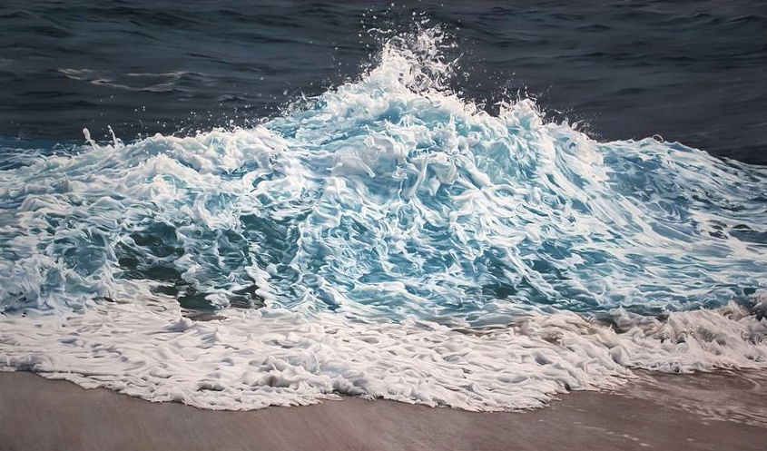
Resources on Forman
TED Talk | Drawings that Show the Fragility of Earth
Making Art New York | Perspective: Zaria Forman & Climate Change
Wide Walls | Highlight of Zaria Forman
Website | https://www.zariaforman.com/
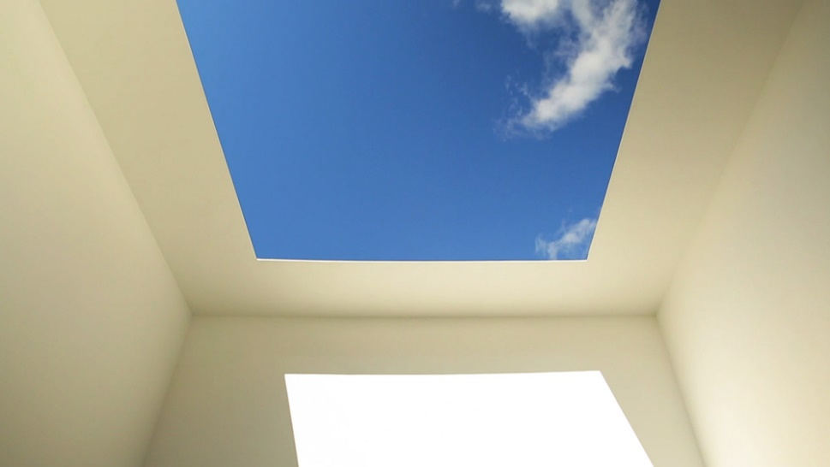
James Turrell
American, born 1943
Second Meeting from Skyspace Series(1989)
James Turrell has innovated photographic techniques that allow light to have a physical presence. Using holography to make the light itself the subject rather than the medium, Turrell creates colored light installations that appear to possess mass and take up space as planes, cubes, pyramids, and tunnels. Turrell’s series “Skyspace,” (begun in the 1970s), which he has constructed around the world, are enclosed spaces open to the sky through an aperture in the roof that enable viewers to observe changes in light from minute to minute and season to season, what has been described as a religious experience.

Resources on James Turrell
James Turrell | Image List of Skyspaces
Art 21 | Extended Play: Second Meeting
Khan Academy | The Way of Color
Guggenheim | Artist Talk

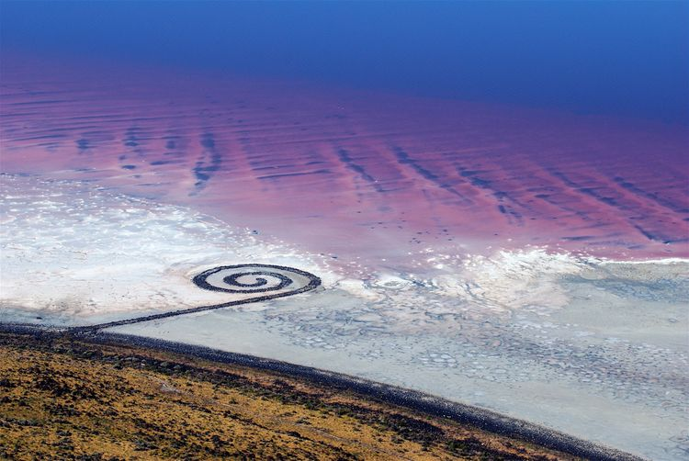
Robert Smithson
American, 1938-1973
Spiral Jetty (1970)

Smithson was known for sculpture and land art who often used drawing and photography in relation to the spatial arts. Few major works by Smithson remain as he died in a plane crash while surveying a potential art site in Texas.
Considered to be his most important work, Spiral Jetty, is an earthwork sculpture constructed in April 1970. The sculpture was built of mud, precipitated salt crystals, and basalt rocks. The Spiral Jetty is a 1,500ft long and 15ft wide counterclockwise spiral on the northeastern shore of the Great Salt Lake in Utah. Smithson reportedly chose the Rozel Point site based on the blood-red color of the water and its connection with the primordial sea. The red hue of the water is due to the presence of salt-tolerant bacteria and algae that thrive in the extreme 27% salinity of the lake’s north shore, which was isolated from freshwater sources by the building of a causeway by the Southern Pacific Railroad in 1959.
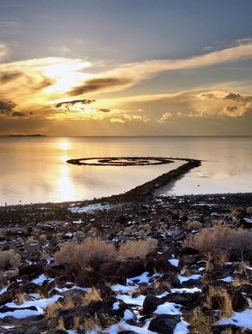
Resources on Smithson
Khan Academy | Spiral Jetty
PBS Art Assignment | Spiral Jetty, Sun Tunnels, and Salt
Atlas Obscura | Smithson’s Jetty

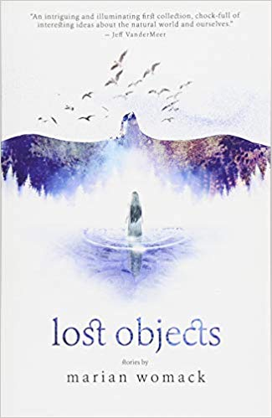
Relevant Literature: Young Adult
Lost Objects by Marian Womack
“An intriguing and illuminating first collection, chockfull of interesting ideas about the natural world and ourselves.” These stories explore place and landscape at different stages of decay, positioning them as fighting grounds for death and renewal. From dystopian Andalusia to Scotland or the Norfolk countryside, they bring together monstrous insects, ghostly lovers, soon-to-be extinct species, unexpected birds, and interstellar explorers, to form a coherent narrative about loss and absence.

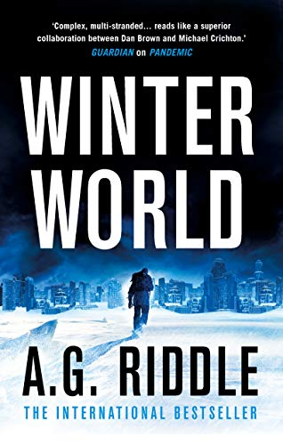
Winter World (2019) by A.G. Riddle
In space, NASA discovers a mysterious object drifting toward the sun. Is it responsible for the ice age? Or could it be our last chance of stopping it? With time running out, an international consortium launches a mission to make contact with the artifact. But it isn’t what anyone thought. Humanity faces a new kind of threat--and an event that will change the future forever. Each month, it grows colder. Snow falls in summer. Glaciers trample cities across North America, Europe, and Asia. The new ice age gripping the Earth shows no signs of stopping. Chaos erupts. Around the world, people abandon their homes, fleeing the cold, flocking to regions where they can survive. Nations prepare to go to war for the world’s last habitable zones.

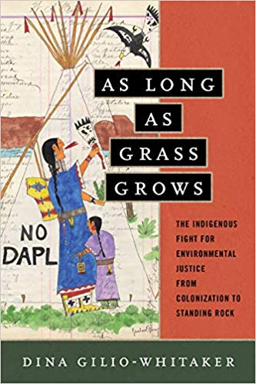
As Long as Grass Grows: The Indigenous Fight for Environmental Justice, from Colonization to Standing Rock (2019)
by Dina Gilio-Whitaker
Through the unique lens of “Indigenized environmental justice,” Indigenous researcher and activist Dina Gilio-Whitaker explores the fraught history of treaty violations, struggles for food and water security, and protection of sacred sites, while highlighting the important leadership of Indigenous women in this centuries-long struggle. As Long As Grass Grows gives readers an accessible history of Indigenous resistance to government and corporate incursions on their lands and offers new approaches to environmental justice activism and policy.
Throughout 2016, the Standing Rock protest put a national spotlight on Indigenous activists, but it also underscored how little Americans know about the longtime historical tensions between Native peoples and the mainstream environmental movement. Ultimately, she argues, modern environmentalists must look to the history of Indigenous resistance for wisdom and inspiration in our common fight for a just and sustainable future.

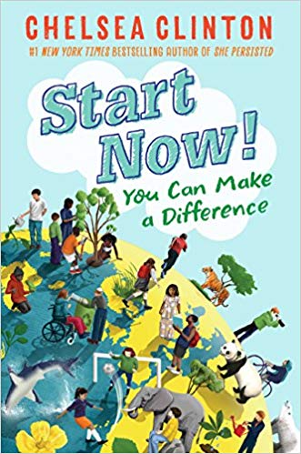
Start Now!: You Can Make a Difference (2018) by Chelsea Clinton
What can I do to help save endangered animals? How can I eat healthy? Why do I need to cover my mouth when I cough? What do I do if I'm being bullied?
With information on problems both large and small, Chelsea Clinton breaks down the concepts of health, hunger, climate change, endangered species and bullying, so that readers can understand the world around them, and how they can make a difference in their own lives, as well as in their communities and the world at large. With comic drawings to illustrate Clinton's words, photographs of real live kids who are making a difference today, and lists of ways to get involved, this book is the perfect introduction to young activists who want to make the world a better place. A book equally important and welcome for any elementary school kid, the Cub Scout and Girl Scout set, and for moms who want to raise socially active children.
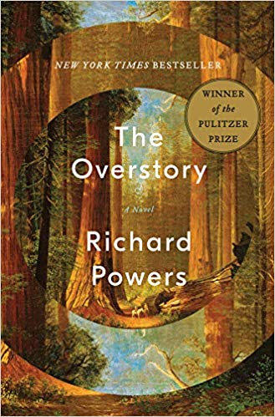
The Overstory: A Novel (2018) by Richard Powers
This Pulitzer Prize winning novel about an Air Force loadmaster in the Vietnam War is shot out of the sky, then saved by falling into a banyan. An artist inherits a hundred years of photographic portraits, all of the same doomed American chestnut. A hard-partying undergraduate in the late 1980s electrocutes herself, dies, and is sent back into life by creatures of air and light. A hearing- and speech-impaired scientist discovers that trees are communicating with one another. These four, and five other strangers―each summoned in different ways by trees―are brought together in a last and violent stand to save the continent’s few remaining acres of virgin forest.
In his twelfth novel, National Book Award winner Richard Powers delivers a sweeping, impassioned novel of activism and resistance that is also a stunning evocation of―and paean to―the natural world.
The Overstory is a book for all readers who despair of humanity’s self-imposed separation from the rest of creation and who hope for the transformative, regenerating possibility of a homecoming. If the trees of this earth could speak, what would they tell us? "Listen. There’s something you need to hear."

Relevant Literature: Background & Thematic
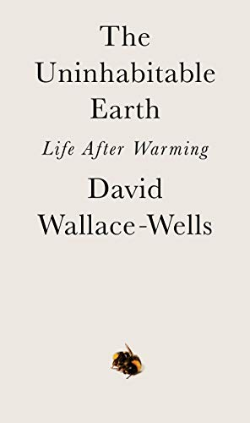
The Uninhabitable Earth: Life After Warming (2019)
by David Wallace-Wells

It is worse, much worse, than you think. If your anxiety about global warming is dominated by fears of sea-level rise, you are barely scratching the surface of what terrors are possible. In California, wildfires now rage year-round, destroying thousands of homes. Across the US, “500-year” storms pummel communities month after month, and floods displace tens of millions annually.
This is only a preview of the changes to come. And they are coming fast. Without a revolution in how billions of humans conduct their lives, parts of the Earth could become close to uninhabitable, and other parts horrifically inhospitable, as soon as the end of this century.
In his travelogue of our near future, David Wallace-Wells brings into stark relief the climate troubles that await—food shortages, refugee emergencies, and other crises that will reshape the globe. But the world will be remade by warming in more profound ways as well, transforming our politics, our culture, our relationship to technology, and our sense of history. It will be all-encompassing, shaping and distorting nearly every aspect of human life as it is lived today.
Like An Inconvenient Truth and Silent Spring before it, The Uninhabitable Earth is both a meditation on the devastation we have brought upon ourselves and an impassioned call to action. For just as the world was brought to the brink of catastrophe within the span of a lifetime, the responsibility to avoid it now belongs to a single generation.

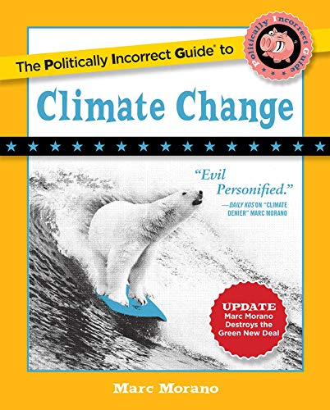
The Politically Incorrect Guide to Climate Change (2018)
By Marc Morano

Less freedom. More regulation. Higher costs. Make no mistake: those are the surefire consequences of the modern global warming campaign waged by political and cultural elites, who have long ago abandoned fact-based science for dramatic fearmongering in order to push increased central planning.

The Politically Incorrect Guide to Climate Change gives a voice -- backed by statistics, real-life stories, and incontrovertible evidence -- to the millions of "deplorable" Americans skeptical about the multibillion dollar "climate change" complex, whose claims have time and time again been proven wrong.

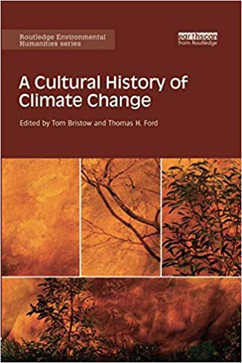
A Cultural History of Climate Change (2017)
by Tom Bristow and Thomas Ford
Charting innovative directions in the environmental humanities, this book examines the cultural history of climate change under three broad headings: history, writing and politics. Climate change compels us to rethink many of our traditional means of historical understanding, and demands new ways of relating human knowledge, action and representations to the dimensions of geological and evolutionary time. To address these challenges, this book positions our present moment of climatic knowledge within much longer histories of climatic experience. Only in light of these histories, it argues, can we properly understand what climate means today across an array of discursive domains, from politics, literature and law to neighbourly conversation. Its chapters identify turning-points and experiments in the construction of climates and of atmospheres of sensation. They examine how contemporary ecological thought has repoliticised the representation of nature and detail vital aspects of the history and prehistory of our climatic modernity.
This ground-breaking text will be of great interest to researchers and postgraduate students in environmental history, environmental governance, history of ideas and science, literature and eco-criticism, political theory, cultural theory, as well as all general readers interested in climate change.

Relevant Literature: Poetry
“California Dreaming”
by Lachlan Mackinnon
Almonds and vines and lawns
drink up the last
of shallow, short-term water
then suck on the black depths
with a draw mightier
than the moon’s. And suck.
In sudden places the ground
puckers and caves.
Far westward, China smokes.
Nobody sees the rains fail
until they have.
Tableland mesas crack.
In the mountains the snowpack thins,
meltwater now brown
reluctant drops.
Cities gasp in the sun’s stare.
Faucets cough
and families turn inwards.
There must be somebody to blame.
Better ourselves than no-one.
We brag
of damage done
but whether we could truly
dry all rain, bake all earth,
science does not know.
The wastefulness was all
ours but this fetid heat
could be a planetary
impersonal adjustment
like an ice age,
so it might well be wise
to keep always
facepaint and ash about us.
When the last clouds
wagon-train off,
loincloth and invocation will be
the one hope for last
woman and last man discovering
she’s pregnant.
Idioms Updated for climate Change
by Ginny Hogan (The New Yorker)
- A rising tide floods all houses.
- A bird in the hand is worth more than it used to be because they’re going extinct.
- She vanished into oddly thick air!
- Stop and smell the flower.
- One man’s trash is everybody’s trash because it all goes in the same enormous landfill.
- It happens only once in a blue moon, and that’s pretty frequently because now the moon is all sorts of weird colors.
- She’s a real force of almost entirely decimated rain forest.
- A rose by any other name would wilt and die without water, which we’re running out of.
- She’s so hot and cold, like the month of January.
- When it rains, it acid-rains.
- Can we please address the elephant in the room? Why has this elephant been displaced from Africa? It doesn’t belong in New York City.
- Ugh, she’s giving me the tepid shoulder again.
- There’s got to be at least one other fish left in the sea.
- Let’s save it for a rainy day—and by that I mean let’s never, ever do it.
- You can lead a horse to a dried-up reservoir, but you can’t make it drink dirt.
- Every cloud has a silver lining, but that’s something we really ought to investigate because, much like the weirdly colored moon, clouds aren’t supposed to be silver.
- Who let the cat out of the bag? Please be more careful with her. She’s our last cat.
- It’s beginning to look a lot like Christmas. (It’s June.)
- You’re on thin ice, buddy. In fact, we all are. If there’s a part of the world that still has thick ice, we need to know about it immediately.
- You killed two birds with one stone! Unfortunately, those were the only two birds we had left.
- Don’t put all your eggs in one basket—it’s unclear if we’ll be able to find any new eggs. As I just mentioned, all the birds are dead.
- Curiosity killed the cat—oh, wait, no, we killed it for food.
- You catch more flies with honey—here, let me show you how to catch flies. That’s dinner right there.
- Don’t eat a dead horse. Not until we’ve eaten this cat, at least.
- It’s not rocket science. You know, rocket science? The only type of science that matters anymore because we need to find a new planet to live on?
- Let’s cross that bridge when we come to it, as we escape this raging fire and sprint for dear life toward the rocket ship.
- She’s really got her head in the clouds, which makes sense because our rocket actually is currently in the clouds.
- Time flies when you’re travelling at the speed of light to escape the now uninhabitable Earth!
- You only live once—specifically, for the remainder of this spaceship ride because it’s unlikely that we’ll find another planet with potable water.
- Shoot for the moon, and even if you miss—damn it, we missed. Well, humans had a good run. Better luck next time.
- The world is just that one oyster. Go forth and repopulate, little one.

“A Language of Change”
by David Sergeant
We’re sat by the ocean and this
could be a love poem; but that lullaby murderer
refuses each name I give it
and the icebergs seep into our sandwiches,
translated by carbon magic. And even this might be
to say too much. But the muse of poetry
has told me to be more clear – and don’t,
s/he said, for the love of God, please, screw things up.
Ambiguous, I didn’t reply; as we’re sat
by the ocean and I could make it
anything you wanted, for this moment
of speaking – but we have made it
something forever. Together
the weather
is a language we can barely understand;
but confessional experts detect
in the senseless diktat of hurricane
a hymning of our sins, our stupid counterpoint.
Love has served its purpose, now must be
transformed by an impersonal sequester
of me into the loves I will not see,
or touch, or in any way remember.
Perhaps it was always like this – take my hand,
horizon – ceding this land.

“Extinction”
by Jackie Kay
We closed the borders, folks, we nailed it.
No trees, no plants, no immigrants.
No foreign nurses, no Doctors; we smashed it.
We took control of our affairs. No fresh air.
No birds, no bees, no HIV, no Poles, no pollen.
No pandas, no polar bears, no ice, no dice.
No rainforests, no foraging, no France.
No frogs, no golden toads, no Harlequins.
No Greens, no Brussels, no vegetarians, no lesbians.
No carbon curbed emissions, no Co2 questions.
No lions, no tigers, no bears. No BBC picked audience.
No loony lefties, please. No politically correct classes.
No classes. No Guardian readers. No readers.
No emus, no EUs, no Eco warriors, no Euros,
No rhinos, no zebras, no burnt bras, no elephants.
We shut it down! No immigrants, no immigrants.
No sniveling-recycling-global-warming nutters.
Little man, little woman, the world is a dangerous place.
Now, pour me a pint, dear. Get out of my fracking face.

Some Questions About the Strom
by Hilda Raz
What's the bird ratio overhead?
Zero: zero. Maybe it's El Niño?

The storm, was it bad?
Here the worst ever. Every tree hurt.

Do you love trees?
Only the gingko, the fir, the birch.

Yours? Do you name your trees?
Who owns the trees? Who's talking

You presume a dialogue. Me and You.
Yes. Your fingers tap. I'm listening.

Will you answer? Why mention trees?
When the weather turned rain into ice, the leaves failed.

So what? Every year leaves fail. The cycle. Birth to death.
In the night the sound of cannon, and death everywhere.

What did you see?
Next morning, roots against the glass.

Who's talking now and in familiar language? Get real.
What's real is the broken crown. The trunk shattered.

Was that storm worse than others?
Yes and no. The wind's torque twisted open the tree's tibia.

Fool. You're talking about vegetables. Do you love the patio
tomato? The Christmas cactus?
Yes. And the magnolia on the roof, the felled crabapple, the topless
spruce.

The Purpose of the Chesapeake & Ohio Canal
by Dave Smith
Thick now with sludge from the years of suburbs, with toys,
fenders, wine bottles, tampons, skeletons of possums, and
edged by blankets of leaves, jellied wrappers unshakably
stuck to the scrub pine that somehow lift themselves
from the mossed wall of blockstone headlined a hundred
years back, this water is bruised as a shoe at Goodwill.
Its brown goes nowhere, neither does it remain, and elms
bend over its heavy back like patient fans, dreamlessly.
This is the death of hope’s commerce, the death of cities
blank as winter light, the death of people who are gone
erratic and hopeless as summer’s glittering water-skimmers.
Yet the two climbing that path like a single draft horse
saw the heart of the water break open only minutes ago,
and the rainbow trout walked its tail as if the evening
arranged an offering in an unimaginable room where plans
inched ahead for the people, as if the trout always meant
to hang from that chain, to be borne through the last shades
like a lure sent carefully, deviously in the blue ache of
air thickening in still streets and between brown walls.

Water Devil
Jamaal May
Spout of a leaf,
listen out for the screams
of your relentless audience:
the applause of a waterfall
in the distance,

a hurricane looting
a Miami shopping mall.
How careful you are
with the rain-cradling
curve of your back.

Near your forest,
all are ready to swim
and happy to drown
in me: this lake of fire
that moats the edges.

From my mouth,
they come to peel the flames
and drink their slick throats
into the most silent
of ashes.

Halloween in the Anthropocene, 2015
Craig Santos Perez
Darkness spills across the sky like an oil plume.
The moon reflects bleached coral. Tonight, let us
praise the sacrificed. Praise the souls of black

boys, enslaved by supply chains, who carry
bags of cacao under West African heat. “Trick
or treat, smell my feet, give me something good

to eat,” sings a girl dressed as a Disney princess.
Let us praise the souls of brown girls who sew
our clothes as fire unthreads sweatshops into

smoke and ash. “Trick or treat, smell my feet, give me
something good,” whisper kids disguised as ninjas.
Tonight, let us praise the souls of Asian children

who manufacture toys and tech until gravity sharpens
their bodies enough to cut through suicide nets.
“Trick or treat, smell my feet, give me,” shout boys

camouflaged as soldiers. Let us praise the souls
of veterans who salute with their guns because
only triggers will pull God into their ruined

temples. “Trick or treat, smell my feet,” chant kids
masquerading as cowboys and Indians. Tonight,
let us praise the souls of native youth, whose eyes

are open-pit uranium mines, veins are poisoned
rivers, hearts are tar sands tailings ponds. “Trick
or treat,” says a boy dressed as the sun. Let us

praise El Niño, his growing pains, praise his mother,
Ocean, who is dying in a warming bath among dead
fish and refugee children. Let us praise our mothers

of asthma, mothers of cancer clusters, mothers of
miscarriage — pray for us — because our costumes
won’t hide the true cost of our greed. Praise our

mothers of lost habitats, mothers of fallout, mothers
of extinction — pray for us — because even tomorrow
will be haunted — leave them, leave us, leave —

Artist’s Official Website: Maya Lin.
Official Website: Interactive "What is Missing?" Memorial
Quoted in "Q&A with Maya Lin on Saving the Planet Through Art".
Wikipedia.
Definition from WikiArt.

