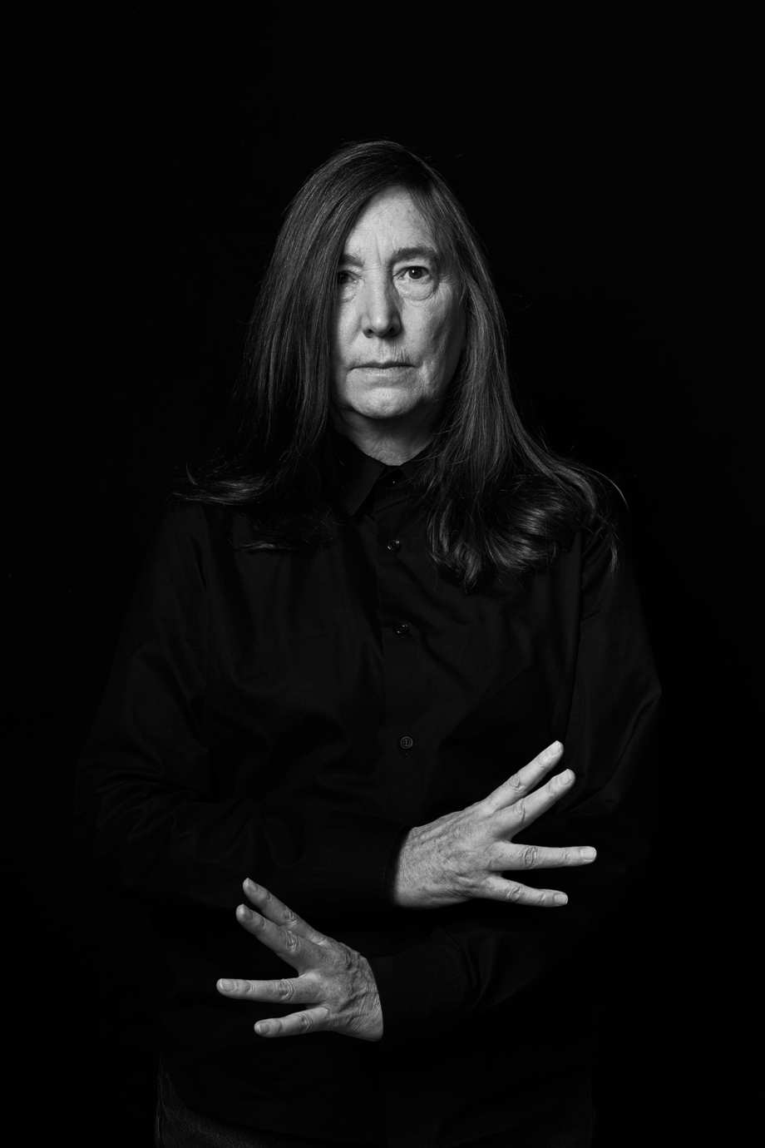
Jenny Holzer
American, born 1950
Conceptual artist, Jenny Holzer challenges the minds of audiences through thought-provoking language and text. Holzer’s main focus is “the delivery of words and ideas in public spaces”. Holzer belongs to the feminist branch of a generation of artists that emerged around 1980, looking for new ways to make narrative or commentary an implicit part of visual objects.
Holzer’s “truisms” such as “Abuse of power comes as no surprise” and “Protect me from what I want,” have appeared on posters, billboards, as LED signs and monumental light projections. Whether questioning consumerism, describing torture, or lamenting death and disease, her use of language (sometimes mistaken for advertising when installed in public spaces) is designed to agitate and disturb.
Holzer began her celebrated “truisms” series in her mid-twenties, after enrolling in the Whitney Museum of American Art’s renowned independent study program in 1977. After being assigned a hefty reading list, Holzer recalls, “I reduced all the reading to one-liners.” She began to print her one-line summaries on white paper in bold, black, italicized capital letters and posted them across Manhattan. The public dimension is integral to Holzer’s work. LED signs have become her most visible medium, although her diverse practice incorporates a wide array of media including street posters, painted signs, stone benches, paintings photographs, sound, video, projections, the Internet, and a race car for BMW. Text-based light projections have been central to Holzer’s practice since 1996. As of 2010, her LED signs have become more sculptural.
Born in Gallipolis, Ohio, in 1950, Holzer aspired to become an abstract painter. She received her BFA at Ohio University in 1972 and her MFA from Rhode Island School of Design in 1977. Holzer was the second woman to represent the United States at the Venice Biennale. She currently lives and works in Manhattan, New York.
Artistic Practice
Widely regarded as a Conceptual artist, Jenny Holzer’s text-based projects explore how language is used as a form of communication and as a means of concealment and control. Known for her eye-catching public displays, works such as Heap (2013) utilize violet, blue, and pink LED lights to display inciting quotations on a loop. The vibrant text flashes across beam-like screens while also casting a luminescent hue in the space.
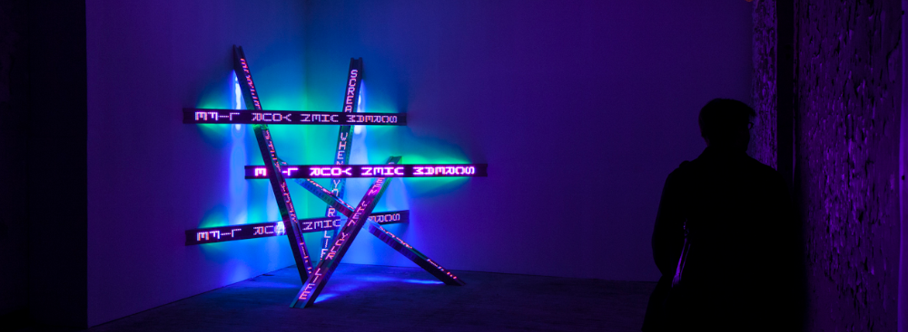
Referring to this work as a “light stream”, Holzer states, “Though I rely on minimalist configurations, for decades I have wanted to offer a massive, irrational unpredictable heap of glittering displays. I am happy about the paradox—what appears wild, chaotic, and spontaneous is a greater technical puzzle and more difficult challenge to realize. Pearl Lam Galleries and years of building precisely configured LED signs have made this new electronic wilderness possible.”

Detail of Heap: “Scream when your life…”, Pearl Lam Galleries, Hong Kong (2013)
Selected Solo and Group Exhibitions
2018 “Artist Rooms: Jenny Holzer”, Tate Modern, London, UK
2009 Living Series, Beyeler Foundation Museum, Riehen, Switzerland
2009 Jenny Holzer: Protect Protect, Whitney Museum of Art, New York
1991 Walker Art Center, Minneapolis
1989 Jenny Holzer: Laments, Dia Art Foundation, New York
1989 Selections from Truisms and Inflammatory Essays, The Living Series, Under a Rock,
Guggenheim Museum, New York
Selected Awards and Honors
2011 Barnard Medal of Distinction
2010 Distinguished Women in the Arts Award – Museum of Contemporary Art, LA
2000 Order of Arts and Letters – Diploma of Chevalier from the French Government
1994 Skowhegan Medal
1990 Golden Lion from the Venice Biennale
1982 Blair Award – Art Institute of Chicago
Key Terms
- conceptual art: art in which the idea presented by the artists is considered more important than the finished product, if there is one; sometimes called conceptualism, an art in which the concept or idea involved in the work take precedence over traditional aesthetic, technical, and material concerns
- feminism: the advocacy of women’s rights on the basis of the equality of the sexes; a range of social, political, and ideological movements that share a common goal: to define, establish, and achieve the political, economic, personal, and social equality of the sexes
- consumerism: the theory that an increasing consumption of goods is economically desirable also; a preoccupation with and an inclination toward the buying of consumer goods; the promotion of the consumer’s interests

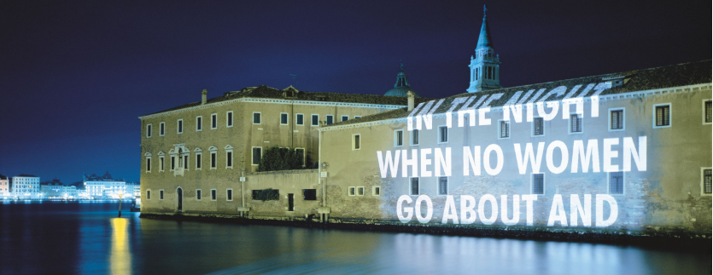

Articles and Interviews
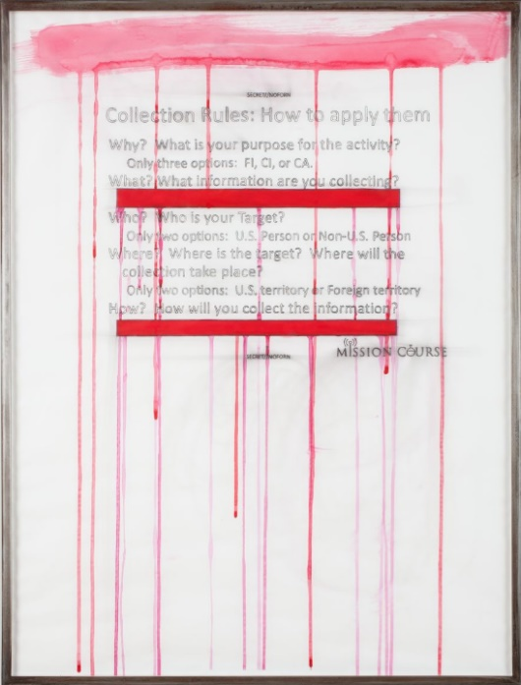
Hauser & Wirth | Biography, Selected Images & List of Holzer’s Exhibitions
Wallpaper Magazine | Battle Lines: Artist Jenny Holzer Proves that Words are Weapons
Wallpaper Magazine reiterates Holzer’s engagement with social issues throughout her career and how they continue to inform her projects. This article addresses Holzer’s reaction to contemporary political, the public image war, its veterans, and government.
Art Newspaper | Holzer Interview: Words of Conflict
Art 21 | Curator Elizabeth Smith discusses on PROTECT PROTECT
Art 21| Jenny Holzer’s Collaboration with the Poet Henri Cole
Art 21 | Jenny Holzer Discusses “For 7 World Trade, Redaction Paintings, and Truisms”
CNN | Sex, Violence and Global Conflict: Jenny Holzer Sheds Light on Humanity’s Dark Side
In this article, Holzer acknowledges her aspirations to be an abstract painter fell away after realizing she could not put forward explicit political and social content abstractly. It expressly deals with Holzer’s projects that interact with the MeToo movement.
TATE | Summaries of Several Holzer Artworks
The Cut | Jenny Holzer Made Good Things Out of Horror
The Cut gives a very detailed interview/chronicling of the artist’s life and how its informed her career. This article also examines how Holzer’s 1970s’ “truisms” have become a part of today’s culture of social (media) movements.
Artsy | Why Jenny Holzer’s “Inflammatory Essays” is the Perfect Work for Our Times
This article covers Holzer’s reaction to her “truisms” series, what its was like in the 1970s to broadcast such inciting language, and why that may still be an important tool in today’s socio-political climate.
Artsy | Holzer's Paintings Exploring Government Abuses During the War on Terror
Phaidon | Holzer's Debuts "Heap" in Hong Kong
Videos
Video interviews and examples of Jenny Holzer’s work.
- BBC Two | Culture Show – Interview with Jenny Holzer
- Hillary Clinton Campaign | Women for Hilary & Holzer’s Hillary Campaign Video
- Guggenheim | Video of Jenny Holzer’s “For the Guggenheim”
- Art 21 | Conversation Art Basel – Artist Talk with Jenny Holzer and Trevor Paglen
- Art 21 | Several Interviews and project highlights of Jenny Holzer
- Whitney Museum of American Art | Podcast Interview with Holzer on “Protect Protect”
- Foundation Beyeler | Interview with Jenny Holzer
- Foundation Beyeler | Holzer Discusses the project “Black Sun”
- Foundation Beyeler | Projections in Basel – Switzerland 2009
- University of California | UCSD Jenny Holzer collection
- LightWork | Jenny Holzer Interview on the work “For Syracuse”
- TATE | Artist: Jenny Holzer

Publications
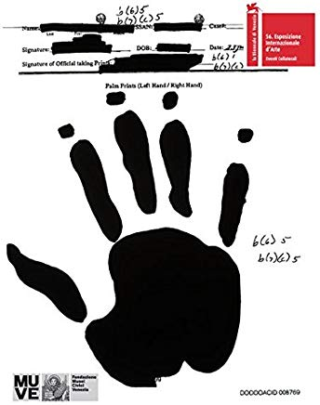
Jenny Holzer: War Paintings (2015)
“Jenny Holzer (born 1950) became known in the 1980s with her billboards, projections and LED installations that often used text to deliver social critique. Jenny Holzer: War Paintings is a significant departure from the works for which she is known. It draws from declassified and US government documents concerning the War on Terror and military operations in Afghanistan and Iraq. Holzer transforms these redacted documents--memoranda, planning maps, diplomatic communiqués, interrogation records, autopsy reports and the handwritten cris de coeur of detainees themselves--into ravishing silkscreened and handpainted oil-on-linen paintings several times their original size. Holzer embarked on the war paintings in an effort to end the normalization of torture. This volume compiles over 200 images--full-bleed reproductions and installation views--of some of the most important political art of our time.”

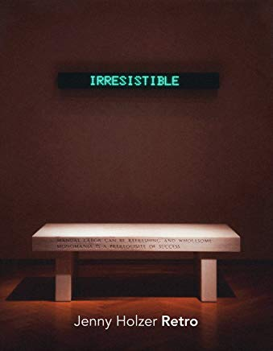
Jenny Holzer: Retro by Cary Levine and Jenny Holzer (2011)
Famed for her LED message boards and the declarative, politicized cast of her linguistic materials, Jenny Holzer (born 1950) has in fact employed a great variety of media in her subversions of dominant ideologies. Among these media are granite and marble benches, enamel signs and even, as this handsome catalogue for Holzer’s 2010 show at Skarstedt Gallery reveals, a sarcophagus. Jenny Holzer: Retro covers a decade of Holzer’s oeuvre from the late 1970s to the late 1980s, underlining the diversity of media in some of the artist’s most iconic works. It shows how each medium elicits differing types of language composition, from the direct provocations of the ephemeral LED message boards to the horrific cracked narratives of the stone benches with their rhetoric of enshrinement and permanence. Surveying works that vary thus from the fleeting to the fixed, Retro also underscores the temporal scale of Holzer’s bold and influential oeuvre.
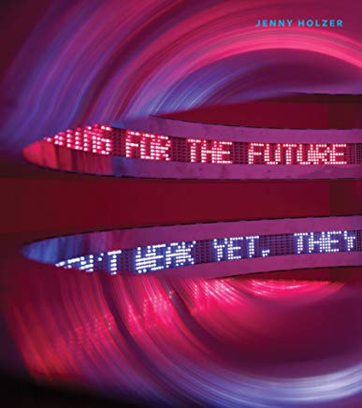
Jenny Holzer by Elizabeth A.T. Smith and Jenny Holzer (2008)
For the past three decades, the influential American conceptual artist Jenny Holzer has been challenging viewers' assumptions about the world through language that conveys the multiplicity of often contradictory voices, opinions and attitudes that form the basis of contemporary society. Alternating between fact and fiction, public and private, the universal and the particular, Holzer's work offers an incisive social and psychological portrait of our times. During the last decade, Holzer has shown extensively in Europe but has been less visible in the United States--following a period of wide exposure and pervasive influence beginning in the late 1970s. This volume, which accompanies a major presentation of Holzer's work in various media from the 1990s onward at the Museum of Contemporary Art, Chicago, goes a long way towards rectifying this situation, and reintroduces her to the American audience at a timely political moment. Featuring several scholarly essays and an interview with the artist, this volume provides an overview of the work of one of the leading artists of the 80s generation.

Related Recent Exhibitions
- The Whole Truth Exhibition | Galleria d’Arte Moderna e Contemporanea di Bergamo
The text in The Whole Truth exhibition speak of “violence, oppression, gender, sexuality, power, war, and death. In Holzer’s art, modes of presentation more often associated with institutional information, news, and advertising become a powerful tool to address political and social issues. The walls of Sala delle Capriate, a symbolic place where historically local justice was administered, will provide the backdrop for a series of new light projections. The texts chosen by Holzer for this special occasion will touch on important themes in her work—identity, gender, and dialogue and in particular will address the ongoing migrant crisis. The exhibition texts also draw from several Italian and national poets.
- Jenny Holzer: Thing Indescribable | Guggenheim-Bilbao
The exhibition “will highlight Frank Gehry’s architecture through site-responsive installations. Works will include Truisms and Inflammatory Essays posters with text in five languages, cast plaques, and painted metal signs that reference Holzer’s beginnings in street art, as well as engraved benches and stone sarcophagi. Drawings, objects, and ephemera from the artist’s archive will complement these early works. More recent oil paintings and watercolors of publicly released U.S. documents will trace Holzer’s response to government redaction and distribution of information after the events of 9/11. New robotic assemblies, especially conceived for the show, will animate electronic signs that scroll text, sometimes illuminating human bones.”
- Artist Rooms: Jenny Holzer | Tate Modern
The Artist Rooms program partners with museums and galleries throughout the UK to provide access to modern and contemporary art. Jenny Holzer describes the aims of her work by stating, “’I wanted a lot simultaneously; to leave art outside for the public, to be a painter of mysterious yet ordered works, to be explicit but not didactic, to find the right subjects, to transforms spaces, to disorient and transfix people, to offer up beauty, to be funny and never lie.’ [Holzer’s work] addresses the information overload and multiple perspectives we read daily. Eye-catching or quiet and lyrical, Holzer’s art invites us to read and interpret for ourselves.”

Broader Thematic Overview & Discussion
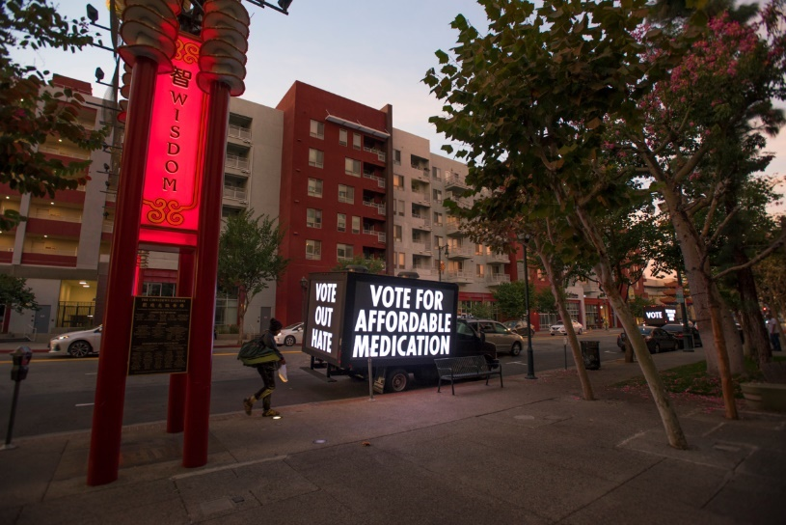
Activist Art
is a term used to describe art that is grounded in the act of ‘doing’ and addresses political or social issues.

Photograph from Holzer’s project Vote Your Future

TED Talks | A Visual History of Inequality in Industrial America
Photographer Latoya Ruby Frazier captures the real impact of inequality and environmental toxicity in the portraits of her friends, family, and neighbors in Braddock, Pennsylvania.

TED Talks | How Art Gives Way to Social Change with Thelma Golden
“Thelma Golden, curator at the Studio Museum in Harlem, talks through three recent shows that explore how art examines and redefines culture. The “post-black” artists she works with are using their art to provoke a new dialogue about race and culture—and about meaning of art itself.”
WideWalls | What is Political Art?
A quasi-chronological approach to identifying political art through a few case studies. This article examines how artworks have ebbed and flowed alongside social and political issues in the nineteenth and twentieth centuries.
The Art Story | Political Artists
A list of artists whose career are either focused on or can be conflated with political and social issues. These artists include Ai Weiwei, Marina Abramovic, Chris Ofili, and Adrian Piper.
Center for Artistic Activism | Creative Resistance 1: What is Artistic Activism?
In the first of five podcasts, the Center for Artistic Activism interviews artist-activists affiliated with the organization to find out their approach to art making in today’s socio-political climate.
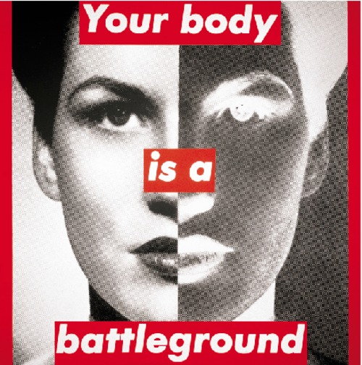
Feminist Art
is a category of art associated firstly with feminists of the late 1960s and 1970s and feminism generally criticized the traditional gender expections and the art-history canon, using art to create a dialogue between the viewer and the artwork through a feminist lens. Rather than creating artwork for the visual pleasure of the viewer. Feminist art aimed to make the viewer question the social and political norms of society in the hopes that would inspire change towards what feminism is all about—ending sexism and oppresion. Since the 1970s, feminist art has evolved and been challenged through various “waves”; however, a plethora of mediums continue to be used inlcuding painting, drawing, sculpture, performance art, conceptual art, body art, craftivism, video, and film.

“A developed feminist consciousness brings with it an altered concept of reality that is crucial to the art being made and to the lives lived with that art.” – Lucy Lippard

The Art Story | Feminist Art, It’s History and Concepts
This article provides a history of the development of feminist art and some of the conceptual issues it tackles.

TATE | Art Term: Feminist Art
A short introduction to the history of feminist art and its leading artists and scholars. This includes Linda Nochlin’s famous essay “Why Have there Been No Great Women Artists?” and Judy Chicago’s The Dinner Party.

TATE | Who Are the Guerrilla Girls?
“How can you really tell the story of culture when you don’t include all the voices within the culture?” A series of questions and short answers about the feminist activist group Guerilla Girls.

Google Arts & Culture | The Feminist Artworks You Should Know

Discussion Themes & Prompts
Activist Art & Artistic Freedom
“Congress shall make no law respecting an establishment of religion, or prohibiting the free exercise thereof; or abridging the freedom of speech, or of the press; or the right of the people peaceably to assemble, and to petition the Government for a redress of grievances.”
– First Amendment, Constitution of the United States of America, 1789
“A free society is based on the principle that each and every individual has the right to decide what art or entertainment he or she wants—or does not want—to receive or create. Once you allow the government to censor someone else, you cede to it the same power to censor you, or something you like.” – ACLU
- Free Speech in Art Spaces
Art Newspaper | Museums Have a Duty to be Political
Responsible for the hashtag “Museums Are Not Neutral”, this article addresses the situation about the former director of the Queens Museum in New York, Laura Raicovich, and her activist strides.
ACLU | Freedom of Expression in the Arts and Entertainment
This article from the ACLU takes a didactically critical look at the freedom of expression and its alternative—censorship—and the role it plays in our society under the First Amendment.
The Smithsonian | When Art Fought the Law and the Art Won
Highlighting the famous Mapplethorpe obscenity trial, this article examines how art has been put on trial and become the centerpiece of political showdowns.
Art News | How the Dana Schultz Controversy Have Changed Museums Forever
Museum leaders describe how a year of protests have changed the way they view their institution’s roles.
Art Law Podcast | Art, Censorship and the First Amendment
This Art Law Podcast episode discusses government and non-government attempts to censor art, what the legal boundaries are and where the law actually has little if nothing to say about the censorship of art. They describe applicable First Amendment doctrine, apply it to art and examine particular examples of art “censorship” from the culture wars of the 1990s through today, from both the political right and left.
Questions:
- Who has the authority or power to determine what art is?
- Does something have to be in a museum/gallery/exhibition/predetermined site to be considered art? How does this impact public art and/or collaborative art?
- Can art be illegal? Should some art be considered illegal?

Authority & Power in Art Spaces:
- Feminism, Race, and LGBQT
Linda Nochlin | Why Are There No Great Women Artists?
In this seminal essay, Linda Nochlin asks a question that continues to trouble artists, curators, and the public around the world.
The Boston Globe | The Gardener, Botticelli, and #MeToo
Hyperallergic | Carrie Mae Weems Brings Change to the Guggenheim
Culture Type | 10 Black American Firsts in Modern and Contemporary Art
Leslie-Lohman Museum | 50 Years of LGBTQ Art
Grey Art Gallery | Art After Stonewall 1969-1989
Museum Next | How Museums Can Expand Narratives with LGBT Interpretation
Questions:
- Is it a problem for art spaces to disproportionately show works that are not representative of the community/population? Is it important to always have democratic institutional representation?
- “But generally, brutal acts glossed over by the transcendent beauty of their renderings is a long-standing institutional practice.” Does the (subjective) beauty of art make it immune to accusations of misogyny, racism, homophobia, and other forms of discrimination?
- Can “socio-political correctness” go too far? Does it risk erasing artistic freedom and free speech? Can artistic freedom and free speech be applied to the past?

Activism & Socio-Political Issues
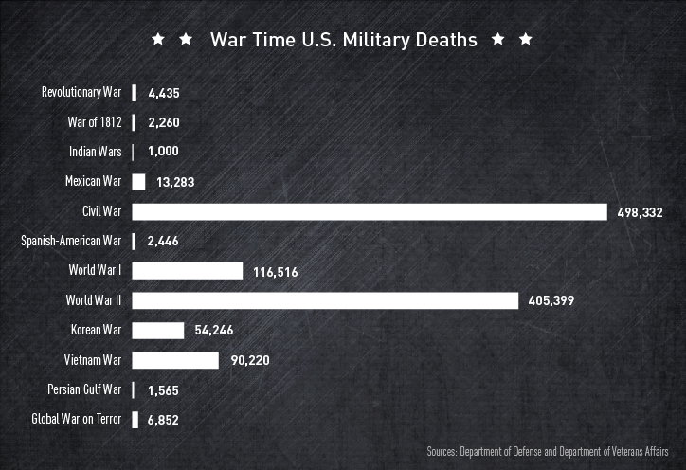
- War on Terror
HISTORY | What is the War on Terror?
This article provides a short timeline and introduction to what we now call the “War on Terror” which began in 2001 after the September 11th attacks and lasts until today.

The Washington Post | The Mall Needs a Memorial for the War on Terrorism
This Op-Ed calls for a memorial recognizing the men and women who have served the U.S. in America’s longest war.
(Related: Maya Lin’s Vietnam Memorial and Ann Hamilton’s Cortlandt Street Installation)

Imperial War Museum | Age of Terror: Art Since 9/11
Encompassing a global response, this UK exhibition includes over 40 international artists whose artwork reacts to war and conflict since 9/11.
(Related: Jenny Holzer and Ai Weiwei are included in this exhibition)

TATE | The Legacy of the War on Terror
A short examination on how artists have responded to the Age of War on Terror and the legacy it’s left on the art world.

Questions:
- The Constitution designates the power to declare war to Congress. The last time Congress passed joint resolutions for a “state of war” was in 1942 during World War II. If this the case, why has the U.S. been in four wars since then—including America’s longest war, The War on Terror, which has lasted eighteen years. What does this mean for the process of democracy and constitutional power?

- War on AIDS
NYT: The Daily | This Drug Could End HIV Why Hasn’t It?
This New York Times podcast interviews Dr. Robert Grant who developed a treatment known as PrEP—which could stop the AIDS crisis—and why it is still largely unavailable. This podcast sheds light on the socio-political that prevent this drug from becoming widely available and the power of large pharmaceutical companies.
NYT: The Daily | A Path to Curing HIV
This New York Times podcast examines the second case of someone being cured of H.I.V and the larger implications for the global epidemic.
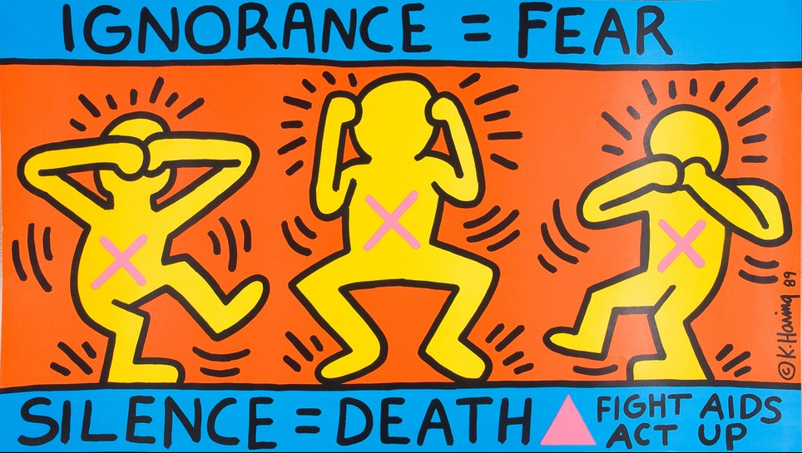

The New Yorker | Posters form the War on AIDS
This short article reviews several posters from the War on AIDS in the 1980s. Many of them were created by the Massachusetts Department of Public Health and translated into a range of languages and dialects.
(Related: Jenny Holzer’s LIGHT THE FIGHT project for World AIDS Day 2018)

Comparable Artists & Artworks
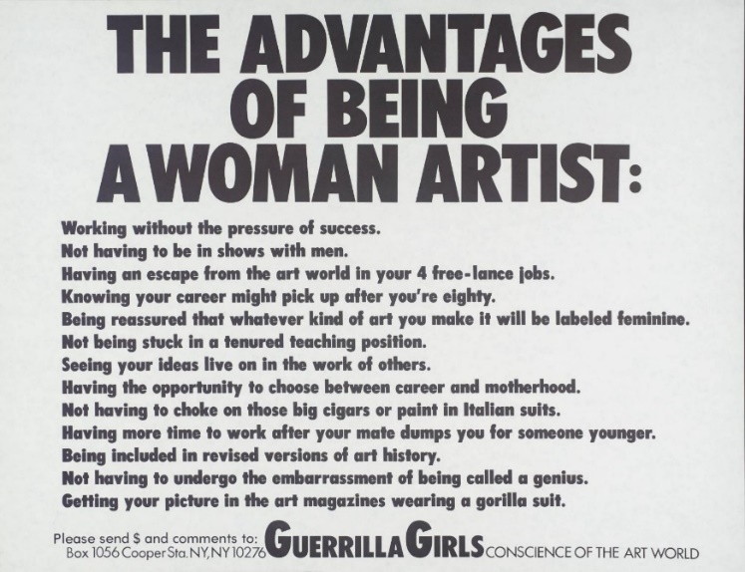
Guerilla Girls
American, active since 1985
The Advantages of Being a Woman Artist (1988)
Reinventing the ‘F’ Word: Feminism
The Guerrilla Girls are feminist activist artists. We wear gorilla masks in public and use facts, humor and outrageous visuals to expose gender and ethnic bias as well as corruption in politics, art, film, and pop culture. Our anonymity keeps the focus on the issues, and away from who we might be: we could be anyone and we are everywhere. We believe in an intersectional feminism that fights discrimination and supports human rights for all people and all genders. We undermine the idea of a mainstream narrative by revealing the understory, the subtext, the overlooked, and the downright unfair. We have done hundreds of projects (posters, actions, books, videos, stickers) all over the world. We also do interventions and exhibitions at museums, blasting them on their own walls for their bad behavior and discriminatory practices, including our 2015 stealth projection on the façade of the Whitney Museum about income inequality and the super rich hijacking art.
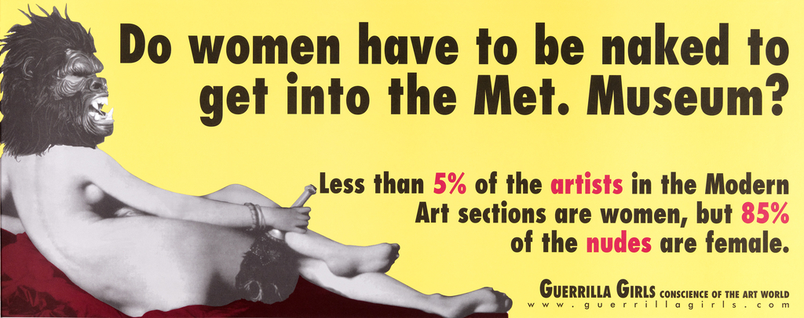
Resources on the Guerilla Girls
TATE | You Have to Question What You See
PBS Public Media | The Art of Complaining
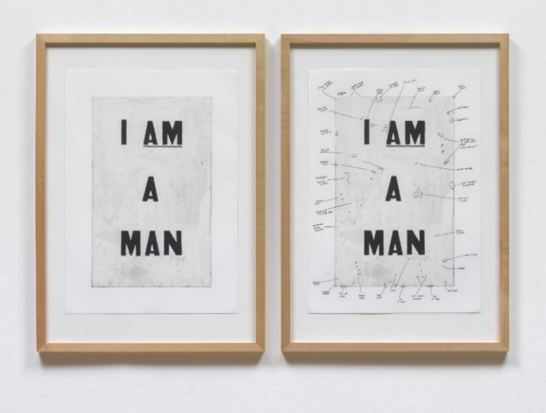
Glen Ligon
American, born 1960
Untitled (I AM A MAN), 1988
Ligon is best known for intertextual works that re-present American history and literature, in particular narratives of slavery and civil rights, for contemporary audiences. His work engages a powerful mix of racial and gender-oriented struggles for the self, leading viewers to reconsider problems inherent in representation. Untitled (I Am a Man) is just such a representation—a signifier—of the actual signs carried by 1,300 striking African American sanitation workers in Memphis, made famous in Ernest Withers' 1968 photographs. Prompted by the wrongful deaths of two coworkers from faulty equipment, the strikers marched to protest low wages and unsafe working conditions. They took up the slogan "I Am a Man" as a variant on the first line of Ralph Ellison's prologue to Invisible Man, "I am an invisible man." By deleting the word "invisible," the Memphis strikers asserted their presence, making themselves visible in standing up for their rights. Martin Luther King Jr. traveled to Memphis to address the striking workers; the next day, he was assassinated.
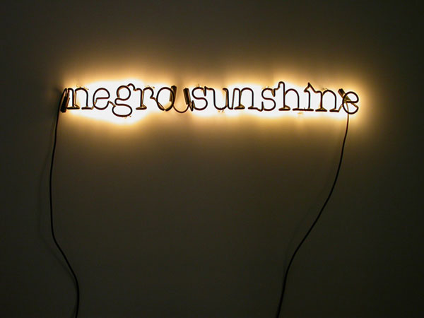
This painting (above) is Ligon's most important and iconic work. As the first object in which he used a selected text, Untitled (I Am a Man) is his breakthrough. He took pains to differentiate the painting from the original signs, avoiding a one-to-one relationship by reorganizing the line breaks. And while he preserved the original black-on-white of the sign, his choice to paint the black letters in eye-catching enamel calls attention to a black figure ("Man") as a text that replaces the human form in figurative painting. Throughout his career, Ligon has used "blackness" as a trope for both personal and collective experience. As Ligon has said (paraphrasing Muhammed Ali), "It's not about me. It's about we." The deliberately rough surface of the painting, which Ligon later documented by having a condition report made as an ancillary work of art, seems to index the scars and struggles of the work's great subject.
Resources on Glenn Ligon
Art 21 | Glenn Ligon in “History”
National Gallery of Art | A Conversation with Glenn Ligon
VIMEO | Heni Talk with Glenn Ligon
San Francisco MOMA | The Idea of a Black Man

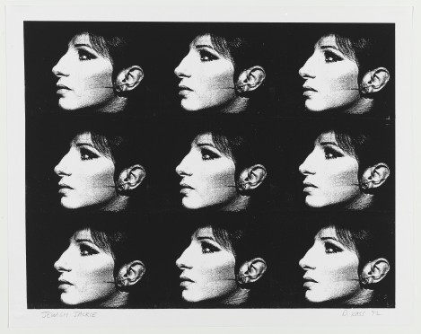
Deborah Kass
American, born 1952
Jewish Jackie (1992)
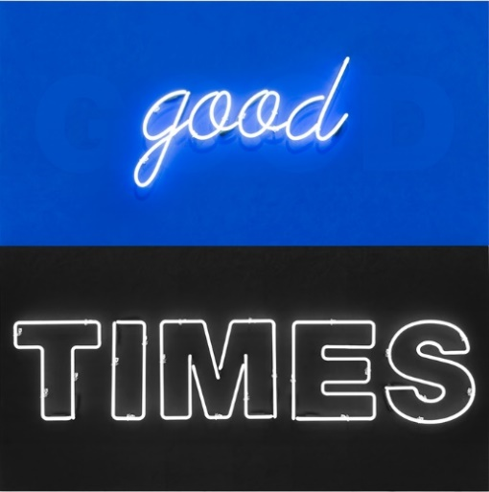
“In 1992, Kass embarked on The Warhol Project, a multiyear series responding to the celebrity portraits of Pop artist Andy Warhol. In Jewish Jackie, Kass takes Warhol’s paintings that repeat an image of former First Lady Jacqueline Kennedy Onassis in profile and replaces her with actress and singer Barbra Streisand. While growing up as a Jewish American girl, Kass noticed that people on television and in movies looked different than she did. Streisand, also Jewish, was someone with who she could identify: “I had never seen a movie start that looked like Barbra, which is to say that looked like me and everyone I knew,” she says. Kass’s work could be considered both an homage to Andy Warhol and a critique of exclusionary depictions of glamour and beauty in mainstream media. For Kass, appropriating Warhol’s work allowed her to insert aspects of her identity into the history of art: “In my work I replace Andy’s male homosexual desire with my own specificity: Jew love, female voice, and blatant lesbian diva worship.”
“In 2002, Kass began a new body of work, feel good paintings for feel bad times, inspired, in part, by her reaction to the Bush administration. In 2007 and in 2010, she presented the work at Paul Kasmin Gallery in two solo shows to great critical acclaim. These works combine stylistic devices from a wide variety of post-war painting[.] The paintings view American art and culture of the last century through the lens of that time period’s outpouring of creativity that was the result post-war optimism, a burgeoning middle class, and democratic values. Responding to uncertain political and ecological climate of the new century in which they have been made, Kass’s work looks back on the 20th century critically and simultaneously with great nostalgia, throwing the present into high relief.”
Resources of Deborah Kass
WhiteHot Magazine | Interview with Deborah Kass
ArtNet | Artist Interview with Deborah Kass

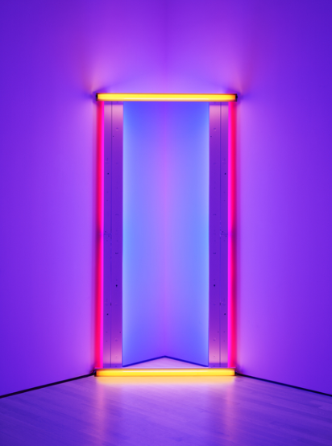
Dan Flavin
American, 1933-1996
Untitled (to Barnett Newman) two (1971)
Utilizing fluorescent light tubing available on the commercial market, Dan Flavin created light installations (or ‘situations’ as he preferred to call them) that became icons of Minimalism. Flavin’s wall-and floor-mounted, site-specific fixtures, composed of intersecting and parallel lines of light in conventional colors, flood spaces with their glow. A number of the sculptures feature tubes traversing corners or doorways, or at a right angle to the wall, further engaging the architecture of a room. As Flavin’s installations grew more complex, so too did the spaces built expressly for the purpose of exhibiting them. Though the emitted light transcends its physical encasement and transforms the surrounding space, Flavin avoided characterizing his work as sublime and instead considered his light installation “situations” or proposals. “One might not think of light as a matter of fact, but I do,” [Flavin] stated. “And it is...as plain and open and direct an art as you will ever find.” Interestingly enough, most of Flavin’s works are untitled and then followed by a dedication in parenthesis often to friends, artists, critics and others.
Resources on Dan Flavin
MoMA | Artist: Dan Flavin
LACMA | Director Discusses Flavin’s Installations

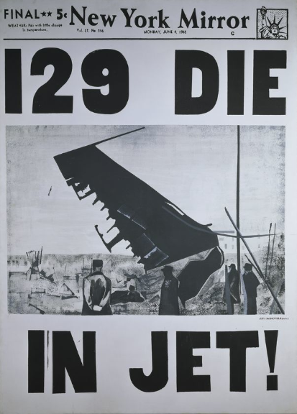
Andy Warhol
American, 1928-1987
129 Die in Jet!
Obsessed with celebrities, consumer culture, and mechanical (re)production, Pop artist Andy Warhol created some of the most iconic images of the 20th century. Known to say, “art is what you can get away with”, Warhol drew widely from popular culture and everyday subject matter, creating works like his 32 Campbell’s Soup Cans, Brillo pad box sculptures, and portraits of Marilyn Monroe, using the medium of silk-screen printmaking to achieve his characteristic hard edges and flat areas of color.
Warhol’s silk-screened images also utilized bold texts to convey a vivid and easy to read statement for the viewer. While many of these prints referenced consumer products or celebrity names, some of them drew attention to contemporary events (in a similar manner to Jenny Holzer). One such work is 129 Die in Jet! (1962)—a painting modeled after the frontpage of a local newspaper. “Warhol created this 129 Die in Jet! after the Air France Flight 007 accident in which 129 people aboard were killed with only two survivors. The Atlanta Art Association had sponsored a month-long tour of the art treasures of Europe, and 106 of the passengers were art patrons heading home to Atlanta on this charter flight. The tour group included many of Atlanta’s cultural and civic leaders. The work is a memorial to those who died.”
Resources on Andy Warhol
PBS Art Assignment | The Case for Andy Warhol
Khan Academy | Why is this Art? Andy Warhol

Relevant Literature: Young Adult
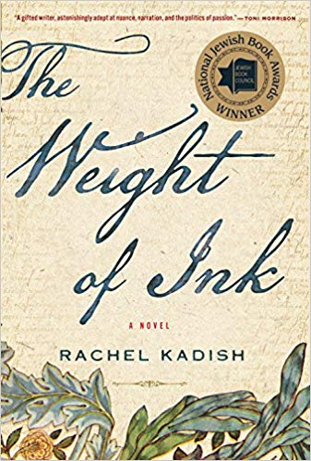
The Weight of Ink (2018) by Rachel Kadish
Electrifying and ambitious, The Weight of Ink is about women separated by centuries—and the choices and sacrifices they must make in order to reconcile the life of the heart and mind. Set in London of the 1660s and of the early twenty-first century, The Weight of Ink is the interwoven tale of two women of remarkable intellect: Ester Velasquez, an emigrant from Amsterdam who is permitted to scribe for a blind rabbi, just before the plague hits the city; and Helen Watt, an ailing historian with a love of Jewish history.
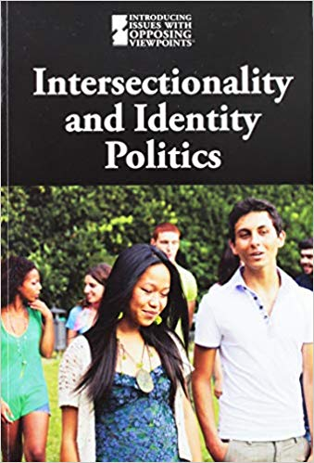
Intersectionality and Identity Politics (2019) by M.M. Boch
In America's melting pot, as the spectrum of power broadens to include different religions, races, genders, and sexual orientations, a complicated reality emerges: Americans don't always fit into one simple category. It is generally agreed that embracing all parts of our complex identities is a positive development, and politicians have taken notice. But who benefits from identity politics? Do they unwittingly divide us? Are they causing unneeded stress in the country? The perspectives in this volume explore intersectionality and identity politics as an emerging force in our culture.
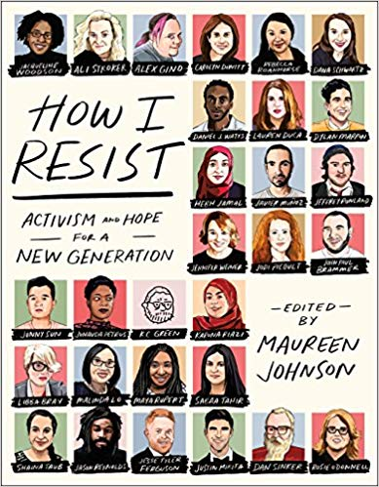
How I Resist: Activism and Hope for a New Generation (2018) edited by Maureen Johnson
Now, more than ever, young people are motivated to make a difference in a world they're bound to inherit. They're ready to stand up and be heard - but with much to shout about, where they do they begin? What can I do? How can I help? How I Resist is the response, and a way to start the conversation. To show readers that they are not helpless, and that anyone can be the change. A collection of essays, songs, illustrations, and interviews about activism and hope.
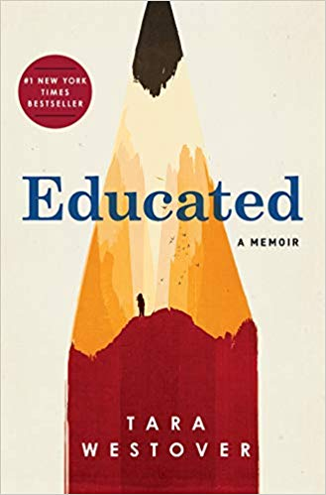
Educated: A Memoir (2018) by Tara Westover
Named one of the New York Times Best Books of the Year, Educated: A Memoir tells the story of a young girl who, kept out of school, leaves her survivalist family and goes on to earn a PhD from Cambridge University.

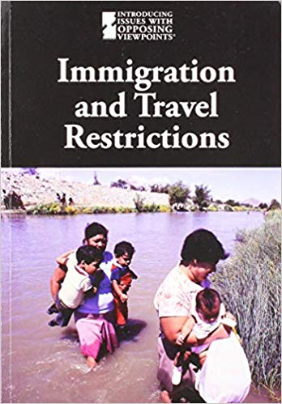
Immigration and Travel Restrictions (2019) by M.M. Boch
Restrictions on immigration and visitation have been in place for decades in the name of security and public health, but recently they have become a point of contention, particularly in the United States and many European nations. As terrorist attacks have proliferated around the world, security restrictions have tightened, resulting in an outcry that travel bans are discriminatory and racist. Is it better to be safe than sorry? Are travel bans such as Executive Order 13769 more about politics than security? A wide array of authoritative voices offers their perspectives on this timely and far-reaching debate.

Relevant Literature: Background & Thematic
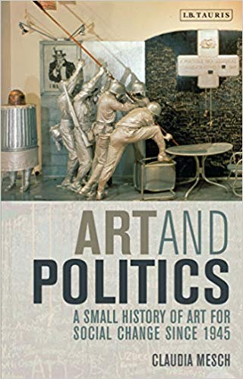
Art and Politics: A Small History of Art for social Change Since 1945 (2013) by Claudia Mesch
Contemporary art is increasingly concerned with swaying the opinions of its viewer. To do so, the art employs various strategies to convey a political message. This book provides readers with the tools to decode and appreciate political art, a crucial and understudied direction in post-war art. From the postwar works of Pablo Picasso and Alexander Deineka to thie Border Film Project and web-based works of Beatriz da Costa, Art and Politics: a Small History of Art for Social Change after 1945 considers how artists visual or otherwise have engaged with major political and grassroots movements, particularly after 1960. With its broad definition of the political, this book features chapters on postcolonialism, feminism, the anti-war movement, environmentalism, gay rights and anti-globalization. It charts how individual artworks reverberated with enormous ideological shifts.

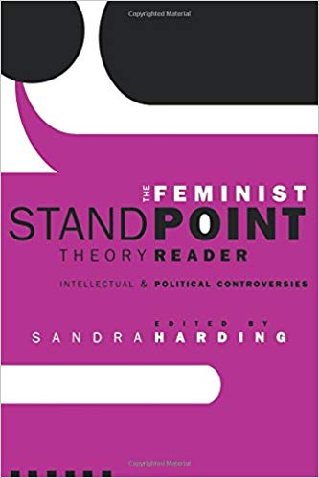
The Feminist Standpoint Theory Reader: Intellectual and Political Controversies (2003) by Sandra Harding
Leading feminist scholar and one of the founders of Standpoint Theory, Sandra Harding brings together the biggest names in the field to not only showcase the most influential essays on the topic but to also highlight subsequent interrogations and developments of these approaches from a wide variety of disciplines and intellectual and political positions.

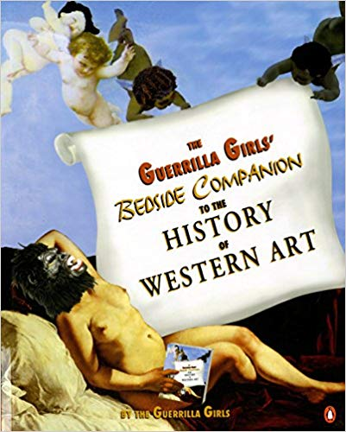
The Guerrilla Girls’ Bedside Companion to the History of Western Art (1998) by Guerrilla Girls
Thanks to the Guerrilla Girls, those masked feminists whose mission it is to break the white male stronghold over the art world, art history-as we know it-is history. Taking you back through the ages, the Guerrilla Girls demonstrate how males (particularly white males) have dominated the art scene, and discouraged, belittled, or obscured women's involvement. Their skeptical and hilarious interpretations of "popular" theory are augmented by the newest research and the expertise of prominent feminist art historians. "Believe-it-or-not" quotations from some of the "experts" are sprinkled throughout, as are the Guerrilla Girls' signature masterpieces: reproductions of famous art works, slightly "altered" for historic accuracy and vindication. This colorful reinterpretation of classic and modern art, as outrageous as it is visually arresting, is a much-needed corrective to traditional art history, and an unabashed celebration of female artists.
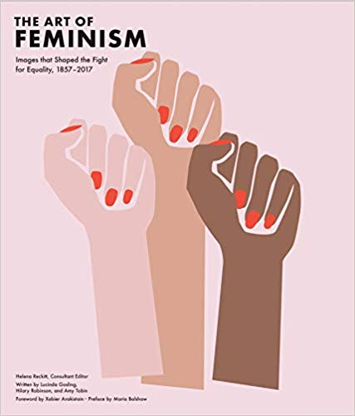
Art of Feminism: Images that Shaped the Fight for Equality 1857-2017 (2018) by Lucinda Gosling et al.
Once again, women are on the march. And since its inception in the 19th century, the women's movement has harnessed the power of images to transmit messages of social change and equality to the world. From highlighting the posters of the Suffrage Atelier, through the radical art of Judy Chicago and Carrie Mae Weems, to the cutting-edge work of Sethembile Msezane and Andrea Bowers, The Art of Feminism traces the way feminists have shaped visual arts and media throughout history. Featuring more than 350 works of art, illustration, photography, performance, and graphic design-along with essays examining the legacy of the radical canon-this rich volume showcases the vibrancy of the feminist aesthetic over the last 150 years.

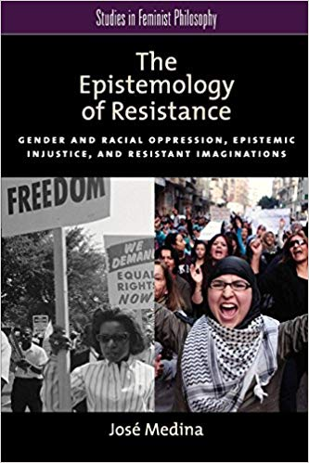
The Epistemology of Resistance: Gender and Racial Oppression, Epistemic Injustice, and Resistant Imaginations (2012)
by José Medina
This book explores the epistemic side of oppression, focusing on racial and sexual oppression and their interconnections. It elucidates how social insensitivities and imposed silences prevent members of different groups from interacting epistemically in fruitful ways--from listening to each other, learning from each other, and mutually enriching each other's perspectives. Medina's epistemology of resistance offers a contextualist theory of our complicity with epistemic injustices and a social connection model of shared responsibility for improving epistemic conditions of participation in social practices.
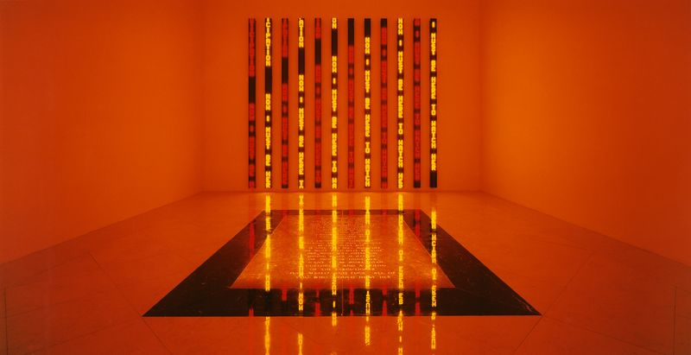
installation image of Jenny Holzer’s The Child Room

Relevant Literature: Poetry
The Happy Ones are Almost Always Also Vulgar
by Patrizia Cavalli
The happy ones are almost always also vulgar;
happiness has a way of thinking
that's rushed and has no time to look
but keeps on moving, compact and manic,
with contempt in passing for the dying:
Get on with your life, come on, buck up!
Those stilled by pain don't mix
with the cheerful, self-assured runners
but with those who walk at the same slow pace.
If one wheel locks and the other's turning
the turning one doesn't stop turning
but goes as far as it can, dragging the other
in a poor, skewed race until the cart
either comes to a halt or falls apart.
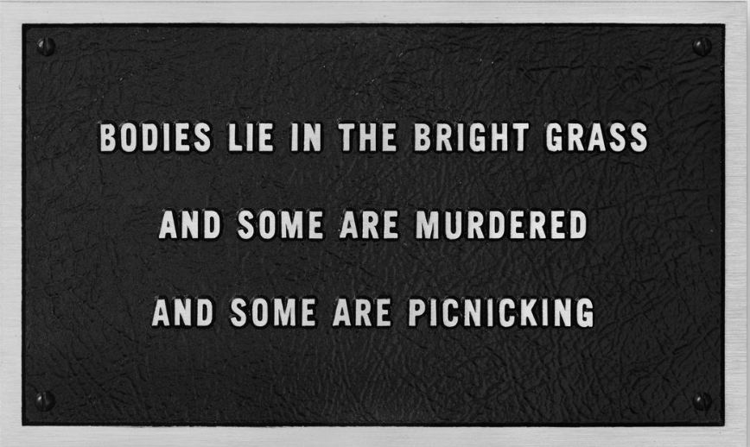
Aluminum cast plaque from Jenny Holzer’s Survival series
A Girl Named Jack
by Jacqueline Woodson
Good enough name for me, my father said
the day I was born.
Don’t see why
she can’t have it, too.
But the women said no.
My mother first.
Then each aunt, pulling my pink blanket back
patting the crop of thick curls
tugging at my new toes
touching my cheeks.
We won’t have a girl named Jack, my mother said.
And my father’s sitters whispered,
A boy named Jack was bad enough.
But only so my mother could hear.
Name a girl Jack, my father said,
and she can’t help but
grow up strong.
Raise her right, my father said,
and she’ll make that name her own.
Name a girl Jack
and people will look at her twice, my father said.
For no good reason but to ask
if her parents were crazy, my mother said.
And back and forth it went until I was Jackie
and my father left the hospital mad.
My mother said to my aunts,
Hand me that pen, wrote
Jacqueline where it asked for a name.
Jacqueline, just in case
someone thought to drop the ie.
Jacqueline, just in case
I grew up and wanted something a little bit longer
and further away from
Jack.
Feminist or a Womanist
by Staceyann Chin
Am I a feminist or a womanist? The student needs to know if I do men occasionally and primarily, am I a lesbian? Tongue tied up in my cheek, I attempt to respond with some honesty. Well, this business of Dykes and Dykery, I tell her, it's often messy. With social tensions as they are, you never quite know what you're getting.
Girls who are only straight at night, hardcore butches be sporting dresses between 9 & 6 every day. Sometimes she is a he, trapped by the limitations of our imaginations. Primarily, I tell her, I am concerned about young women who are raped on college campuses, in bars, after poetry readings like this one, in bars. Bruised lip and broken heart, you will forgive her if she does not come forward with the truth immediately, for when she does, it is she who will stand trial as damaged goods. Everyone will say she asked for it, dressed as she was, she must have wanted it. The words will knock about in her head: " Harlot, slut, tease, loose woman" - some people can not handle a woman on the loose. You know those women in pinstriped shirts and silk ties, You know those women in blood-red stiletto heels and short skirts. These women make New York City the most interesting place. And while we're on the subject of diversity, Asia is not one big race, and there's not one big country called 'The Islands', and no, I am not from there.
There are a hundred ways to slip between the cracks of our not so credible cultural assumptions about race and religion. Most people are surprised that my father is Chinese. Like there's some kind of preconditioned look for the half-Chinese, lesbian poet who used to be Catholic, but now believes in dreams.
Let's get real sister-boy in the double-x hooded sweatshirt. That blonde-haired, blue-eyed Jesus in the Vatican ain't right. That motherfucker was Jewish, not white. Christ was a middle-eastern rasta man who ate grapes in the company of prostitutes and he drank wine more than he drank water. Born of the spirit, the disciples loved him in the flesh.
But the discourse is not on those of us who identify as gay or lesbian or even straight. The state needs us to be either a clear left or right. Those in the middle get caught in the cross - fire away at the other side. If you are not for us, then you must be against us. If you are not for us, then you must be against us. People get scared enough, they pick a team. Be it for Buddha or Krishna or Christ, I believe God is that place between belief and what you name it. I believe holy is what you do when there is nothing between your actions and the truth.
The truth is I'm afraid to draw your black lines around me, I'm not always pale in the middle, I come in too many flavors for one fucking spoon. I am never one thing or the other. At night I am everything I fear, tears and sorrows, black windows and muffled screams. In the morning, I am all I ever want to be: rain and laughter, bare footprints and invisible seams, always without breath or definition. I claim every single dawn, for yesterday is simply what I was, and tomorrow even that will be gone.
(Live Reading by Poet)

Artist’s Official Website: Jenny Holzer.
Tate Biography.
Quoted from Artsy.
Quoted from Artsy.
Tate Biography.
Quoted in Phaidon.
Quoted in GAMeC.
Quoted in Guggenheim-Bilbao.
Quoted in Tate Modern.
Quoted from the Guerrilla Girls Official Website.
Quoted in National Gallery of Art.
Quoted from MoMA.
Quoted from Ro Gallery.
Quoted form Artsy.
Quoted from MoMA.
Quoted from Artsy.
Quoted from Wikipedia.

