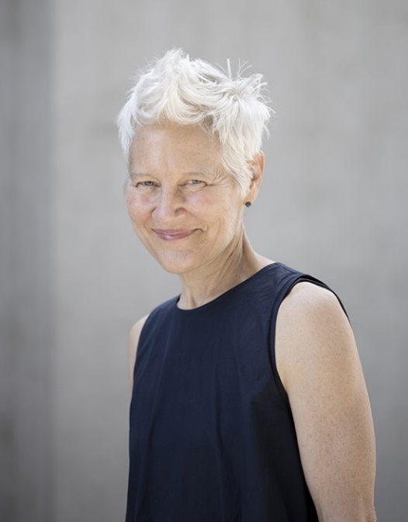
Ann Hamilton
American, born 1956
Ann Hamilton is a visual artist internationally acclaimed for her large-scale multimedia installations, public projects, and performance collaborations. Her site-responsive process works with common materials to invoke particular places, collective voices, and communities of labor. Noted for a dense accumulation of materials, her ephemeral environments create immersive experiences that poetically respond to the architectural presence and social history of their sites. Whether inhabiting a building four stories high or confined to the surface of a thimble, the genesis of Hamilton's art extends outwards from the primary projections of the hand and mouth. Her attention to the uttering of a sound or the shaping of a word with the hand places language and text at the tactile and metaphoric center of her installations. To enter their liminality is to be drawn equally into the sensory and linguistic capacities of comprehension that construct our faculties of memory, reason and imagination.
In a time when successive generations of technology amplify human presence at distances far greater than the reach of the hand, what becomes the place and form of making at the scale and pace of the individual body? How does making participate in the recuperation and recognition of embodied knowledge? What are the places and forms for live, tactile, visceral, face-to-face experiences in a media saturated world? These concerns have animated the site-responsive installations that have formed the bulk of Hamilton's practice over the last 20 years. But where the relations of cloth, sound, touch, motion and human gesture once gave way to dense materiality, Hamilton's work now focuses on the less material acts of reading, speaking and listening. The influence of collaborative processes in ever more complex architectures has shifted her forms of making, wherein the movement of the viewer in time and in space now becomes a central figure of the work.
Born in Lima, Ohio, in 1956, Ann Hamilton received a BFA in textile design from the University of Kansas in 1979 and an MFA in sculpture from the Yale School of Art in 1985. From 1985 to 1991, she taught on the faculty of the University of California at Santa Barbara. Hamilton has served on the faculty of The Ohio State University since 2001, where she is a Distinguished University Professor in the Department of Art.
Artistic Practice
Working primarily as a multimedia installation and public performance artist, Hamilton’s projects often blur the lines between one’s sensory and intellectual faculties. She challenges the connection between what is seen and what is invisible, stating, “what is the relationship between how our bodies know things and how we embody our knowledge through our actions and touch? What is the relationship between that and language?”
In her project entitled tropos (1993-4), Hamilton covered the Dia Center for the Arts gallery floor entirely in horsehair and employed an actor to sit at a table reading a book and burning its lines as she went. In doing so, the words were transformed into an intangible material (smoke), which was then absorbed by the horsehair.”
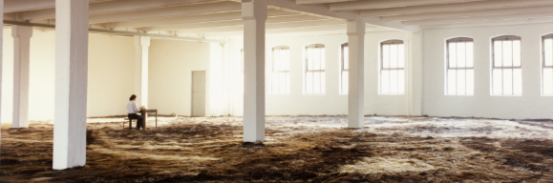
Detail of tropos (Dia Center for the Arts, New York 1993-4).
Selected Solo Exhibitions and Projects
2016 habitus, Fabric Workshop and Museum, Pier 9, Philadelphia, PA
2014 (the common S E N S E ∙ the animals) SITE Santa Fe, NM
2011 VERSE, William Oxley Thompson Memorial Library, The Ohio State Univ., Columbus, OH
1994 Projects 48: Ann Hamilton: seam, The Museum of Modern Art, New York, NY
1993 tropos, DIA Center for the Arts, New York, NY
Selected Awards and Honors
2015 National Medal of Arts Award, National Endowment for the Arts
2013 Best Project in a Public Space, International Association of Art Critics United States
2011 Anonymous Was a Woman Award
2009 Elected Member, American Academy of Arts & Sciences
2000 White House Conference on Culture and Diplomacy
1995 Wexner Center Residency Award
1989 Guggenheim Memorial Fellowship
Key Terms
- multimedia: the combination of multiple artistic mediums; including but not limited to drawing, painting, sculpture, photography, performance, music, film and video
- installation: an artistic genre of three-dimensional works that often are site-specific and designed to transform the perception of a space; a three-dimensional artwork meant to transform a viewer’s experience of an interior space, through a combination of mediums, interactivity, and immersive elements.
- site-specific: artwork that is created to exist in a particular place; typically, the artist takes the location into account while planning and creating the artwork.
The idea of site-specific work came to prominence in the 1960s when artist began to see the physical location and surroundings of an artwork as inseparable from its identity. This concept arose as a result of 1960s artists’ increasing interest in the physical contexts of their artmaking, specifically how different contexts could change (and more importantly, complicate) the experience of an artwork.
- site-responsive: artwork that broadly encompasses multiple aspects of a particular place—including nature, architecture, social environments, and dimensions of time; as with site-specific, this artwork is not limited to a single medium and often encourages multiple inter-disciplinary collaborations.
- ephemeral: describes something which lasts for a very short time or has a short life cycle
- immersive: describes something that seems to surround the participant physically and/or intellectually
- tactile: describing something that is or connected to the sense of touch; something which is designed to be perceived by touch
- sensory: relating to sensation or the physical senses
- linguistic: relating to language
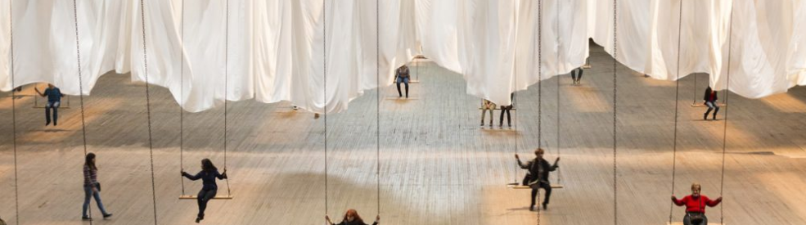
- materiality: relating to the compositional matter of an object; the foundational essence or physicality of a medium or object
Articles and Interviews
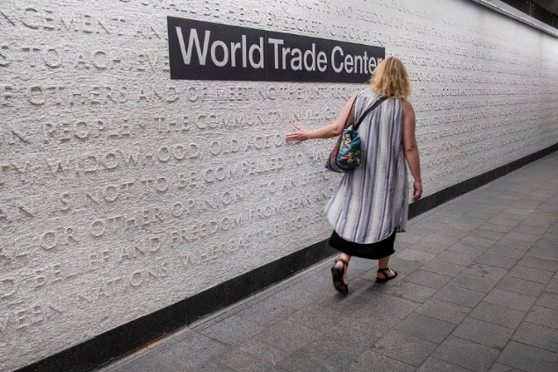
The New York Times | "At Cortlandt Street Subway Station, Art Woven From Words"
Ann Hamilton designed an installation for the Cortlandt Street Subway station in New York City, which reopened in 2018 after the station collapsed during the events of September 11th, 2001. Hamilton’s installation weaves words from texts of cultural significance to reflect the station’s status as a gateway to important sites such as the World Trade Center.
At intervals, certain words from the horizontal texts would align to form vertical spines. Those words—like ‘human’ and ‘justice’—would be common to passages from national documents like the Declaration of Independence, the Constitution and the Declaration of Sentiments, adopted in 1848 in Seneca Falls, N.Y., which held that ‘all men and women are created equal.”
The work bares resemblance to Hamilton’s 2011 floor piece titled ‘Verse’ and is located in the Thompson Library Buckeye Reading Room at Ohio State.
New York Times | Ann Hamilton at the Park Avenue Armory
Columbus Alive | “’Theatre is a Blank Page’ Brings Together Ann Hamilton and SITI Company for Theatre Experience Like No Other”
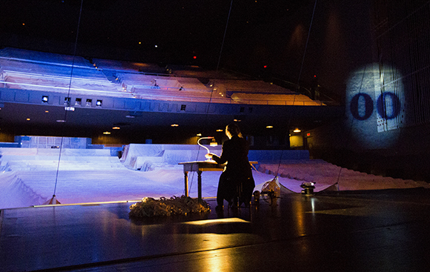
Collaboration is a key element of Ann Hamilton’s work. In 2015, the Wexner Center hosted a project called “theatre is a blank page”, a collaborative effort between SITI (Saratoga International Theatre Institute) Company and Ann Hamilton. The piece interacts with the space of Mershon Auditorium and the text of Virginia Woolf’s 1972 novel, To the Lighthouse. “’Theatre is a blank page’ will take the audience on an adventure that will expose unconventional aspects of the space…. Those attending ‘theatre is a blank page’ will experience something that combines and simultaneously deconstructs the Mershon space, theatrical elements of SITI Company and the visual artistry of Hamilton, all around the text of ‘To the Lighthouse.’”
Los Angeles Times | “It Ain’t Needlepoint: Ann Hamilton Does Old- Fashioned Women’s Work”
Fringe Arts | An Interview with Ann Hamilton
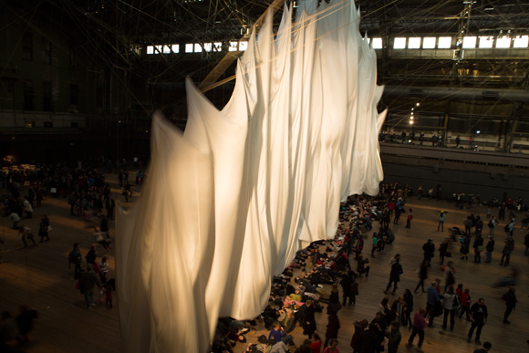
Mosaic: An Interdisciplinary Critical Journal | Theatre as Installation
In this article, Lunberry presents descriptions of varied involvements with installation by the artist Ann Hamilton, interspersed by analysis on how each of them was viewed, moved within, and then finally recalled, reconstructed. Lunberry writes, “Like pictures projected from a magic lantern, Hamilton’s scenes are set before us, fixed like photographs, as we enter the room. Indeed, photographically, the ambient light falls onto objects (and, likewise, onto us), framing and forming the sight to be seen, eyes dilating onto an image, the room dilating into dimension. For it appears almost as if the space itself, being seen, were suddenly seeing those walking within it, like a darkroom developing its own pictures, the pictures now picturing us.
Bomb Magazine | Audra Wolowiec Interviews Ann Hamilton
University of Texas | Highlight of the Artist Ann Hamilton
Blouin Art Info | "Swing State: Ann Hamilton Plans a Major New York Project From an Ohio Studio"
Though internationally-recognized, Ann Hamilton regards Ohio as her home base and is invested in the Columbus community. This article discusses how Hamilton’s career does not follow the traditional art-market pattern. “Although it may seem idyllic to some, Hamilton’s time in Ohio hasn’t been all sunshine and roses. ‘I think people have this fantasy that we have all the time in the world. We don’t, we’re super busy. It’s as busy here as anywhere.’
Five years ago, she stopped working with her longtime gallerist, Sean Kelly, and is now unrepresented, pooling income streams from a teaching job at Ohio State University, exhibition fees, grants, occasional sales, and lecture honoraria. About leaving the conventional market model, Hamilton explains, ‘It was really me just feeling like I didn’t fit. Maybe what’s good for the work and for me was not going to work in that system. In many ways there’s a part of stepping out hat is very humbling, because you really do step out. I had no complaints about my relationship with Kelly, except that I didn’t think it was where the work was going.’ Evidently, Hamilton intends to continue with her expansive installation-based projects rather than make smaller, more collectible works.”
Videos
Video interviews featuring the artist Ann Hamilton discussing several of her installation projects.
- Art 21 | Spotlight Interviews of several Hamilton Works
- National Museum of Women in the Arts | How Can Makers Change the World? Artist Talk
From the National Museum of Women in the Arts: In the third Fresh Talk of the 2016-2017 season, renowned visual artist and MacArthur Genius grant recipient Ann Hamilton, and designer, builder, and founder of the nonprofit design agency Project H Design, Emily Pilloton, came together for a conversation that asked: how can makers change the world? In this segment, Ann Hamilton presents on the poetic nature of her immersive and meditative installations.
- Enviroissues | Waterfront Seattle Artists: Ann Hamilton
- Orion Magazine | Interview on Human/Nature Exhibition
Hamilton was a part of the traveling contemporary art exhibition Human/Nature: Artists Respond to a Changing Planet—a five-year collaboration between the Museum of Contemporary Art San Diego, the Berkeley Art Museum/Pacific Film Archive, and the environmental organization Rare.
- Park Avenue Amory | Ann Hamilton Artist Talk
- San Francisco Museum of Modern Art | Ann Hamilton on Creating “Indigo Blue”
- Pew Center for Arts & Heritage | Ann Hamilton on the Social Connotations of Cloth
- Hirshhorn Museum & Sculpture Garden | Ann Hamilton on the Project “at Hand”
Ann Hamilton creates site-specific, multimedia installations that are simultaneously immersive and ephemeral. Combining the sounds of mechanization with the motorized release of sheets of translucent white paper, which gently descend from the ceiling, “at hand” (2001) speaks to the decline of manual labor in the wake of technological innovation. Though the paper accrues on the gallery floor in a sculptural “drift,” the effect of the installation remains one of loss and absence; the paper is blank, the movement is random, and the hand of the artist remains invisible.
- Light Work | Ann Hamilton on "Table"
- PBS WOSU Public Media | Ann Hamilton Receives the National Medal of Arts from Pres. Obama
- PBS WOSU Public Media | Ann Hamilton on Us is Them and The Theatre is Blank Page
- Univ. of Texas Liberal Arts | Ann Hamilton Discusses the Project "ONEEVERYONE"
- KQED Arts | Ann Hamilton on The Tower & Other Projects
- Ohio State University | Ann Hamilton Textile Installation in China
- Ohio State University | OSU Art Department Guest Speaker on her Recent Work

Publications
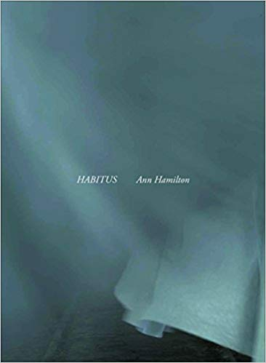
Ann Hamilton: habitus (2017)
Artist Ann Hamilton’s celebrated, multi-venue installation is brought to the page in this striking volume that explores another facet of her work in textile and text. "Held by cloth’s hand, we are swaddled at birth, covered in sleep, and wound in death," muses artist Ann Hamilton. Rather than documenting the experience of her enormous immersive 2016–17 installation in Philadelphia, Hamilton offers here a document—one that is as much a part of the project as its three dimensional counterparts. Lush photography, archival imagery, and lucid prose come together to help readers understand Hamilton’s ideas about the fabric of and in our lives. Like a thread through cloth, these individual images and words weave together strands of history, technology, poetry, and motion into one extraordinary and compelling experience.
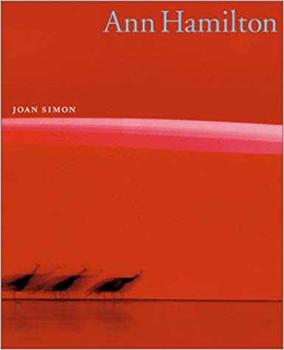
Ann Hamilton (2002) by Joan Simon
“A 118-foot-long wall seems to weep as droplets of water ooze from thousands of tiny holes… 750,000 pennies form a vast copper mosaic… Creating massive sensory environments that combine sound, text, video, photographs, books, and huge quantities of material substances, Ann Hamilton makes theatrical installations that have been praised as ‘evocative… powerfully disturbing… always compelling’ (Vogue). Now this internationally acclaimed artist—winner of a MacArthur Fellowship—and chosen to represent the U.S. at the 1999 Venice Biennale—at last receives the comprehensive study that her works merits. Author Joan Simon has had unprecedented access to Hamilton’s archives, and she has drawn heavily on the artist’s own words and photographs to prepare this incisive portrait, the only complete documentation of Hamilton’s art to date.

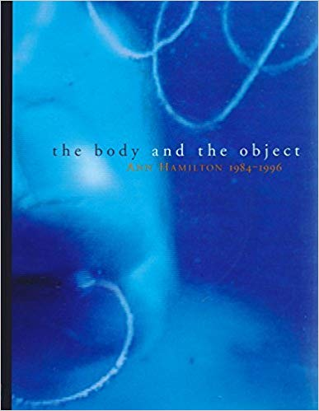
The Body and the Object: Ann Hamilton, 1984-1996 (1996)
by Ann Hamilton, Sherri Geldin, and Sarah Rogers
The exhibition catalog for a retrospective of Ann Hamilton’s art, held at the Wexner Center for the Arts at Ohio State University in 1996.

Related Recent Exhibitions
- Side-by-Side | Centro Internacional das Artes José de Guimarães
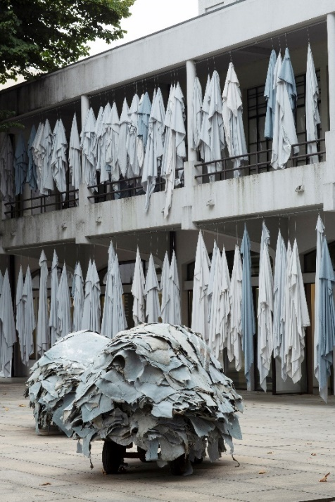
“Held by cloth’s hand, we are swaddled at birth, covered in sleep, and wound in death. A single thread spins a myth of origin and a tale of adventure, interweaves people and webs of communication…. Like weather, however changeable, cloth envelops experience…. This project began in these origins—in the tanneries whose basins were built along the river, in the stone weights whose holes bear evidence of human hands and tools, in the blade made for separating into parts and in the needle threaded for joining and suturing relation. Side-by-Side is the side by side of humans and animals, is objects and their images, is memory etched into stone, space and song, is the view from the library archive and their images, is memory etched into stone, space and song, is the view from the library archive to the cloister garden is the reflection of the body in the museum’s reflective surface, is the silence and the stillness next to the sound and the chaos, is storage next to circulation, is the new market next to the old market, is time, is the distance we see but cannot cross, the voice touching at a distance is bodies side by side, is the hand holding and hand offering. Side-by-side is a body, a hand, a touch. From touch a tending, in tending a voice, a line drawn between our absorbing senses and resisting bones.”

- habitus | Municipal Pier 9 - Philadelphia, Pennsylvania
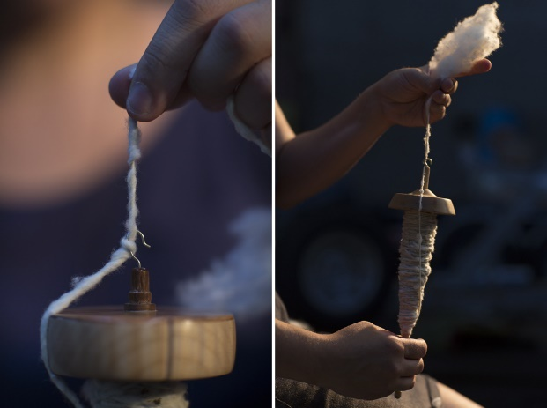
Commemorating the connection between laborers and textile artists throughout the world, Hamilton’s habitus meditates on the relationships between those who partake in the same craft. “Habitus is sitting and moving together, absorbed by words, sound, cloth each other. We cover ourselves. It is a commonness. This is our condition.”
Broader Thematic Overview & Discussion
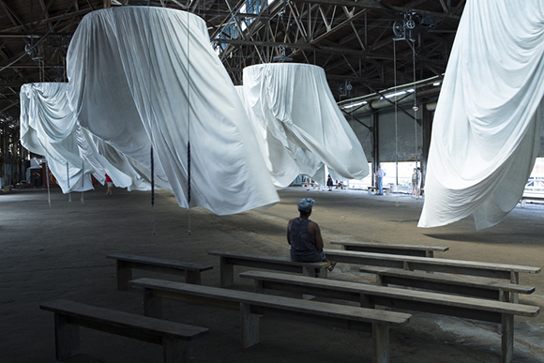
Installation Art
is an artistic genre of three-dimensional works that are often site-specific and designed to transform the perception of a space.

Photograph from Hamilton’s project habitus

The Art Story | Summary of Installation Art and Selected Works
A short introduction to the history of installation art and a select few notable artworks—such as Judy Chicago’s Dinner Party.
Wide Walls | 10 Famous Installation Artists
This article highlights the sensory experience several installation projects adhere to while also describing some of the most famous—sometimes notoriously so—installation works.
New York Public Radio | Richard Serra’s Tilted Arc
An in-depth summary of the site-specific piece Tilted Arc and controversy surrounding it. Alongside the article is an accompanying podcast discussion.
National Public Radio | Gone Girl: Lower Manhattan ‘Fearless Girl’ Statue is ‘On the Move’
This article gives an update about the Fearless Girl statue that faced the long-standing Charging Bull of Wall Street. Many have called for both its removal and for it to be reinstated. The Fearless Girl represents an intersectional debate of society on the stage of installation art.
Sotheby’s | The Best Installations from 2019s Venice Biennale—America to Ghana

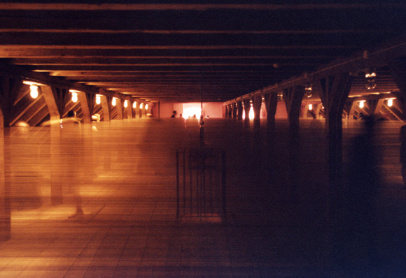
Multi-media Art
is a general label for artworks that combine multiple avenues of visula and performing arts. Sometimes referred to as mixed media blanketly, multi-media is generally used to define an artwork that uses or includes a combination of electoric media, performance, film and lighting. The term was first used in the 1960s to describe events such as those staged by Andy Warhol with the rock group the Velvet Underground, under the title of the Exploiding Plastic Inevitable.
Photograph from Hamilton’s project lignum

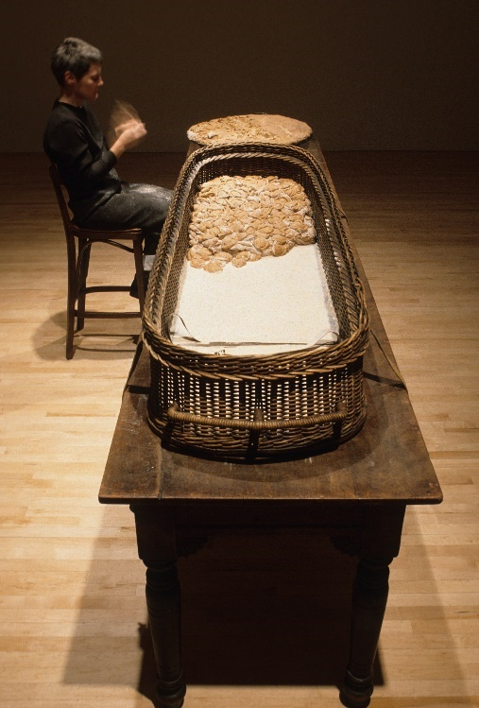
Performance Art
is a genre of art-making in which the artwork is the artist performing—usually live but often in a film or video. Performances started occurring in art contexts—galleries, artist’s studios, museums—in the 1960s, with the rise of Happenings and Fluxus. In the ‘60s and ‘70s, artists such as Vito Acconci, Bruce Nauman, Marina Abramovic, Chris Burden, and Yoko Ono explored the possibilities of performance particularly in works which focused on the body (and often the abuse of it). The rise of performance was directly linked to the rise of Conceptual Art and Process Art in the late 1960s.

Photograph from Hamilton’s project malediction
Khan Academy | What is Performance Art?
Britannica | Definition of Performance Art
The Art Story | Summary of Performance Art
Hyperallergic | WTF… is Performance Art?
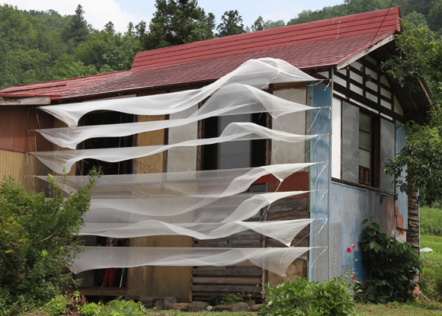
Conceptual Art
are artworks in which the idea, planning, and production process are more important than the result. The term gained currency in the 1960s as a result of Sol LeWitt’s 1967 article “Paragraphs on Conceptual Art” in Artforum. Conceptual art can take many forms, including, most frequently, descriptions and seemingly objective photographic documentation.
Photograph from Hamilton’s project air for everyone
“They [the viewers] don’t have to buy it [art] to have it—they can have it just by knowing it.”
– Lawrence Weiner

PBS Art Assignment | The Case for Conceptual Art
Getty | About Contemporary Art
TED Talks | Why You Don’t Get Contemporary Art
Sol LeWitt | “Paragraphs on Conceptual Art”

Discussion Themes & Prompts
Space in Art & Art in Spaces
“Examining space in art must always take into account the complex social and cultural standings of a given time. Space is not something that was always represented with the pure artistic ideas behind it. Sometimes, the needs coming from the outside of the artistic world influenced the way space was understood and depicted.”
- Art in Spaces of All Shapes
Wide Walls | Space in Art and All of Its Shapes
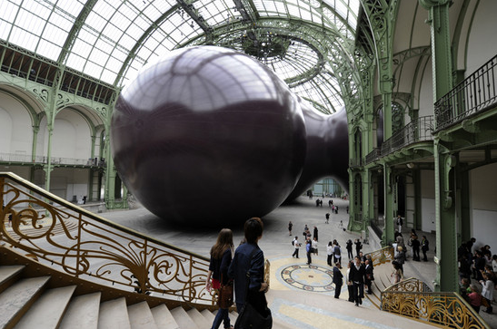
“As artistic styles developed and avant-garde movements took over the art world by storm, space started to dissolve and forms that filled artworks were defined along a much simpler differentiation between positive and negative space. Positive stands in this equation for the place occupied by form, while negative is what remains between and around the form’s shapes.”
Thought Co. | The Element of Space in Artistic Media
A short discussion on the seven elements of art—one of which is space—and how they are interpreted differently across the mediums.
Thought Co. | The Most Important Functions of Art
This short article addresses various ‘functions’ of art—including the physical, social, and personal impacts art has on its viewers. When it comes to installation and performance art the personal function of art can take on a plethora of forms.
Questions:
- What are the advantages to conforming an artwork to a space? a site-specific work?
- Do larger sized artworks necessarily convey a heavier/complex meaning? And vice versa, do smaller works make less of an impact?
- What are some of the advantages and disadvantages of an installation piece?

- Performance Art in Art Spaces
“The line between art and life should be kept as fluid, and perhaps indistinct, as possible.” – Alan Kaprow
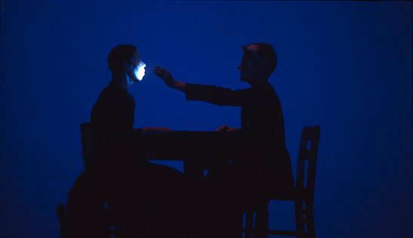
TATE | An Introduction to Performance Art
PBS Art Assignment | The Case for Performance Art
Khan Academy | What is Performance Art?
The Art Story | Summary of Performance Art
Thought Co. | Performance Art 1960s to Present
Questions
- What are the advantages and disadvantages to a performance piece?
- Is there such a thing as an original with a performance piece?
- What boundary, if any, is there between conceptual performance pieces and the performing arts?

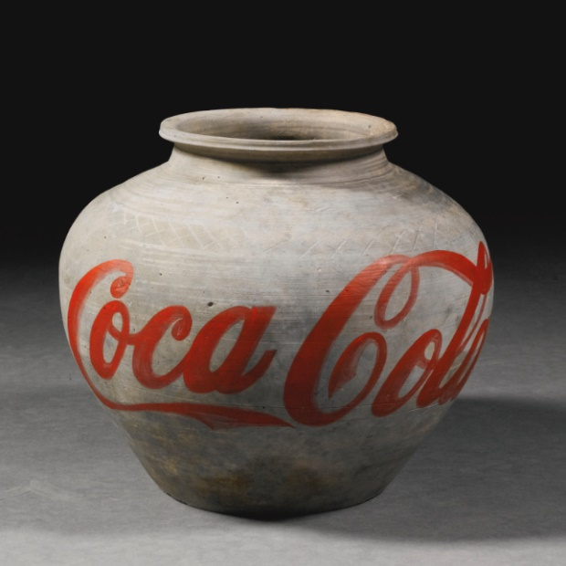
Comparable Artists & Artworks
Ai Weiwei
Chinese, born 1957
(left) Coca Cola Vase (2011),
(below) Dropping a Han Dynasty Urn, 1995
“A cultural figure of international renown, Ai Weiwei is an activist, architect, curator, filmmaker, and China’s most famous artist. Open in his criticism of the Chinese government, Ai was famously detained for months in 2011, then released to house arrest. Some of Ai’s best-known works are installations, often tending towards the conceptual and sparking dialogue between the contemporary world and traditional Chinese modes of thought and production.” This can be seen in his infamous Coca Cola Vase, in which Ai painted the commercial drink logo onto a Han Dynasty Urn. Recalling an earlier piece entitled Dropping an Han Dynasty Urn, Ai encourages discussion about iconoclastic treatment of art objects and the current capitalist market.”
Resources on Ai Weiwei
Bloomberg | Ai Weiwei Artist & Human Rights Champion
Art 21 | Ai Wei Wei Spotlight
MoMA | Ai Weiwei Extended Cut
Khan Academy | Ai Weiwei’s Sunflower Seeds
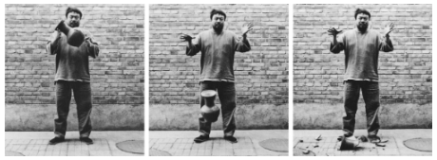
PBS | Ai Weiwei: The Fake Case
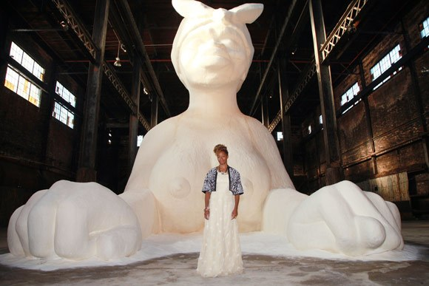
Kara Walker
American, born 1969
A Subtlety (Sugar Baby), 2014
“Kara Walker is known for creating black-and-white silhouette works that invoke themes of African American racial identity. Her subjects, often scenes of slavery, conflict or violence, are rendered in a style recalling traditional African illustration and folklore of the pre-Civil War United States; the works preserve and draw critical attention to these earlier cultural epochs. Working in collage, Walker cuts out and affixes black or white paper directly to gallery walls and utilizes light projectors to cast viewers’ own shadows into her silhouetted narratives, creating a deeply engaging experience. Despite the oftentimes sombre nature of her subjects, Walker relies on humor and viewer interaction. ‘I didn’t want a completely passive viewer,’ she has said. ‘I wanted to make work where the viewer wouldn’t walk away; he would either giggle nervously, get pulled into history, into fiction, into something totally demeaning and possibly very beautiful.’”
The 2014 installation piece known as A Subtlety is subtitled ‘an Homage to the unpaid and overworked Artisans who have refined our Sweet tastes from the cane fields to the Kitchens of the New World on the Occasion of the demolition of the Domino Sugar Refining Plant. The work draws attention to the unpaid slaves who labored in the Americas—particularly to those who worked on sugar plantations. Moreover, the work symbolically alludes to the issue of race, in that, un refined sugar is brown in tone until it is refined to a pure white.

Resources on Kara Walker
Art 21 | Kara Walker Extended Play
MoMA | Spotlight of Kara Walker
SFMoMA | Interviews with Kara Walker

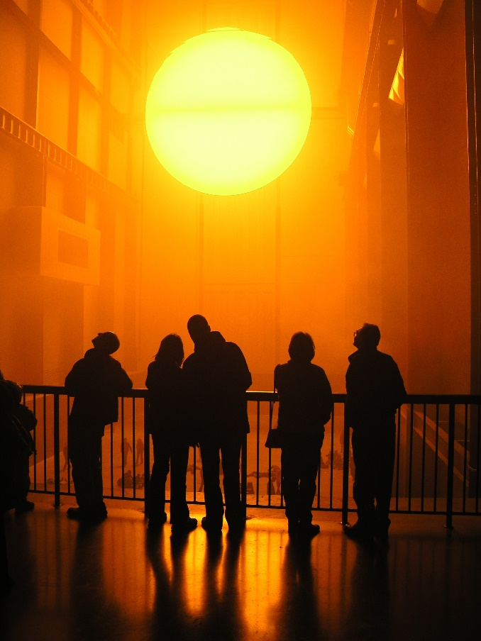
Olafur Eliasson
Danish, born 1967
The Weather Project, 2003
The Danish artist, Olafur Eliasson, uses natural elements (light, water, fog, etc.) and makeshift technical devices to transform museum galleries and public areas into immersive environments. Known for their elegant simplicity and lack of materiality, Eliasson’s installations are rooted in a belief that art can create a space sensitive to both the individual and collective.
Eliasson famously installed a giant artificial sun inside the Tate Modern known as The Weather Project. The installation, representing the sun and sky dominates the space of Turbine Hall. Throughout the day, the mist accumulates into faint, cloud-like formations, before dissipating across the space. A glance overhead, to see where the mist might escape, reveals that the ceiling of the Turbine Hall has disappeared, replaced by a reflection of the space below. At the far end of the hall is a giant semi-circular form made up of hundreds of mono-frequency lamps. The arc repeated in the mirror overhead produces a sphere of dazzling radiance linking the real space with the reflection. Visitors to the space often laid down underneath the installation to immersive themselves in the calming environment.

Resources on Eliasson
TATE | The Collective Experience
TATE | Tate Bio
Bloomberg | Highlights of Several Eliasson Works
Art Space | Ólafur Elíasson and Enviromentalist Art

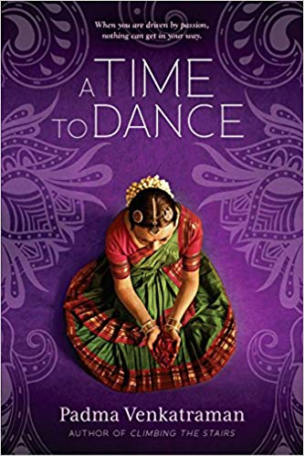
Relevant Literature: Young Adult
A Time to Dance (2015) by Padma Venkatraman
Padma Venkatraman’s inspiring story of a young girl’s struggle to regain her passion and find a new peace is told lyrically through verse that captures the beauty and mystery of India and the ancient bharatanatyam dance form. This is a stunning novel about spiritual awakening, the power of art, and above all, the courage and resilience of the human spirit.

Veda, a classical dance prodigy in India, lives and breathes dance—so when an accident leaves her a below-knee amputee, her dreams are shattered. For a girl who’s grown used to receiving applause for her dance prowess and flexibility, adjusting to a prosthetic leg is painful and humbling. But Veda refuses to let her disability rob her of her dreams, and she starts all over again, taking beginner classes with the youngest dancers. Then Veda meets Govinda, a young man who approaches dance as a spiritual pursuit. As their relationship deepens, Veda reconnects with the world around her, and begins to discover who she is and what dance truly means to her.

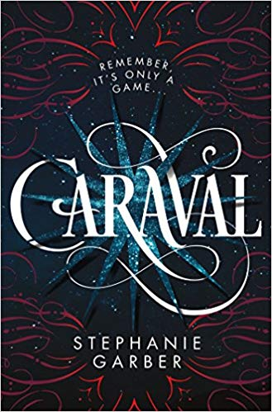
Caraval (2017) by Stephanie Garber
Scarlett has never left the tiny island where she and her beloved sister, Tella, live with their powerful, and cruel, father. Now Scarlett’s father has arranged a marriage for her, and Scarlett thinks her dreams of seeing Caraval, the far-away, once-a-year performance where the audience participates in the show, are over.
Scarlett has been told that everything that happens during Caraval is only an elaborate performance. But she nevertheless becomes enmeshed in a game of love, heartbreak, and magic with the other players in the game. And whether Caraval is real or not, she must find Tella before the five nights of the game are over, a dangerous domino effect of consequences is set off, and her sister disappears forever.
Relevant Literature: Background & Thematic

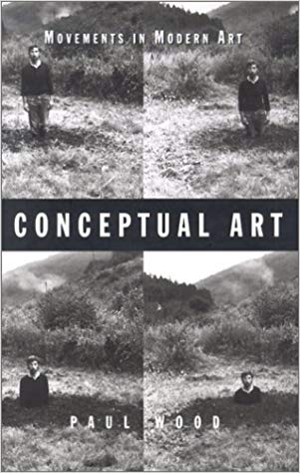
Conceptual Art: Movement in Modern Art (2002)
by Paul wood
As befits an art of the mind, 'Conceptual art' poses problems right from the start. What was it? When was it? (Is it still around or is it 'history'?) Where was it? Who made it? (Are we to consider 'X' a Conceptual artist or not?) And of course, the umbrella-question: why? Why produce a form of visual art premised on undercutting the two principal characteristics of art as it has come down to us in Western culture, namely the production of objects to look at, and the act of contemplative looking itself?...These are real questions ... Looked at in one way, Conceptual art gets to be like Lewis Carroll's Cheshire cat, dissolving away until nothing is left but a grin: a handful of works made over a few short years by a small number of artists, the most important of whom soon went on to do other things. Then again, regarded under a different aspect, Conceptual art can seem like nothing less than the hinge around which the past turned into the present: the modernist past of painting as the fine art, the canon from Cezanne to Rothko, versus the postmodernist present where contemporary exhibition spaces are full of anything and everything, from sharks to photographs, piles of rubbish to multi-screen videos -- full, it seems, of everything except modernist painting.
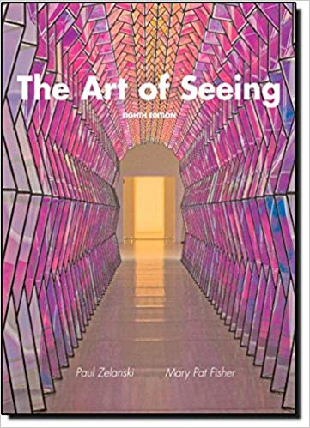
The Art of Seeing (2010) by Paul Zelanski & Mary Pat Fisher
The Art of Seeing explores traditional and contemporary art and artistic media focusing on art as seen from the artist's point of view. The book introduces students to artistic techniques and introductory aesthetic principles. It provides clear, concise presentation, superb illustrations, and strong emphasis on the elements and media.

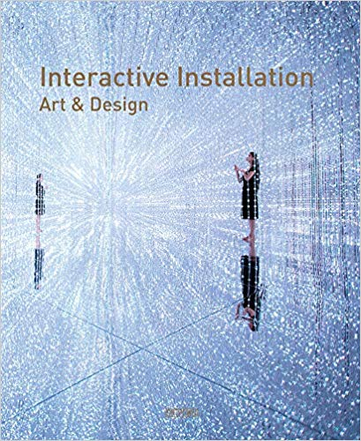
Interactive Installation: Art & Design (2019)
by Wang Chen
A comprehensive and interactive guide of installation art. Instead of accepting information passively, in an interactive installation the audience is encouraged to communicate directly with the art. This book is divided into three parts: immersive installation (environment), experimental installation (technology), and feedback installation (engagement). Featuring examples drawn from 3D-rendered images, photographs and video projects, this book will explain the relationship between art and technology and explores some of the ways these fields can be combined. It is a high-quality and practical guidebook, to accompany any interactive installation art exhibition.

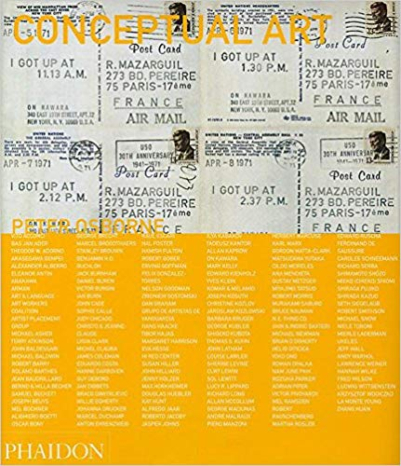
Conceptual Art: Themes & Movements (2011)
by Peter Osborne
Conceptual art is an art of ideas which can be written, enacted or carried in your head, challenging the notion that a work of art is an object of visual pleasure. This text combines survey essays, key words, descriptions and an anthology of key texts.

Relevant Literature: Poetry

Healing Humanity
by Natalie Patterson
Life is complex
You Should Know that upfront.
There will be tears and hurt and joy and pain
So much love and magic and heartbreak.
Did I mention Life is kinda weird
Its is the cacophony of people and things
Ideas and promises we meant to keep
Think of it like a symphony
We each are members of this perfect sound
But independent the song just ain’t the same
Like Drake without the corny dancing
Ok that’s a terrible example
But you know what I mean
We are a symphony
Having a part to play and should we give it our all
We get to bask in the goosebumps
Get to settle into the magic
And speaking of magic
This is the best part
But it is tricky tho
Because magic is this illusion right
This crazy blend of intoxicating allure and hard work
Sometimes you will feel like a prop
Feel like an unfinished trick
But should we execute masterfully
You get to understand the bigger picture
You get the stand center stage while the world claps
And that feels fantastic even if the whole world isn’t actually clapping, let me tell you
Picture yourself in the face of you next heartbreak
But equipped with the knowledge that it all works out
Would you still feel as devastated?
Looking back, I wish I would have known how good my life was going to get
How each hurt prepared me for the next best version of myself
I might have seen rejection as God’s protection and let that fool go with greater ease
Your perspective is your saving grace
Press you spirit against your faith
And promise yourself that something more is coming
This is how you heal.
Do not sulk
Do not give up
Do not invest your energy in people who do not value
Your duty is to place yourself in the best case scenario but not on some creepy capitalist
carbs in a barrel tip
But by proving that you are worthy of magnificence
ESPECIALLY when your faith is wavering
And I mean faith like
Only visualizing positive outcomes
Like praying to your god prayers of thanks even when nothing is working because you know
something will
Faith like not losing hope for recovery
Like staying the course
And when we all do this work
This hard to describe work of not letting our past define the outcome for our future
WE HEAL
And if we heal individually, so do we collectively
And on the other side of pain, we find love
We find joy in the laughter of children
We find balance because we did the work
And it ain’t easy my friend
Healing is not easy
But it can be the best thing you ever do
For yourself and humanity.

George the Poet Inspired by Paul Graham (Spoken Word Performance, 2013)
TATE | George the Poet Performance

Artist’s Official Website: Ann Hamilton Studio.
Quoted in an overview of Hamilton on Artsy. CV: Ann Hamilton Full CV Publications: Ann Hamilton Publications
Quote from Artsy.
Quoted in Ann Hamilton’s project description.
Quoted in Hamilton’s project description.
Quoted from Artsy.
Quoted from Wide Walls.
Quoted from Sotheby’s & Artsy.
Quoted from Artsy.

