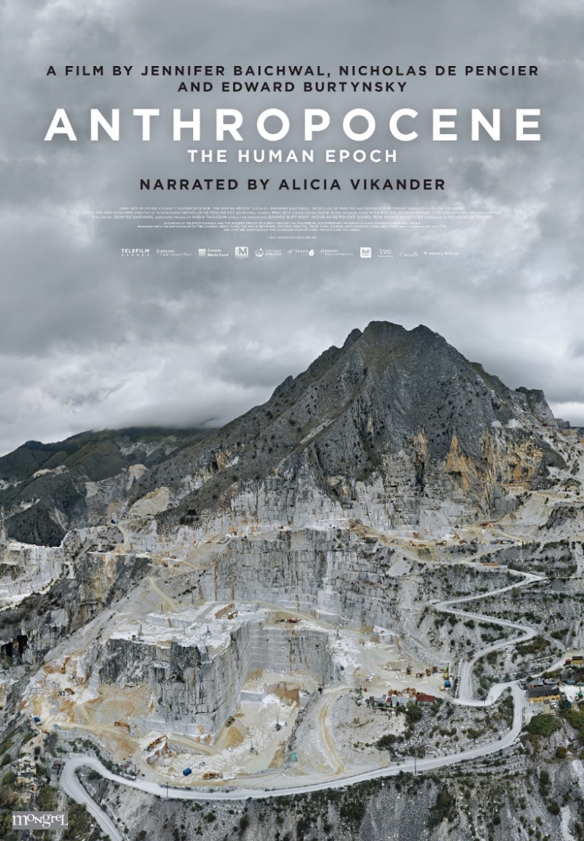
Anthropocene: The Human Epoch
“A cinematic meditation on humanity’s massive reengineering of the planet, ANTHROPOCENE: The Human Epoch is a four years in the making feature documentary film from the multiple-award winning team of Jennifer Baichwal, Nicholas de Pencier and Edward Burtynsky.
Third in a trilogy that includes Manufactured Landscapes (2006) and Watermark (2013), the film follows the research of an international body of scientists, the Anthropocene Working Group who, after nearly 10 years of research, are arguing that the Holocene Epoch gave way to the Anthropocene Epoch in the mid-twentieth century, because of profound and lasting human changes to the Earth.
From concrete seawalls in China that now cover 60% of the mainland coast, to the biggest terrestrial machines ever built in Germany, to psychedelic potash mines in Russia’s Ural Mountains, to metal festivals in the closed city of Norilsk, to the devastated Great Barrier Reef in Australia and surreal lithium evaporation ponds in the Atacama desert, the filmmakers have traversed the globe using high end production values and state of the art camera techniques to document evidence and experience of human planetary domination.
At the intersection of art and science, ANTHROPOCENE: The Human Epoch witnesses in an experiential and non-didactic sense a critical moment in geological history — bringing a provocative and unforgettable experience of our species’ breadth and impact.”
Film Overview
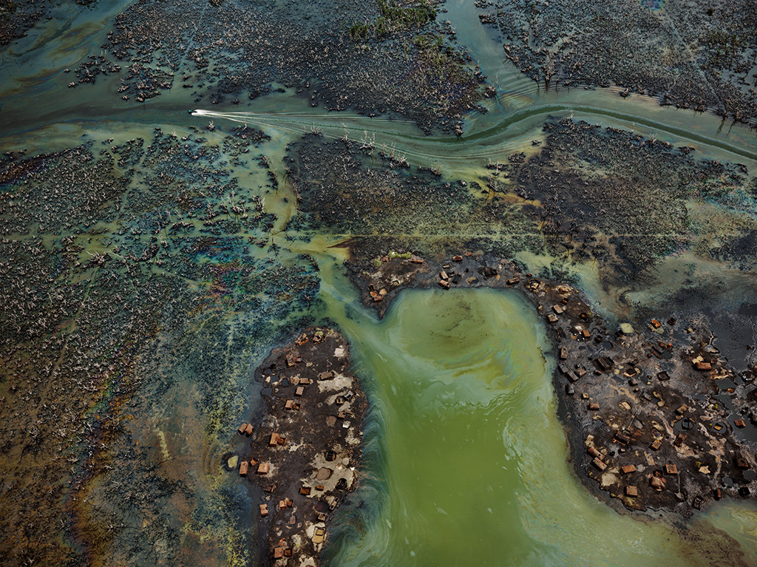
The title of Anthropocene refers to a term popularized by Nobel Prize laureate Paul Crutzen in 2000. It refers to a proposed geological epoch marked by human’s impact upon the planet. Smithsonian Magazine explains, “According to the International Union of Geological Sciences (IUGS), the professional organization in charge of defining Earth’s time scale, we are officially in the Holocene (‘entirely recent’) epoch, which began 11,700 years ago after the last major ice age. But that label is outdated, some experts say. They argue for ‘Anthropocene’—from anthropo, for ‘man,’ and cene, for ‘new’—because human-kind has caused mass extinctions of plant and animal species, polluted the oceans and altered the atmosphere, among other lasting impacts.” The Anthropocene Project, which includes the 2018 documentary film, is a multidisciplinary project which includes film, virtual reality, augmented reality, scientific research, and a museum exhibition.
Edward Burtynsky, Niger Delta (photo)
In Nigeria’s oil-rich Niger Delta, oil bunkering –the practice of siphoning oil from pipelines—has transformed part of the once-thriving delta ecosystem into an ecological dead zone, according to the U.N. Environment Program.
About the Filmmakers
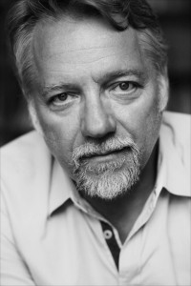
Edward Burtynsky (b. 1955) is known as one of the world's most respected photographers. His remarkable photographic depictions of global industrial landscapes are included in the collections of over sixty major museums around the world, including the National Gallery of Canada, the Museum of Modern Art, the Guggenheim Museum in New York, the Reina Sofia Museum in Madrid, and the Los Angeles County Museum of Art in California. His imagery explores the collective impact we as a species are having on the surface of the planet; an inspection of the human systems we’ve imposed onto natural landscapes.
In an effort to expose the human effect on the earth’s landscape, Burtynsky states in regard to his artwork: “Nature transformed through industry is a predominant theme in my work. I set course to intersect with a contemporary view of the great ages of man; from stone, to minerals, oil, transportation, silicon, and so on. To make these ideas visible I search for subjects that are rich in detail and scale yet open in their meaning. Recycling yards, mine tailings, quarries and refineries are all places that are outside of our normal experience, yet we partake of their output on a daily basis.
These images are meant as metaphors to the dilemma of our modern existence; they search for a dialogue between attraction and repulsion, seduction and fear. We are drawn by desire - a chance at good living, yet we are consciously or unconsciously aware that the world is suffering for our success. Our dependence on nature to provide the materials for our consumption and our concern for the health of our planet sets us into an uneasy contradiction. For me, these images function as reflecting pools of our times.”
Artist Website | Edward Burtynsky

Related Exhibitions | WATER and MELTDOWN

Meltdown, A Visualization of Climate Change
Cleveland Museum of Art & (Kunst Haus Wien Museum 2017)
Flowers Gallery
Financial Times
Lens Scratch
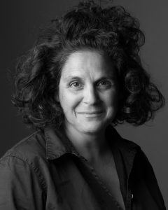
Jennifer Baichwal (b. 1965) has been directing and producing documentaries for over 20 years. Her films have played all over the world and won multiple awards nationally and internationally, including an International Emmy, 3 Gemini Awards, and Best Cultural and Best Independent Canadian Documentary at Hot Docs, for features such as Let It Come Down: The Life of Paul Bowles, The Holier It Gets, Act of God, and Payback. She has been a Director of the Board of the Toronto International Film Festival since 2016 and is a passionate ambassador of their Share Her Journey campaign, a five-year commitment to increasing participation, skills, and opportunities for women behind and in front of the camera.

Canadian native, Baichwal is married to fellow documentary director Nicholas de Pencier and has collaborated with Burtynsky on two other films prior to Anthropocene.

Artist Website | Mercy Films Inc.
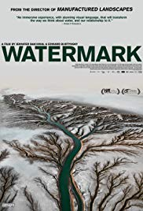
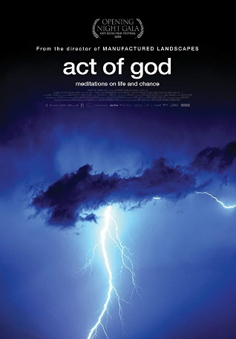
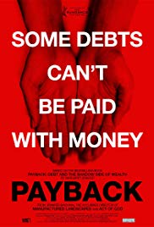
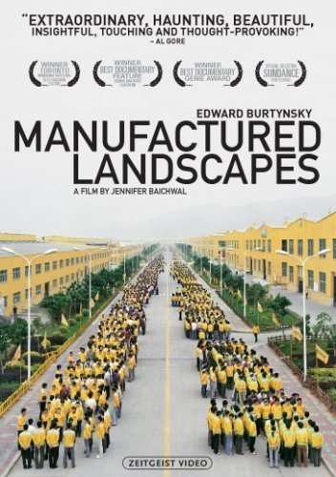

Mercy Films Inc. | Summary of Past Films

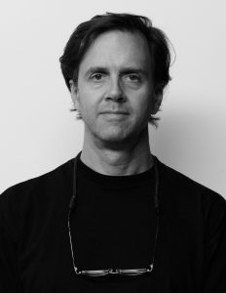
Nicholas De Pencier is a Director, Producer, and Director of Photography working in documentary and video installation. He is President of Mercury Films Inc., the Toronto-based production company he shares with his partner, Jennifer Baichwal.
As both producer and director of photography his credits include the feature documentary Let It Come Down: The Life of Paul Bowles which was nominated for a Genie, a Rockie, and won the International Emmy Award for Best Arts Documentary. The Holier It Gets, a documentary filmed in Canada and India, won Best Cultural and Best Independent Canadian Documentary at Hot Docs, 2000, and won Geminis for best writing, editing, and direction in a documentary series, as well as a nomination for The Donald Brittain award for best documentary and a Chalmers Award nomination.
Selected credits include Let It Come Down: The Life of Paul Bowles (International Emmy), The Holier It Gets, (Best Canadian Doc, Hot Docs), The True Meaning of Pictures (Gemini, Best Arts), Hockey Nomad (Gemini, Best Sports), Manufactured Landscapes, (TIFF Best Canadian Feature; Genie, Best Doc), and Act of God (Gala Opening Night, Hot Docs). He was the Producer and Director of Photography of Watermark, (Special Presentation, TIFF & Berlin, Toronto Film Critics Award, Best Canadian Film, CSA Best Documentary), and Black Code (TIFF 2016), which he also wrote and directed.
Artist Website | Mercy Films Inc.
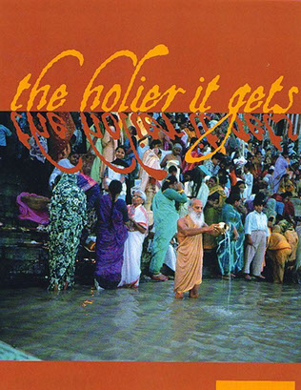
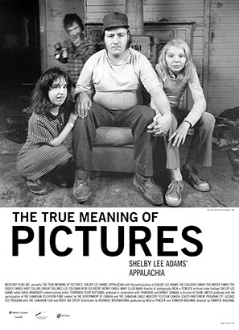

Key Terms
- Anthropocene: the proposed epoch dating from the beginning of significant human impact on Earth’s geology and ecosystems, including, but not limited to, anthropogenic climate change.
- climate change: changes in Earth’s climate system which result in new weather patterns that last for at least a few decades—physical evidence of climate change includes temperature records (low and high), the disappearance of ice, and extreme weather events (such as tornados, hurricanes, tropical storms, earthquakes, and wild fires).
- documentary: a nonfictional motion picture intended to document reality, primarily for the purposes of instruction, education, or maintaining a historical record.
- ecosystem: a community of living organisms along with nonliving components of their environment, interacting as system—these biotic and abiotic components are linked together through nutrient cycles and energy flows
- extinction: the termination of an organism or of a group of organisms, usually species; the moment of extinction is generally considered to be the death of the last individual of the species, although the capacity to breed and recover may have been lost before this point
- geology: an earth science concerned with the solid earth, the rocks which is composed, and the processes by which they change over time
- species: the largest group of organisms in which any two individuals of the appropriate sexes or mating types can produce fertile offspring, typically by sexual reproduction
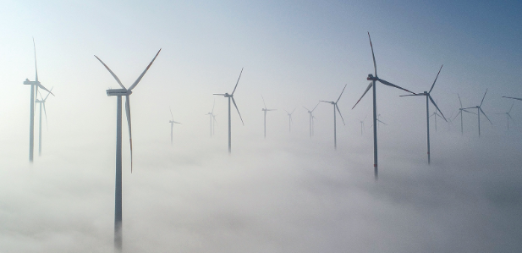

Articles
Anthropocene: The Human Epoch
Film Website | The Anthropocene Project
NPR | “Oh Dear: Photos Show What Humans Have Done to the Planet”
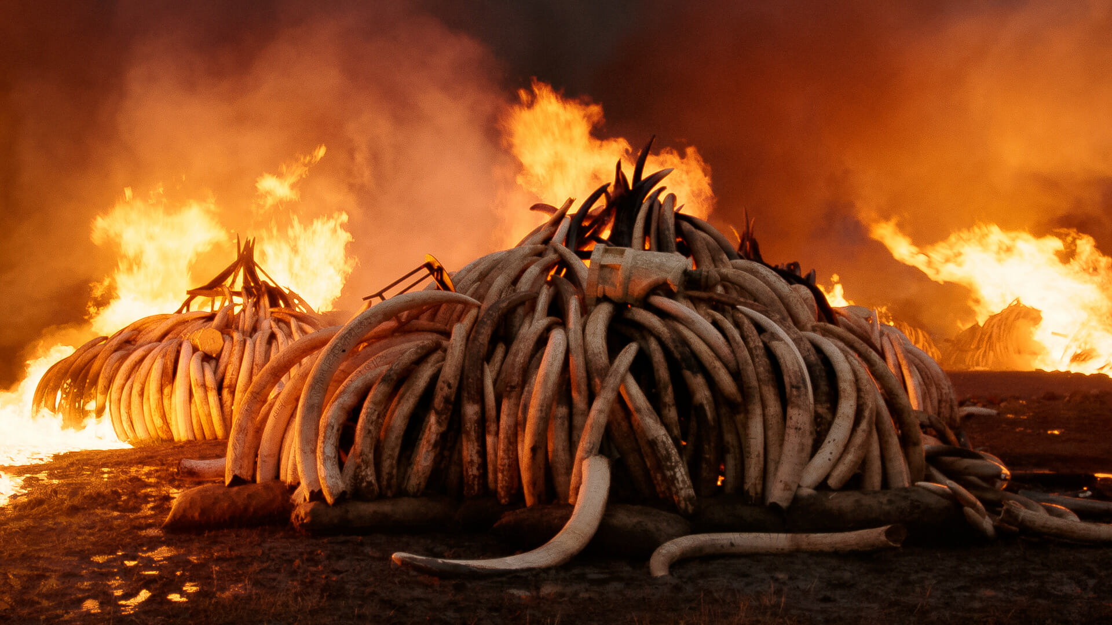
Sundance Institute | About the Film

Related Topics & Projects
The New Yorker | “The Long View”
An anecdotal account of one of Burtynsky’s projects and the steps needed to make his powerful images happen.
VICE News | collection of articles on climate change
Smithsonian Magazine | “The Age of Humans: Living in the Anthropocene”
The Smithsonian Magazine collects articles about the Anthropocene on their site—all of which can be accessed from the above link.
“While arriving only recently in Earth's timeline, humans are driving major changes to the planet's ecosystems. Even now, the basic requirements for human life—air, water, shelter, food, nature and culture—are being rapidly transformed by the billions of people on the planet. These changes have become so noticeable on a global scale that scientists believe we are living in a new chapter in Earth's story: the Anthropocene.”
Smithsonian | “What is the Anthropocene and Are We in It?”
Smithsonian | “Where in the World Is the Anthropocene?”
Smithsonian | “How Climate Change-Fueled ‘Mega Droughts’ Could Harm Human Health”
Under the worst-case scenario – the path we’re currently on – fine dust levels in the Southwest could increase by 30 percent by the end of this century compared to present-day values. This would result in a 130 percent increase in premature deaths and a 300 percent increase in hospital admissions attributable to fine dust exposure.

Even under the best-case climate mitigation scenario, we project that fine dust levels in the region could increase by 10 percent. This rise would increase premature deaths and hospital admissions due to fine dust exposure by 20 percent and 60 percent respectively, compared to present-day values.

Smithsonian | “One in Six Global Deaths Linked to Pollution”
"Pollution is much more than an environmental challenge—it is a profound and pervasive threat that affects many aspects of human health and wellbeing," Philip Landrigan, a global health researcher with the Mount Sinai School of Medicine, says in a statement. The new report emerged from a commission Landrigan co-led for the medical journal The Lancet.
The commission spent two years compiling data from past reports of the World Health Organization and other scientific research bodies about various types of pollution and their impact on exposed populations in 130 countries, reports Brady Dennis for the Washington Post. Overall, they found that some nine million deaths in 2015 were connected to pollution—a killer that far surpassed deaths from malaria, tuberculosis and HIV/AIDS combined.

NASA | “The Effects of Climate Change: NASA”
In the next several decades, storm surges and high tides could combine with sea level rise and land subsidence to further increase flooding in many regions. Sea level rise will continue past 2100 because the oceans take a very long time to respond to warmer conditions at the Earth’s surface. Ocean waters will therefore continue to warm and sea level will continue to rise for many centuries at rates equal to or higher than those of the current century.
National Geographic | “Effects of Global Warming: National Geographic”
Climate change encompasses not only rising average temperatures but also extreme weather events, shifting wildlife populations and habitats, rising seas, and a range of other impacts. All of these changes are emerging as humans continue to add heat-trapping greenhouse gases to the atmosphere.

Columbus Dispatch | “Scientists Warn of Climate Change’s Impact on Ohio”
Models suggest Ohio summers will be as hot as Arkansas’ by 2095 — an average high temperature of about 91 degrees from June to August — attracting new pests, species and diseases into the region. Climatologists predict that longer-than-usual dry spells will be punctuated by intense storms and flash flooding.

Related Films
Watermark (2013)
Every living thing requires water. We humans interact with it in a myriad of ways, numerous times a day. But how often do we consider the complexity of that interaction? And, unless confronted by scarcity, when do we meditate on its ubiquity in creating, sustaining and enriching life?
Watermark is a feature documentary film that brings together diverse stories from around the globe about our relationship with water: how we are drawn to it, what we learn from it, how we use it and the consequences of that use. We see massive floating abalone farms off China’s Fujian coast and the construction site of the biggest arch dam in the world – the Xiluodu, six times the size of the Hoover. We visit the barren desert delta where the mighty Colorado River no longer reaches the ocean, and the water-intensive leather tanneries of Dhaka.
We witness how humans are drawn to water, from the U.S. Open of Surfing in Huntington Beach to the Kumbh Mela in Allahabad, where thirty million people gather for a sacred bath in the Ganges at the same time. We speak with scientists who drill ice cores two kilometers deep into the Greenland Ice Sheet, and roam the sublime pristine watersheds of Northern British Columbia.
Shot in stunning 5K ultra high-definition video and full of soaring aerial perspectives, this film shows water as a terraforming element and the scale of its reach, as well as the magnitude of our need and use. This is balanced by forays into the particular: a haunting memory of a stolen river, a mysterious figure roaming ancient rice terraces, the crucial data hidden in a million year old piece of ice, a pilgrim’s private ritual among thousands of others at the water’s edge.
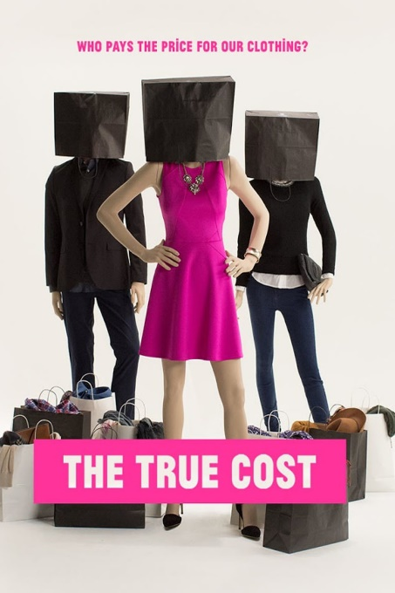
The True Cost (2015)
“This is a story about clothing. It’s about the clothes we wear, the people who make them, and the impact the industry is having on our world. The price of clothing has been decreasing for decades, while the human and environmental costs have grown dramatically. The True Cost is a groundbreaking documentary film that pulls back the curtain on the untold story and asks us to consider, who really pays the price for our clothing?
Filmed in countries all over the world, from the brightest runways to the darkest slums, and featuring interviews with the world’s leading influencers including Stella McCartney, Livia Firth and Vandana Shiva, The True Cost is an unprecedented project that invites us on an eye opening journey around the world and into the lives of the many people and places behind our clothes.”

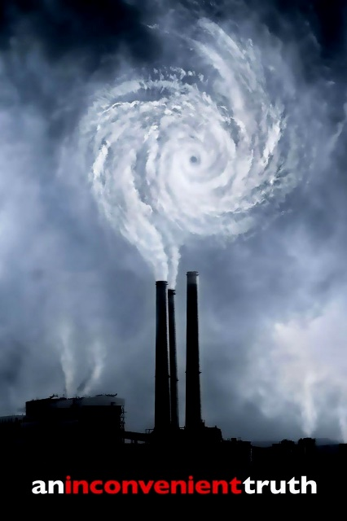
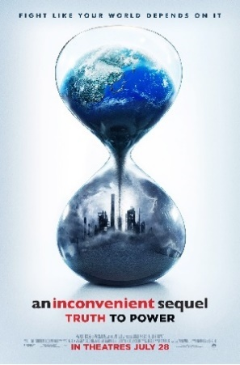
An Inconvenient Sequel: Truth to Power (2017)
“A sequel to “An Inconvenient Truth”, the follow-up documentary addresses the progress made to tackle the problem of climate change and Al Gore's global efforts to persuade governmental leaders to invest in renewable energy, culminating in the landmark signing of 2016's Paris Climate Agreement.”

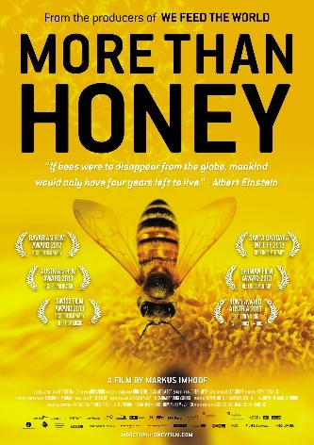
More Than Honey (2013)
In the US, the latest estimates suggest that a total of 1.5 million (out of 2.4 million total beehives) have disappeared across 27 states. In Germany, according to the national beekeepers association, one fourth of all colonies have been destroyed, with losses reaching up to 80% on some farms. The same phenomenon has been observed in Switzerland, France, Italy, Portugal, Greece, Austria, Poland and England, where this syndrome has been nicknamed ‘the Mary Celeste Phenomenon’, after a ship whose crew vanished in 1872.
Scientists have found a name for the phenomenon that matches its scale, ‘colony collapse disorder,’ and they have good reason to be worried: 80% of plant species require bees to be pollinated. Without bees, there is no pollenization, and fruits and vegetables could disappear from the face of the Earth. Apis mellifera (the honey bee), which appeared on Earth 60 million years before man and is as indispensable to the economy as it is to man’s survival.”
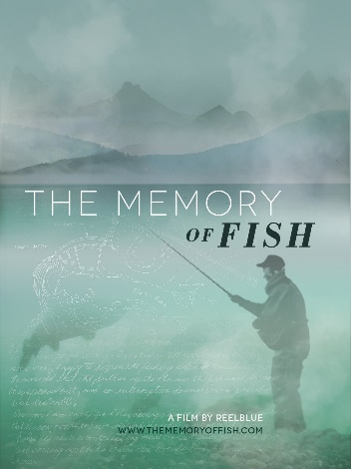
The Memory of Fish (2016)
“’The Memory of Fish’ is an award-winning documentary portrait of one man, the wild salmon he loves, and his fight to free a river.
Dick Goin and his family have been fed by the Elwha River's salmon since migrating to Washington's Olympic Peninsula during the Dust Bowl. Dick has never forgotten his debt to the fish — who have been steadily disappearing.
A pulp mill worker and master fisherman turned salmon advocate, Dick uses his memories and persistence to battle for the biggest dam removal project in U.S. history. His goal: bring the salmon home.”

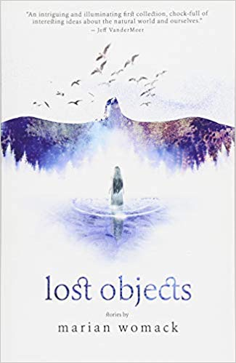
Relevant Literature: Young Adult
Lost Objects by Marian Womack
“An intriguing and illuminating first collection, chockfull of interesting ideas about the natural world and ourselves.” These stories explore place and landscape at different stages of decay, positioning them as fighting grounds for death and renewal. From dystopian Andalusia to Scotland or the Norfolk countryside, they bring together monstrous insects, ghostly lovers, soon-to-be extinct species, unexpected birds, and interstellar explorers, to form a coherent narrative about loss and absence.

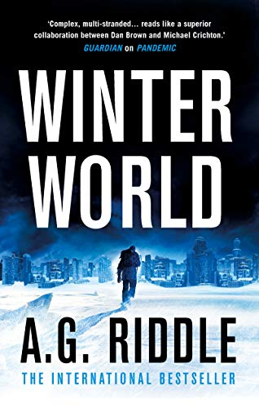
Winter World (2019) by A.G. Riddle
In space, NASA discovers a mysterious object drifting toward the sun. Is it responsible for the ice age? Or could it be our last chance of stopping it? With time running out, an international consortium launches a mission to make contact with the artifact. But it isn’t what anyone thought. Humanity faces a new kind of threat--and an event that will change the future forever. Each month, it grows colder. Snow falls in summer. Glaciers trample cities across North America, Europe, and Asia. The new ice age gripping the Earth shows no signs of stopping. Chaos erupts. Around the world, people abandon their homes, fleeing the cold, flocking to regions where they can survive. Nations prepare to go to war for the world’s last habitable zones.

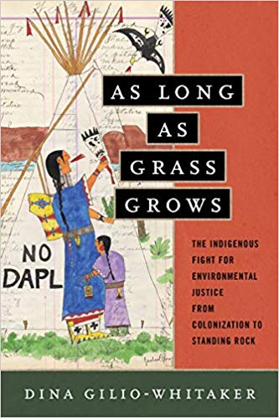
As Long as Grass Grows: The Indigenous Fight for Environmental Justice, from Colonization to Standing Rock (2019)
by Dina Gilio-Whitaker
Through the unique lens of “Indigenized environmental justice,” Indigenous researcher and activist Dina Gilio-Whitaker explores the fraught history of treaty violations, struggles for food and water security, and protection of sacred sites, while highlighting the important leadership of Indigenous women in this centuries-long struggle. As Long As Grass Grows gives readers an accessible history of Indigenous resistance to government and corporate incursions on their lands and offers new approaches to environmental justice activism and policy.
Throughout 2016, the Standing Rock protest put a national spotlight on Indigenous activists, but it also underscored how little Americans know about the longtime historical tensions between Native peoples and the mainstream environmental movement. Ultimately, she argues, modern environmentalists must look to the history of Indigenous resistance for wisdom and inspiration in our common fight for a just and sustainable future.

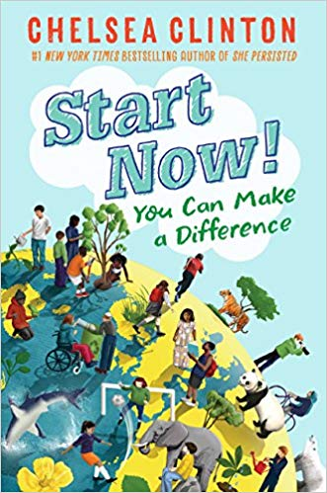
Start Now!: You Can Make a Difference (2018) by Chelsea Clinton
What can I do to help save endangered animals? How can I eat healthy? Why do I need to cover my mouth when I cough? What do I do if I'm being bullied?
With information on problems both large and small, Chelsea Clinton breaks down the concepts of health, hunger, climate change, endangered species and bullying, so that readers can understand the world around them, and how they can make a difference in their own lives, as well as in their communities and the world at large. With comic drawings to illustrate Clinton's words, photographs of real live kids who are making a difference today, and lists of ways to get involved, this book is the perfect introduction to young activists who want to make the world a better place. A book equally important and welcome for any elementary school kid, the Cub Scout and Girl Scout set, and for moms who want to raise socially active children.
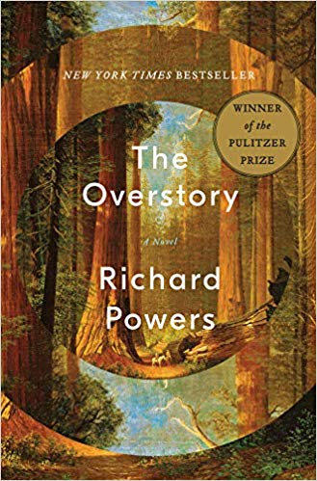
The Overstory: A Novel (2018) by Richard Powers
This Pulitzer Prize winning novel about an Air Force loadmaster in the Vietnam War is shot out of the sky, then saved by falling into a banyan. An artist inherits a hundred years of photographic portraits, all of the same doomed American chestnut. A hard-partying undergraduate in the late 1980s electrocutes herself, dies, and is sent back into life by creatures of air and light. A hearing- and speech-impaired scientist discovers that trees are communicating with one another. These four, and five other strangers―each summoned in different ways by trees―are brought together in a last and violent stand to save the continent’s few remaining acres of virgin forest.
In his twelfth novel, National Book Award winner Richard Powers delivers a sweeping, impassioned novel of activism and resistance that is also a stunning evocation of―and paean to―the natural world.
The Overstory is a book for all readers who despair of humanity’s self-imposed separation from the rest of creation and who hope for the transformative, regenerating possibility of a homecoming. If the trees of this earth could speak, what would they tell us? "Listen. There’s something you need to hear."

Relevant Literature: Background & Thematic
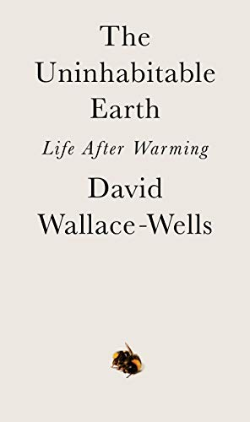
The Uninhabitable Earth: Life After Warming (2019)
by David Wallace-Wells

It is worse, much worse, than you think. If your anxiety about global warming is dominated by fears of sea-level rise, you are barely scratching the surface of what terrors are possible. In California, wildfires now rage year-round, destroying thousands of homes. Across the US, “500-year” storms pummel communities month after month, and floods displace tens of millions annually.
This is only a preview of the changes to come. And they are coming fast. Without a revolution in how billions of humans conduct their lives, parts of the Earth could become close to uninhabitable, and other parts horrifically inhospitable, as soon as the end of this century.
In his travelogue of our near future, David Wallace-Wells brings into stark relief the climate troubles that await—food shortages, refugee emergencies, and other crises that will reshape the globe. But the world will be remade by warming in more profound ways as well, transforming our politics, our culture, our relationship to technology, and our sense of history. It will be all-encompassing, shaping and distorting nearly every aspect of human life as it is lived today.
Like An Inconvenient Truth and Silent Spring before it, The Uninhabitable Earth is both a meditation on the devastation we have brought upon ourselves and an impassioned call to action. For just as the world was brought to the brink of catastrophe within the span of a lifetime, the responsibility to avoid it now belongs to a single generation.

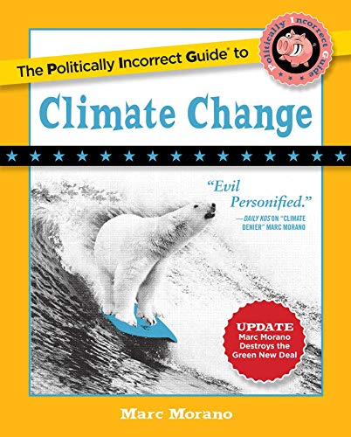
The Politically Incorrect Guide to Climate Change (2018)
By Marc Morano

Less freedom. More regulation. Higher costs. Make no mistake: those are the surefire consequences of the modern global warming campaign waged by political and cultural elites, who have long ago abandoned fact-based science for dramatic fearmongering in order to push increased central planning.

The Politically Incorrect Guide to Climate Change gives a voice -- backed by statistics, real-life stories, and incontrovertible evidence -- to the millions of "deplorable" Americans skeptical about the multibillion dollar "climate change" complex, whose claims have time and time again been proven wrong.

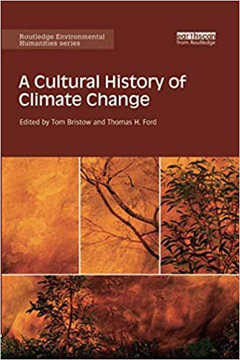
A Cultural History of Climate Change (2017)
by Tom Bristow and Thomas Ford
Charting innovative directions in the environmental humanities, this book examines the cultural history of climate change under three broad headings: history, writing and politics. Climate change compels us to rethink many of our traditional means of historical understanding, and demands new ways of relating human knowledge, action and representations to the dimensions of geological and evolutionary time. To address these challenges, this book positions our present moment of climatic knowledge within much longer histories of climatic experience. Only in light of these histories, it argues, can we properly understand what climate means today across an array of discursive domains, from politics, literature and law to neighbourly conversation. Its chapters identify turning-points and experiments in the construction of climates and of atmospheres of sensation. They examine how contemporary ecological thought has repoliticised the representation of nature and detail vital aspects of the history and prehistory of our climatic modernity.
This ground-breaking text will be of great interest to researchers and postgraduate students in environmental history, environmental governance, history of ideas and science, literature and eco-criticism, political theory, cultural theory, as well as all general readers interested in climate change.

Relevant Literature: Poetry

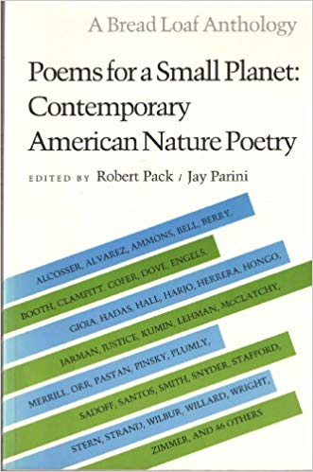
The Poetry Foundation has a long collection of poems about the environment: here. This includes Dave Smith’s “The Purpose of the Chesapeake & Ohio Canal” which is a series of poems.

A source for poetry on the environment:
Poems for a Small Planet: Contemporary American Nature Poetry by Robert Pack

“Some Questions About the Storm”
by Hilda Raz

What's the bird ratio overhead?
Zero: zero. Maybe it's El Niño?

The storm, was it bad?
Here the worst ever. Every tree hurt.

Do you love trees?
Only the gingko, the fir, the birch.

Yours? Do you name your trees?
Who owns the trees? Who's talking

You presume a dialogue. Me and You.
Yes. Your fingers tap. I'm listening.

Will you answer? Why mention trees?
When the weather turned rain into ice, the leaves failed.

So what? Every year leaves fail. The cycle. Birth to death.
In the night the sound of cannon, and death everywhere.

What did you see?
Next morning, roots against the glass.

Who's talking now and in familiar language? Get real.
What's real is the broken crown. The trunk shattered.

Was that storm worse than others?
Yes and no. The wind's torque twisted open the tree's tibia.

Fool. You're talking about vegetables. Do you love the patio
tomato? The Christmas cactus?
Yes. And the magnolia on the roof, the felled crabapple, the topless
spruce.

“For a Coming Extinction”
by W.S. Merwin

Gray whale
Now that we are sending you to The End
That great god
Tell him
That we who follow you invented forgiveness
And forgive nothing

I write as though you could understand
And I could say it
One must always pretend something
Among the dying
When you have left the seas nodding on their stalks
Empty of you
Tell him that we were made
On another day

The bewilderment will diminish like an echo
Winding along your inner mountains
Unheard by us
And find its way out
Leaving behind it the future
Dead
And ours

When you will not see again
The whale calves trying the light
Consider what you will find in the black garden
And its court
The sea cows the Great Auks the gorillas
The irreplaceable hosts ranged countless
And fore-ordaining as stars
Our sacrifices

Join your word to theirs
Tell him
That it is we who are important

“Once the World Was Perfect”
by Joy Harjo

Once the world was perfect, and we were happy in that world.
Then we took it for granted.
Discontent began a small rumble in the earthly mind.
Then Doubt pushed through with its spiked head.
And once Doubt ruptured the web,
All manner of demon thoughts
Jumped through—
We destroyed the world we had been given
For inspiration, for life—
Each stone of jealousy, each stone
Of fear, greed, envy, and hatred, put out the light.
No one was without a stone in his or her hand.
There we were,
Right back where we had started.
We were bumping into each other
In the dark.
And now we had no place to live, since we didn't know
How to live with each other.
Then one of the stumbling ones took pity on another
And shared a blanket.
A spark of kindness made a light.
The light made an opening in the darkness.
Everyone worked together to make a ladder.
A Wind Clan person climbed out first into the next world,
And then the other clans, the children of those clans, their children,
And their children, all the way through time—
To now, into this morning light to you.

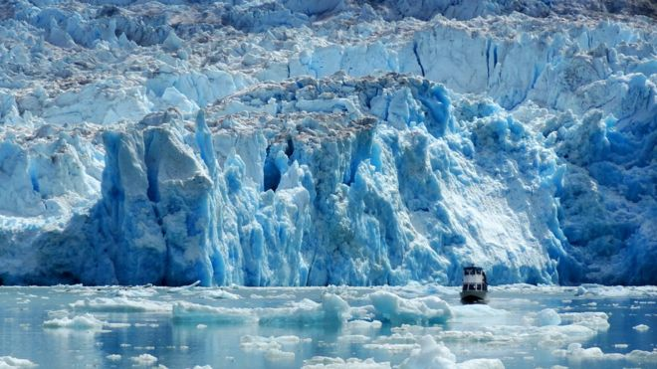

Discussion Themes & Prompts
- U.S. Government & Climate Change
Washington Post | We Would Need 1.7 Earths to Make Our Consumption Sustainable
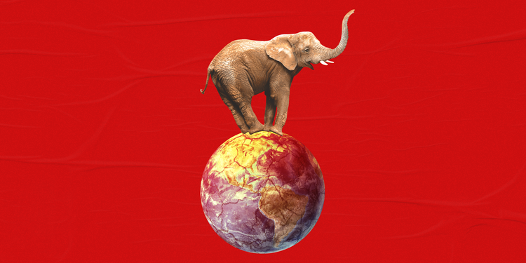

Business Insider | 130 Current Members of Congress Who Deny or Doubt Climate Change
“Over 97% of scientists agree that human activity has contributed to the steady warming of the Earth’s climate. Legislation that hopes to mitigate the potentially disastrous effects of climate change is dependent on the curbing human activity that has a large carbon footprint. Despite the consensus among scientists about the urgent need to curb emissions, there are more than 100 current members of Congress who have expressed skepticism about the role humans have played in climate change and the value of limiting our emissions.”

- Ecological Footprint
Foot Print Network | What is the ‘Ecological Footprint’?
Ecological Footprint accounting measures the demand on and supply of nature.
On the demand side, the Ecological Footprint measures the ecological assets that a given population requires to produce the natural resources it consumes (including plant-based food and fiber products, livestock and fish products, timber and other forest products, space for urban infrastructure) and to absorb its waste, especially carbon emissions.
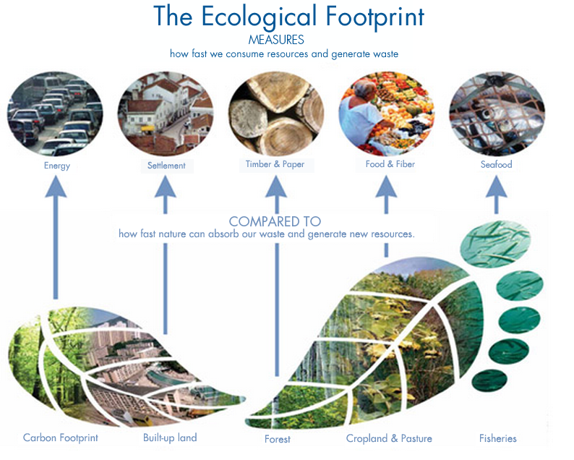
The Ecological Footprint tracks the use of six categories of productive surface areas: cropland, grazing land, fishing grounds, built-up land, forest area, and carbon demand on land.
On the supply side, a city, state or nation’s biocapacity represents the productivity of its ecological assets (including cropland, grazing land, forest land, fishing grounds, and built-up land). These areas, especially if left unharvested, can also absorb much of the waste we generate, especially our carbon emissions.

Earth Day | The Ecological Footprint Quizzes
Earth Day Network’s mission is to diversify, educate and activate the environmental movement worldwide. Growing out of the first Earth Day, Earth Day Network is the world’s largest recruiter to the environmental movement, working with more than 75,000 partners in nearly 192 countries to build environmental democracy. More than 1 billion people now participate in Earth Day activities each year, making it the largest civic observance in the world. We work through a combination of education, public policy, and consumer campaigns.
The first Earth Day on April 22, 1970, activated 20 million Americans from all walks of life and is widely credited with launching the modern environmental movement. The passage of the landmark Clean Air Act, Clean Water Act, Endangered Species Act and many other groundbreaking environmental laws soon followed. Twenty years later, Earth Day went global, mobilizing 200 million people in more than 190 countries and lifting environmental issues onto the world stage.

- Youth Activism & the Environment

TEDTalk | “The Disarming Case to Act Right Now on Climate Change”
This TEDxStockholm talk is by 16-year-old climate activist Greta Thunberg, who organized a school walk out and protest outside the Swedish parliament in August 2018. Translated into English by Akinori Oyama.

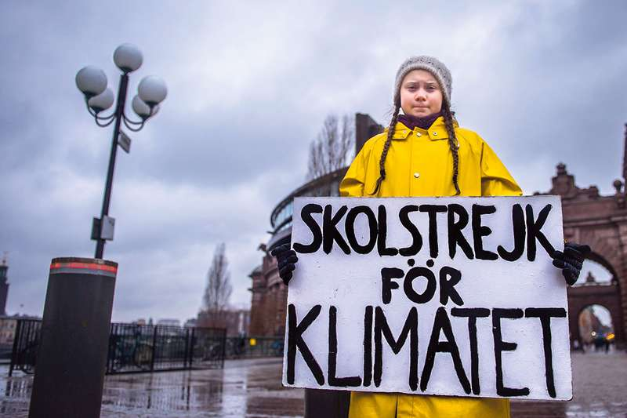
[Transcript]
“When I was about eight years old, I first heard about something called climate change or global warming. Apparently, that was something humans had created by our way of living. I was told to turn off the lights to save energy and to recycle paper to save resources. I remember thinking that it was very strange that humans, who are an animal species among others, could be capable of changing the Earth's climate. Because if we were, and if it was really happening, we wouldn't be talking about anything else. As soon as you'd turn on the TV, everything would be about that. Headlines, radio, newspapers, you would never read or hear about anything else, as if there was a world war going on. But no one ever talked about it. If burning fossil fuels was so bad that it threatened our very existence, how could we just continue like before? Why were there no restrictions? Why wasn't it made illegal?
To me, that did not add up. It was too unreal. So when I was 11, I became ill. I fell into depression, I stopped talking, and I stopped eating. In two months, I lost about 10 kilos of weight. Later on, I was diagnosed with Asperger syndrome, OCD and selective mutism. That basically means I only speak when I think it's necessary - now is one of those moments.
For those of us who are on the spectrum, almost everything is black or white. We aren't very good at lying, and we usually don't enjoy participating in this social game that the rest of you seem so fond of.
I think in many ways that we autistic are the normal ones, and the rest of the people are pretty strange, especially when it comes to the sustainability crisis, where everyone keeps saying climate change is an existential threat and the most important issue of all, and yet they just carry on like before. I don't understand that, because if the emissions have to stop, then we must stop the emissions. To me that is black or white. There are no gray areas when it comes to survival. Either we go on as a civilization or we don't. We have to change.
Rich countries like Sweden need to start reducing emissions by at least 15 percent every year. And that is so that we can stay below a two-degree warming target. Yet, as the IPCC have recently demonstrated, aiming instead for 1.5 degrees Celsius would significantly reduce the climate impacts. But we can only imagine what that means for reducing emissions. You would think the media and every one of our leaders would be talking about nothing else, but they never even mention it. Nor does anyone ever mention the greenhouse gases already locked in the system. Nor that air pollution is hiding a warming so that when we stop burning fossil fuels, we already have an extra level of warming perhaps as high as 0.5 to 1.1 degrees Celsius. Furthermore does hardly anyone speak about the fact that we are in the midst of the sixth mass extinction, with up to 200 species going extinct every single day, that the extinction rate today is between 1,000 and 10,000 times higher than what is seen as normal. Nor does hardly anyone ever speak about the aspect of equity or climate justice, clearly stated everywhere in the Paris Agreement, which is absolutely necessary to make it work on a global scale. That means that rich countries need to get down to zero emissions within 6 to 12 years, with today's emission speed. And that is so that people in poorer countries can have a chance to heighten their standard of living by building some of the infrastructure that we have already built, such as roads, schools, hospitals, clean drinking water, electricity, and so on. Because how can we expect countries like India or Nigeria to care about the climate crisis if we who already have everything don't care even a second about it or our actual commitments to the Paris Agreement?
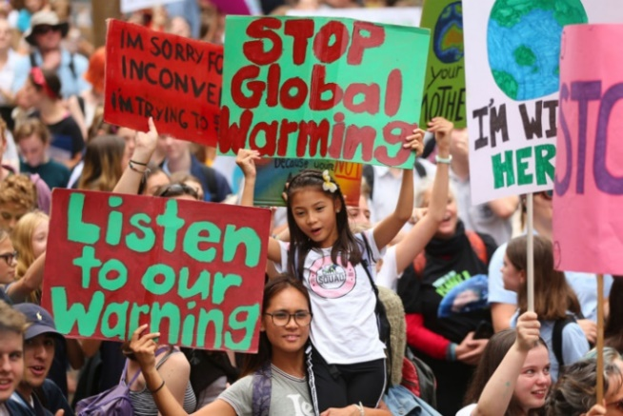
So, why are we not reducing our emissions? Why are they in fact still increasing? Are we knowingly causing a mass extinction? Are we evil? No, of course not. People keep doing what they do because the vast majority doesn't have a clue about the actual consequences of our everyday life, and they don't know that rapid change is required. We all think we know, and we all think everybody knows, but we don't. Because how could we? If there really was a crisis, and if this crisis was caused by our emissions, you would at least see some signs. Not just flooded cities, tens of thousands of dead people, and whole nations leveled to piles of torn down buildings. You would see some restrictions. But no. And no one talks about it. There are no emergency meetings, no headlines, no breaking news. No one is acting as if we were in a crisis. Even most climate scientists or green politicians keep on flying around the world, eating meat and dairy. If I live to be 100, I will be alive in the year 2103. When you think about the future today, you don't think beyond the year 2050. By then, I will, in the best case, not even have lived half of my life.
What happens next? The year 2078, I will celebrate my 75th birthday. If I have children or grandchildren, maybe they will spend that day with me. Maybe they will ask me about you, the people who were around, back in 2018. Maybe they will ask why you didn't do anything while there still was time to act. What we do or don't do right now will affect my entire life and the lives of my children and grandchildren. What we do or don't do right now, me and my generation can't undo in the future. So when school started in August of this year, I decided that this was enough. I set myself down on the ground outside the Swedish parliament. I school striked for the climate. Some people say that I should be in school instead. Some people say that I should study to become a climate scientist so that I can "solve the climate crisis." But the climate crisis has already been solved. We already have all the facts and solutions. All we have to do is to wake up and change. And why should I be studying for a future that soon will be no more when no one is doing anything whatsoever to save that future? And what is the point of learning facts in the school system when the most important facts given by the finest science of that same school system clearly means nothing to our politicians and our society. Some people say that Sweden is just a small country, and that it doesn't matter what we do, but I think that if a few children can get headlines all over the world just by not coming to school for a few weeks, imagine what we could all do together if you wanted to.
Now we're almost at the end of my talk, and this is where people usually start talking about hope, solar panels, wind power, circular economy, and so on, but I'm not going to do that. We've had 30 years of pep-talking and selling positive ideas. And I'm sorry, but it doesn't work. Because if it would have, the emissions would have gone down by now. They haven't. And yes, we do need hope, of course we do. But the one thing we need more than hope is action. Once we start to act, hope is everywhere.
So instead of looking for hope, look for action. Then, and only then, hope will come.
Today, we use 100 million barrels of oil every single day. There are no politics to change that. There are no rules to keep that oil in the ground. So we can't save the world by playing by the rules, because the rules have to be changed. Everything needs to change -- and it has to start today. Thank you.” – Greta Thunberg

The Guardian | “Young Climate Activists Around the World: Why I’m Striking Today”
Youth activists who participated in the school climate change walk out and who participate in other environmental initiatives share their stories and why they are passionate about advocating for our planet. Hear stories from teenagers from Taiwan, India, Japan, Samoa, Argentina, Australia, Ukraine, South Africa and all over the globe.

Medium Corp. | “5 Young Environmental Activists Making a Difference in Climate Change”
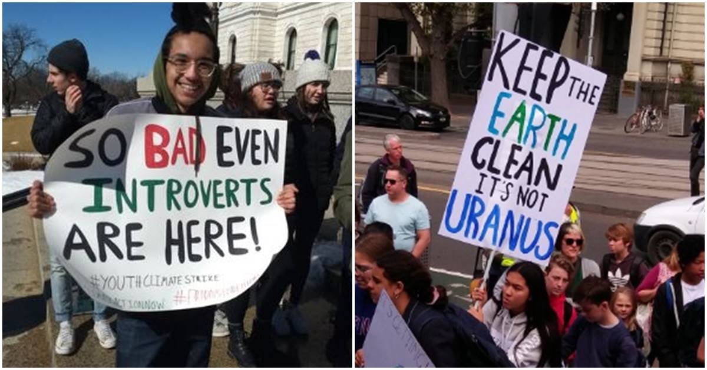
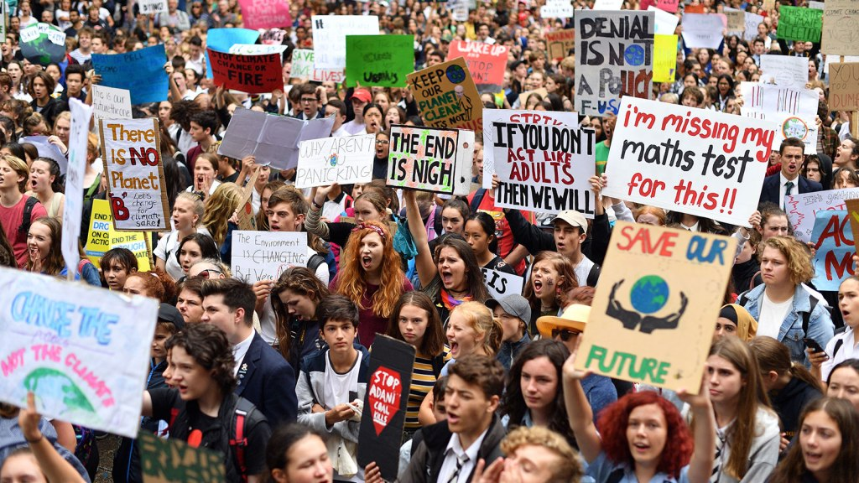
A young climate activist from Cameroon, Loic Tchinda, profiles 5 youth from the ages of 9 to 17 working to fight for the environment. In this article you’ll read about Timoci Naulusala, Ridhima Pandey, Xiuhtezcatl Martinez, Shalvi Shakshi, and Jaden Anthony.
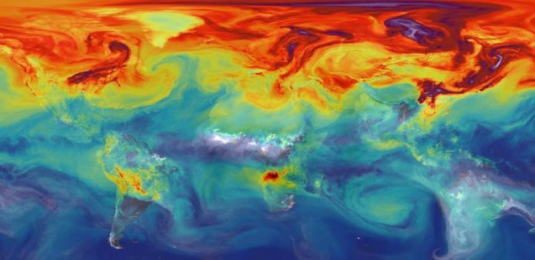

View PBS’s Frontline hour-long piece on climate change called “Hot Politics”: here.

Discussion Questions
- Have you noticed recent changes in the weather or unusual weather patterns where you live? If so, describe them.
- How many recent sever weather events can you recount? Do you think their effects are the result of climate change?
- Do you think the recent changes in climate and weather are more attributed to natural or human causes? Explain your reasons.
- If you feel humans are the main cause of global warming, do you think you contribute to global warming? If yes, how? Are you taking any steps to reduce your own ‘climate change footprint’? (i.e. recycling, using less plastic, etc.)
- Where do you stand on whether the U.S. government should be doing about global warming and climate change?

Summary of Anthropocene from the project’s official website: theanthropocene.org.
Edward Burtynsky’s Artist Statement.

